****MINISTRY OF EDUCATION AND TRAINING

FPT UNIVERSITY

**Capstone Project Document**

EQUIPMENT MANAGEMENT SYSTEM

**(EMS)**

|  |  |
| --- | --- |
| **Group 7** | |
| **Group members** | Nguyễn Thanh Tiến - SE61848  Nguyễn Huy Hoàng - SE62014  Trịnh Thanh Hậu - SE61951  Bùi Quang Nhật Châu - SE61740  Đoàn Trọng Lam Điền - SE61501 |
| **Supervisor** | Lại Đức Hùng |
| **Ext. Supervisor** | N/A |
| **Project Code** | EMS |

-Ho Chi Minh City, ***14/05/2018***-

**ACKNOWLEDGEMENT**

In order to be able to finish this EMS project, we have got a lot of help from other people. We would love to thank each person who helped us with this project.

First of all, we would like to thank FPT University for giving us a chance to work on this project, a chance to improve ourselves within 4 years.

Secondly, we are really thankful to Mr. Lai Duc Hung - our supervisor. He has been always with us giving a lot of useful suggestions from the very beginning till the end of this project. We would like to give a special thanks to him for supporting us with a suitable place to work, for helping us when we have no idea about some problems.

Next, we would like to thank all of the instructors who have lectured us in (about) 4 years.

And we shall not forget about all of the authors from the documentation we read.

Most importantly, we would like to dedicate this work to our parents. Thanks for supporting us from the first day when we were born.

In conclusion, thanks everyone, it has been a pleasure working with all of you.

-EMS Team-

# Table of Contents

Table of Contents 5

List of Tables 10

List of Figures 13

A. Introduction 17

1. Project Information 17

2. Introduction 17

3. Current Situation 18

4. Problem Definition 18

5. Proposed Solution 19

5.1 Feature functions 19

5.2 Advantages and disadvantages 19

6. Functional Requirements 20

7. Role and Responsibility 22

B. Software Project Management Plan 23

1. Problem Definition 23

1.1 Name of this Capstone Project 23

1.2 Problem Abstract 23

1.3 Project Overview 23

2. Project organization 26

2.1 Software Process Model 26

2.2 Roles and Responsibilities 27

2.3 Tools and Techniques 27

3. Project management plan 28

3.1 Software development life cycle 28

3.2 Phase Detail 29

3.3 Meeting Minutes 31

4. Convention Rules 31

C. Software Requirement Specification 32

1. User Requirement Specification 32

1.1 Unauthorized User Requirement 32

1.2 Admin Requirement 32

1.3 Manager Requirement 32

1.4 Maintainer Requirement 32

1.5 Equipment Staff Requirement 33

1.6 Team Leader Requirement 33

2. System Requirement Specification 33

2.1 External Interface Requirement 34

2.2 System Overview Use Case 35

2.3 List of Use Case 36

3. Software System Attribute 93

3.1 Usability 93

3.2 Reliability 93

3.3 Availability 93

3.4 Security 93

3.5 Maintainability 94

3.6 Portability 94

3.7 Performance 94

4. Conceptual Diagram 95

D. Software Design Description 95

1. Design Overview 95

2. System Architectural Design 96

3. Component Diagram 98

4. Detail Description 99

4.1 Class Diagram 99

4.2 Class Diagram Explanation 102

4.3 Interactive Diagram 109

4.4 State Machine Diagram 116

5. User Interface Design 117

5.1. Web application user interface 117

6. Database Design 129

6.1 Entity relationship diagram (ERD) 129

6.2 Entity dictionary 131

7. Algorithms 131

7.1. Optimal Equipment Suggestion 131

E. System Implementation & Test 136

1. Introduction 136

1.1 Overview 136

1.2 Test approach 136

2. Database Relationship Diagram 136

2.1 Physical diagram 136

2.2 Data dictionary 138

3. Test plan 145

3.1 Features to be tested 145

3.2 Features not to be tested 145

4. System Testing Test Case 145

4.1 Test case 145

4.2 テストケース 152

F1. Software User’s Manual 157

1. Installation Guide 157

1.1 Hardware Requirement 157

1.2 Software Requirement 157

2. User Guide 158

2.1 Login 158

2.2 View Dashboard 159

2.3 View Work Order 159

2.4 View Equipment 160

2.5 Import an Equipment 160

2.6 Edit an Equipment Information 162

2.7 Create Equipment Items 163

2.8 View Location <List View> 165

2.9 View Location <Map View> 166

2.10 Create a Location 166

2.11 View Vendor 168

2.12 Create a Vendor 168

2.13 Edit a Location Information 170

2.14 View Account 172

2.15 Create an Account 172

2.16 Edit an Account Information 174

2.17 View Team 176

2.18 Create a Team 176

2.19 Edit a Team Information 177

F2. ソフトウェアユーザーマニュアル 179

1. インストレーションガイド 179

1.1ハードウェア要件 179

1.2ソフトウェア要件 179

2. ユーザーガイド 180

2.1ログイン 180

2.2ダッシュボードを表示します 181

2.3作業の順序を管理します 181

2.4機器の表示します 182

2.5設備を追加します 182

2.6設備を編集します 184

2.7設備の項目を作成します 185

2.8場所を表示します＜リストビュー＞ 187

2.9場所を表示します＜マップビュー＞ 188

2.10場所を作成します 188

2.11ベンダーを表示します 190

2.12ベンダーを作成します 190

2.13ベンダーを編集します 192

2.14口座を表示します 194

2.15口座を作成します 194

2.16口座を編集します 196

2.17チームを表示します 198

2.18チームを作成します 198

2.19チームを編集します 199

G. Appendix 202

1. SOFTWARE ENGINEERING 9TH EDITION, BY IAN SOMMERVILLE 202

2. STARUML DOCUMENTATION FOR ACTIVITY DIAGRAM: 202

3. STARUML DOCUMENTATION OF IBM: 202

4. UML FOR DRAWING DIAGRAM (2.0 STANDARD) 202

5. VUEJS FEATURES 202

# List of Tables

Table 1- Role and Responsibility 22

Table 2 - Hardware requirements 25

Table 3 - Software requirements 25

Table 4 - Role and Responsibilities 27

Table 5 - Tools and Techniques 27

Table 6 - Software development life cycle 29

Table 7 - Requirements Definition 29

Table 8 - System and Software Design 30

Table 9 - Implementation and Unit Testing 30

Table 10 - Integration and System Testing 30

Table 11 - Operation and Maintenance 31

Table 12 - Login specification 37

Table 13 - Logout specification 39

Table 14 - Edit Profile specification 41

Table 15 - View Schedule specification 43

Table 16 - View Work Order specification 44

Table 17 - View Equipment specification 46

Table 18 - View Equipment Items specification 48

Table 19 - View Location specification 49

Table 20 - Create Account specification 51

Table 21 - Edit Account specification 53

Table 22 - View Account specification 54

Table 23 - View Status History specification 57

Table 24 - Locate Equipment Items 58

Table 25 - Create Vendor specification 60

Table 26 - Add New Equipment specification 62

Table 27 - Edit Vendor specification 63

Table 28 - Edit Equipment specification 65

Table 29 - Add Items specification 67

Table 30 - Close Work Order 69

Table 31 - Change Location specification 71

Table 32 - Edit Equipment Item specification 73

Table 33 - Approve Work Order specification 74

Table 34 - Reject Work Order specification 76

Table 35 - Create Location specification 78

Table 36 - Edit Location specification 79

Table 37 - Create Team specification 81

Table 38 - Edit Team specification 83

Table 39 - Create Working Order specification 86

Table 40 - Edit Working Order specification 88

Table 41 - Create Maintenance Order specification 91

Table 42 - Edit Maintenance Order specification 93

Table 43 - Component Dictionary 98

Table 44 - Class Dictionary 102

Table 45 - Class Diagram Explanation <User> 102

Table 46 - Class Diagram Explanation <Admin> 102

Table 47 - Class Diagram Explanation <Manager> 103

Table 48 - Class Diagram Explanation <Equipment Staff> 103

Table 49 - Class Diagram Explanation <Maintainer> 104

Table 50 - Class Diagram Explanation <Team Leader> 104

Table 51 - Class Diagram Explanation <Team> 104

Table 52 - Class Diagram Explanation <Location> 105

Table 53 - Class Diagram Explanation <TeamUser> 105

Table 54 - Class Diagram Explanation <Block> 105

Table 55 - Class Diagram Explanation <Floor> 106

Table 56 - Class Diagram Explanation <Tile> 106

Table 57 - Class Diagram Explanation <TeamLocation> 106

Table 58 - Class Diagram Explanation <Equipment> 106

Table 59 - Class Diagram Explanation <EquipmentItem> 107

Table 60 - Class Diagram Explanation <WorkOrder> 108

Table 61 - Class Diagram Explanation <WorkOrderDetail> 108

Table 62 - Class Diagram Explanation <WorkOrderRecord> 108

Table 63 - Login <Field> 117

Table 64 - Login <Buttons/Hyperlinks> 117

Table 65 - Manage Equipment <Buttons/Hyperlinks> 119

Table 66 - Add an Equipment <Field> 120

Table 67 - Add an Equipment <Buttons/Hyperlinks> 120

Table 68 - Edit Equipment <Field> 121

Table 69 - Edit Equipment <Buttons/Hyperlinks> 121

Table 70 - Create Equipment Items <Field> 123

Table 71 - Create Equipment Items <Buttons/Hyperlinks> 123

Table 72 - Manage Location List View <Field> 123

Table 73 - Manage Location Map View <Field> 124

Table 74 - Create a Vendor <Field> 124

Table 75 - Create a Vendor <Buttons/Hyperlinks> 124

Table 76 - Edit a Vendor <Field> 125

Table 77 - Edit a Vendor <Buttons/Hyperlinks> 125

Table 78 - Create an Account <Field> 126

Table 79 - Create an Account <Buttons/Hyperlinks> 126

Table 80 - Edit an Account <Field> 127

Table 81 - Edit an Account <Buttons/Hyperlinks> 127

Table 82 - Manage Team <Field> 128

Table 83 - Create a Team <Field> 128

Table 84 - Create a Team <Buttons/Hyperlinks> 128

Table 85 - Edit a Team <Field> 129

Table 86 - Edit a Team <Buttons/Hyperlinks> 129

Table 87 - Entity Dictionary 131

Table 88 - Algorithms Examples 134

Table 89 - Data Dictionary All Tables 138

Table 90 - Data Dictionary 144

Table 91 - Test case <Add Location> 146

Table 92 - Test case <Edit Location> 147

Table 93 - Test case <Add Vendor> 148

Table 94 - Test case <Edit Vendor> 148

Table 95 - Test case <Add Equipment> 150

Table 96 - Test case <Add Account> 151

Table 97 - Test case <Add Equipment Items> 152

Table 98 - テストケース<場所を追加します> 153

Table 99 - テストケース<場所を編集します> 153

Table 100 - テストケース<ベンダーを追加します> 155

Table 101 - テストケース<ベンダーを編集します> 155

Table 102 - テストケース<設備を追加します> 157

Table 103 - Hardware Requirement 157

Table 104 - Software Requirement 157

Table 105 - User Guide <Login> 158

Table 106 - User Guide <View Dashboard> 159

Table 107 - User Guide <View Work Order> 159

Table 108 - User Guide <View Equipment> 160

Table 109 - User Guide <Import Equipment> 161

Table 110 - User Guide <Edit Equipment Information> 163

Table 111 - User Guide <Create Equipment Items> 165

Table 112 - User Guide <View Locations List View> 165

Table 113 - User Guide <View Location Map View> 166

Table 114 - User Guide <Create a Location > 167

Table 115 - User Guide <View Vendor> 168

Table 116 - User Guide <Create Vendor> 169

Table 117 - User Guide <Edit Location information> 171

Table 118 - User Guide <View Account> 172

Table 119 - User Guide <Create an Account> 173

Table 120 - User Guide <Edit Account Information> 175

Table 121 - User Guide <View Team> 176

Table 122 - User Guide <Create a Team> 177

Table 123 - User Guide <Edit Team Information > 179

Table 124 - ハードウェア要件 179

Table 125 - ソフトウェア要件 179

Table 126 - ユーザーガイド<ログイン> 180

Table 127 - ユーザーガイド<ダッシュボードを表示します> 181

Table 128 - ユーザーガイド <作業の順序を管理します> 181

Table 129 - ユーザーガイド <機器の表示します> 182

Table 130 - ユーザーガイド <設備を追加します> 183

Table 131 - ユーザーガイド <設備を編集します> 185

Table 132 - ユーザーガイド <設備の項目を作成します> 187

Table 133 - ユーザーガイド <場所を表示します> 187

Table 134 - ユーザーガイド <場所を表示します> 188

Table 135 - ユーザーガイド <場所を作成します> 189

Table 136 - ユーザーガイド <ベンダーを表示します> 190

Table 137 - ユーザーガイド <ベンダーを作成します> 191

Table 138 - ユーザーガイド <ベンダーを編集します> 193

Table 139 - ユーザーガイド <口座を表示します> 194

Table 140 - ユーザーガイド <口座を作成します> 195

Table 141 - ユーザーガイド <口座を編集します> 197

Table 142 - ユーザーガイド <チームを表示します> 198

Table 143 - ユーザーガイド <チームを作成します> 199

Table 144 - ユーザーガイド <チームを編集します> 201

# List of Figures

Figure 1 - Waterfall Model 26

Figure 2 - System Overview Use Case 35

Figure 3 - < Unauthorized User>Overview Use Case 36

Figure 4 - < Unauthorized User> Login 36

Figure 5 - < Authorized User>Overview Use Case 38

Figure 6 - < Authorized User> Logout 38

Figure 7 - < Authorized User> Edit Profile 39

Figure 8 - < Authorized User> View Schedule 42

Figure 9 - < Authorized User> View Work Order 43

Figure 10 - < Authorized User> View Equipment 45

Figure 11 - < Authorized User> View Equipment Items 46

Figure 12 - < Authorized User> View Location 48

Figure 13 - < Admin>Overview Use Case 49

Figure 14 - < Admin> Create Account 50

Figure 15 - < Admin> Edit Account 52

Figure 16 - < Admin> View Account 53

Figure 17 - < Equipment Staff>Overview Use Case 55

Figure 18 - < Equipment Staff> View Status History 55

Figure 19 - < Equipment Staff> Locate Equipment Item 57

Figure 20 - < Equipment Staff> Create Vendor 58

Figure 21 - < Equipment Staff> Add New Equipment 60

Figure 22 - < Equipment Staff> Edit Vendor 62

Figure 23 - < Equipment Staff> Edit Equipment 64

Figure 24 - < Equipment Staff> Add Items 66

Figure 25 - < Equipment Staff> Close Out Work Order 68

Figure 26 - < Equipment Staff> Change Location 69

Figure 27 - < Equipment Staff> Edit Equipment Item 71

Figure 28 - < Manager>Overview Use Case 73

Figure 29 - < Manager> Approve Work Order 73

Figure 30 - < Manager> Reject Work Order 75

Figure 31 - < Manager> Create Location 76

Figure 32 - < Manager> Edit Location 78

Figure 33 - < Manager> Create Team 80

Figure 34 - < Manager> Edit Team 82

Figure 35 - < Team Leader>Overview Use Case 84

Figure 36 - < Team Leader> Create Working Order 84

Figure 37 - < Team Leader > Edit Working Order 87

Figure 38 - < Maintainer>Overview Use Case 89

Figure 39 - < Maintainer> Create Maintenance Order 89

Figure 40 - < Maintainer> Edit Maintenance Order 91

Figure 41 - Conceptual Diagram 95

Figure 42 - System Architectural Design 96

Figure 43 - Component Diagram 98

Figure 44 - Class Diagram 100

Figure 45 - Sequence Diagram for Create User <Admin> 109

Figure 46 - Sequence Diagram for Login < Unauthorized User > 110

Figure 47 - Sequence Diagram for Approve Work Order < Manager > 110

Figure 48 - Sequence Diagram for Reject Work Order < Manager > 111

Figure 49 - Sequence Diagram for Create Team < Manager > 111

Figure 50 - Sequence Diagram for Change Status Work Order < Equipment Staff > 112

Figure 51 - Sequence Diagram for List Work Order < Equipment Staff > 112

Figure 52 - Sequence Diagram for Create Vendor < Equipment Staff > 113

Figure 53 - Sequence Diagram for Create Equipment Category < Equipment Staff > 113

Figure 54 - Sequence Diagram for Create Equipment Items < Equipment Staff > 114

Figure 55 - Sequence Diagram for Logout < Authorized User > 114

Figure 56 - Sequence Diagram for Create Work Order < Team Leader/ Maintainer > 115

Figure 57 - Sequence Diagram for Edit Work Order < Team Leader/ Maintainer > 115

Figure 58 - State Machine Diagram of Work Order 116

Figure 59 - State Machine Diagram of Equipment Item 116

Figure 60 - User Interface <Login> 117

Figure 61 - User Interface <View Dashboard> 118

Figure 62 - User Interface <Manage Work Order> 118

Figure 63 - User Interface <Manage Equipment> 119

Figure 64 - User Interface <View Schedule> 119

Figure 65 - User Interface <Add an Equipment> 120

Figure 66 - User Interface <Edit Equipment> 121

Figure 67 - User Interface <Create Equipment Item> 122

Figure 68 - User Interface <Manage Location List View> 123

Figure 69 - User Interface <Manage Location Map View> 124

Figure 70 - User Interface <Create a Vendor> 124

Figure 71 - User Interface <Edit a Vendor> 125

Figure 72 - User Interface <Create an Account> 126

Figure 73 - User Interface <Edit an Account> 127

Figure 74 - User Interface <Manage Team> 128

Figure 75 - User Interface <Create a Team> 128

Figure 76 - User Interface <Edit a Team> 129

Figure 77 - Entity Relationship Diagram 130

Figure 78 - Flowchart of Algorithm 135

Figure 79 - Database Diagram 137

Figure 80 - User Guide <Login> 158

Figure 81 - User Guide <View Dashboard> 159

Figure 82 - User Guide <View Work Order> 159

Figure 83 - User Guide <View Equipment> 160

Figure 84 - User Guide <Import Equipment 1> 160

Figure 85 - User Guide <Import Equipment 2> 161

Figure 86 - User Guide <Edit Equipment Information 1> 162

Figure 87 - User Guide <Edit Equipment Information 2> 162

Figure 88 - User Guide <Edit Equipment Information 3> 162

Figure 89 - User Guide <Create Equipment Items 1> 163

Figure 90 - User Guide <Create Equipment Items 2> 164

Figure 91 - User Guide <View Location List View> 165

Figure 92 - User Guide <View Location Map View> 166

Figure 93 - User Guide <Create a Location 1> 166

Figure 94 - User Guide <Create a Location 2> 167

Figure 95 - User Guide <Create a Location 3> 167

Figure 96 - User Guide <View Vendor> 168

Figure 97 - User Guide <Create a Vendor 1> 168

Figure 98 - User Guide <Create a Vendor 2> 169

Figure 99 - User Guide <Edit Location Information 1> 170

Figure 100 - User Guide <Edit Location Information 2> 170

Figure 101 - User Guide <Edit Location Information 3> 171

Figure 102 - User Guide <View Account> 172

Figure 103 - User Guide <Create an Account 1> 172

Figure 104 - User Guide <Create an Account 2> 173

Figure 105 - User Guide <Edit Account Information 1> 174

Figure 106 - User Guide <Edit Account Information 2> 174

Figure 107 - User Guide <Edit Account Information 3> 175

Figure 108 - User Guide <View Team> 176

Figure 109 - User Guide <Create a Team 1> 176

Figure 110 - User Guide <Create a Team 2> 177

Figure 111 - User Guide <Edit Team Information 1> 177

Figure 112 - User Guide <Edit Team Information 2> 178

Figure 113 - User Guide <Edit Team Information 3> 178

Figure 114 - ユーザーガイド <ログイン> 180

Figure 115 - ユーザーガイド <ダッシュボードを表示します> 181

Figure 116 - ユーザーガイド <作業の順序を管理します> 181

Figure 117 - ユーザーガイド <機器の表示します> 182

Figure 118 - ユーザーガイド <設備を追加します> 182

Figure 119 - ユーザーガイド <設備を追加します> 183

Figure 120 - ユーザーガイド <設備を編集します> 184

Figure 121 - ユーザーガイド <設備を編集します> 184

Figure 122 - ユーザーガイド <設備を編集します> 185

Figure 123 - ユーザーガイド <設備の項目を作成します> 185

Figure 124 - ユーザーガイド <設備の項目を作成します> 186

Figure 125 - ユーザーガイド <場所を表示します> 187

Figure 126 - ユーザーガイド <場所を表示します> 188

Figure 127 - ユーザーガイド <場所を作成します> 188

Figure 128 - ユーザーガイド <場所を作成します> 189

Figure 129 - ユーザーガイド <場所を作成します> 189

Figure 130 - ユーザーガイド <ベンダーを表示します> 190

Figure 131 - ユーザーガイド <ベンダーを作成します> 190

Figure 132 - ユーザーガイド <ベンダーを作成します> 191

Figure 133 - ユーザーガイド <ベンダーを編集します> 192

Figure 134 - ユーザーガイド <ベンダーを編集します> 192

Figure 135 - ユーザーガイド <ベンダーを編集します> 193

Figure 136 - ユーザーガイド <口座を表示します> 194

Figure 137 - ユーザーガイド <口座を作成します> 194

Figure 138 - ユーザーガイド <口座を作成します> 195

Figure 139 - ユーザーガイド <口座を編集します> 196

Figure 140 - ユーザーガイド <口座を編集します> 196

Figure 141 - ユーザーガイド <口座を編集します> 197

Figure 142 - ユーザーガイド <チームを表示します> 198

Figure 143 - ユーザーガイド <チームを作成します> 198

Figure 144 - ユーザーガイド <チームを作成します> 199

Figure 145 - ユーザーガイド <チームを編集します> 199

Figure 146 - ユーザーガイド <チームを編集します> 200

Figure 147 - ユーザーガイド <チームを編集します> 200

# A. Introduction

## 1. Project Information

* Project name: Equipment Management System
* Project Code: EMS
* Product Type: Web Application
* Start Date: 14/05/2018
* End Date: 30/08/2018

## 2. Introduction

Companies without an automated maintenance management system, generally, record maintenance data manually with a pencil and paper. With the enormous amount of equipment, the management by pen and paper is usually very time-consuming and inefficient to use, maintain or coordinate the equipment. Based on our researches and analysis, we proposed a solution for companies in Vietnam and other developed countries. Equipment Management System (EMS) is simple, easy to use and effective equipment asset management software that helps companies store, manage, maintain and report on their assets and equipment.

In this document, we introduce a solution for companies. EMS will eliminate the need for disjunction and unorganized paper and digital information, decrease equipment downtime and increase productivity by tracking equipment and asset availability. In addition, EMS can schedule regular maintenance and keep track of all the work that has been done, perfect for equipment staffs and full visibility for those who need it most.

This document also describes our working process in 4 months includes our perspective in the system, component designs and detailed core workflows. We hope the system and our solution will help resolve the problems from companies in Vietnam and other countries.

## 3. Current Situation

Nowadays, most of the companies in Vietnam are still using traditional stationary such as pen and paper to deal with their works and equipment management process.

In the field of mobilizing equipment, Team Leader, who wishes to use equipment for on-site construction activities within the scope of the company, needs to make a request under some particular kinds of form. After receiving the request form, person in charge of equipment management (the staff) will clarify whether the request is for internal construction or external leasing. Next, the manager is responsible for checking the equipment proposal to allocate if it meets the needs of use and confirming the request. And then, the staffs are to follow the manager's confirmation to record and store all the relevant documents.

For periodical maintenance of equipment side, Team Leader will set up a maintenance plan, generally evaluate to get periodic repairs or replacements and propose request form. Then, the manager is responsible for considering if the request matches the usage need and confirm it in the maintenance plan. The repair and maintenance team will select the repairing agents to suit the actual status. The staff must follow the procedure whenever the repaired equipment is exported from the warehouse. Next, the management team is in charge of checking the equipment after they have been repaired. Finally, the staff is to record and store all the relevant documents.

For routine repairs, during construction or when equipment is damaged, the site manager is responsible for informing the equipment management team. Subsequently, the equipment staff will make the proposal to the manager for repairing request. The manager is responsible for inspection tasks and deciding on a repair plan. The staff is responsible for the practical repair. Next, the manager is in charge of checking the equipment after they have been repaired. Finally, the staff is to record and store all the relevant documents.

## 4. Problem Definition

Below are disadvantages of current situation:

* Forget equipment periodic maintenance date.
* Hard for manage and track all work orders and inspections (planned or unplanned).
* Hard for report on equipment repaired history and open upcoming work orders.
* Hard for report equipment downtime and record downtime history to increase productivity by tracking equipment and asset availability.
* Hard for find location of equipment when needed.
* Time-consuming and inefficient in equipment management.
* Hard for sync data.

## 5. Proposed Solution

Our proposed solution is to build an equipment management system named “Equipment Management System” to resolve the current situations and compatible with a process of device allocation, we also design the system to be scalable so we can deploy this system to a multiple insurance services company in the future plan.

EMS system includes a web application with the following functions:

### 5.1 Feature functions

* + Equipment management
  + Work Orders management
    - Creating a Work Order
    - Modifying a Work Order
    - Closing Out a Work Order
  + Visual Asset and Equipment Mapping
    - Advanced Dash, allows users to interact with their asset and equipment information directly from their [interactive floor plans and drawings](https://www.hippocmms.com/hippo-maintenance-management-reports-0).
    - Using visual asset mapping, system users can locate critical pieces of equipment in every section and floor of their facility
  + Asset and Equipment Reporting
    - Manage and track all work orders and inspections (planned or unplanned)
    - Easily report on equipment repair history and open upcoming work orders
    - Quick access to images, contacts, warranty info and more
    - Record meter readings (run-time hours, mileage, etc.)
    - Report equipment downtime and record downtime history
    - Transfer equipment from facility to facility within enterprise

### 5.2 Advantages and disadvantages

* Advantages:
* Real-time notifications and alerts
* Monitor costs and view reports
* A better way to manage your team
* Keeping History
* Improve efficiency and increase productivity
* All communication through one simple app
* Visual Asset and Equipment Mapping
* Disadvantages:
* Only suitable for large companies.

## 6. Functional Requirements

Function requirements of the system are listed as below:

* Manager component
* Manage Work Order
  + Reject Work Order
  + Approve Work Order
* View Schedule
* View Location
* View Work Order
* View Equipment
* View Equipment Items
* Edit Profile
* Log out
* Manage Location
  + Create Location
  + Edit Location
  + Manage Block
* Create Block
* Edit Block
* Delete Block
* Manage Floor
* Create Floor
* Edit Floor
* Delete Floor
* Manage Tile
* Create Tile
* Edit Tile
* Delete Tile
* Display Equipment Items
* Manage Team
  + Create Team
  + Edit Team
* Admin component
* Manage Account
  + Create Account
  + View Account
  + Update Account
* View Schedule
* View Location
* View Work Order
* View Equipment
* View Equipment Items
* Edit Profile
* Log out
* Edit configuration
* Equipment Staff component
* Close Work Order
* Check Work Order
* Deliver Work Order
* Manage Equipment
  + List Equipment
  + Search Equipment
  + View Status History
  + Edit Equipment
  + Add New Equipment
  + Locate Equipment
* View Schedule
* View Location
* View Work Order
* View Equipment
* View Equipment Items
* Edit Profile
* Log out
* Manage Unit
* Create Unit
* Edit Unit
* Delete Unit
* Manage Vendor
* Create Vendor
* Edit Vendor
* Manage Maintenance Duration
* Create Maintenance Duration
* Edit Maintenance Duration
* Delete Maintenance Duration
* Manage Category
* Create Category
* Edit Category
* Delete Category
* Team Leader component
* View Schedule
* View Location
* View Work Order
* View Equipment
* View Equipment Items
* Edit Profile
* Log out
* Create Working Order
* Edit Working Order
* Maintainer component
* View Schedule
* View Location
* View Work Order
* View Equipment
* View Equipment Items
* Edit Profile
* Log out
* Create Maintenance Order
* Edit Maintenance Order

## 7. Role and Responsibility

|  |  |  |  |  |
| --- | --- | --- | --- | --- |
| **No** | **Full Name** | **Role** | **Position** | **Contact** |
|  |  |  |  |  |
| 1 | Lại Đức Hùng | Project Manager | Supervisor | hungld5@fe.edu.vn |
| 2 | Nguyễn Thanh Tiến | Developer | Leader | tienntse61848@fpt.edu.vn |
| 3 | Nguyễn Huy Hoàng | Developer | Member | hoangnhse62014@fpt.edu.vn |
| 4 | Bùi Quang Nhật Châu | Developer | Member | chaubqnse61740@fpt.edu.vn |
| 5 | Trịnh Thanh Hậu | Developer | Member | hauttse61951@fpt.edu.vn |
| 6 | Đoàn Trọng Lam Điền | Developer | Member | Diendtlse61501@fpt.edu.vn |

Table 1- Role and Responsibility

# B. Software Project Management Plan

## 1. Problem Definition

### 1.1 Name of this Capstone Project

* Official name: Equipment Management System
* Vietnamese name: Hệ thống quản lý thiết bị
* Abbreviation: EMS

### 1.2 Problem Abstract

Nowadays, most of the companies in Vietnam are still using traditional stationary such as pen and paper to deal with their works and equipment management process. With the enormous amount of equipment, pen and paper are usually very time-consuming and inconvenience to use, which makes maintaining and coordinating device become inefficient or even troublesome.

Therefore, we introduce a solution for companies. For example, the manager can track the date of imported equipment to the maintenance plan, view life cycle for each equipment item: track, compare, and view expenses and time spent on maintenance, assign work orders to equipment staff. The equipment staff can follow the procedure whenever the repaired equipment is exported from the warehouse. Project Management Unit, who wishes to use equipment for on-site construction activities within the scope of the company, can make a request. Equipment Management Unit can set up a maintenance plan, generally, evaluates to get periodic repairs or replacements and propose request form.

### 1.3 Project Overview

#### 1.3.1 The Current System

Below are disadvantages of current situation:

* Forget equipment periodic maintenance date.
* Hard for manage and track all work orders and inspections (planned or unplanned)
* Hard for report on equipment repair history and open upcoming work orders
* Hard for report equipment downtime and record downtime history to increase productivity by tracking equipment and asset availability
* Hard for find location of equipment when needed.
* Time-consuming and inefficient in equipment management.
* Hard for sync data.

#### 1.3.2 The Proposed System

Based on our researches and analysis, we found out that the EMS system is very capable of resolving the current situations in construction companies. EMS can resolve the sync problem, time-consuming and inefficient in equipment management.

We also build a highly available web server to maintain the main system to work 24/7 to make sure that if you need access to the information there, it will be always available.

Moreover, we also use visual asset mapping. System users can locate critical pieces of equipment in every section and floor of their facility; interact with their asset and equipment information directly from their interactive floor plans and drawings.

Our system includes one main system: an online website for the company’s staffs.

#### 1.3.3 Boundaries of the System

This section supposes that users of the system have a stable Internet connection while using. The system can:

* Allow leader/ maintainer to create a work order.
* Allow manager, equipment staff to change status work order.
* Allow manager, equipment staff to manage equipment.
* Allow user to view location’s equipment that they are following
* Allow user to view schedule of work orders that created by them.

#### 1.3.4 Future Plans

* + Build a mobile app for easy to create, modify work order, and change status work order everywhere.
  + Not only manage equipment of internal company but also manage the external leasing equipment from other companies when the company does not have enough equipment to work.
  + Use RFID tag or Beacon technology for automatic manage equipment.

#### 1.3.5 Development Environment

##### 1.3.5.1 Hardware requirements

|  |  |  |
| --- | --- | --- |
| **Windows** | **Minimum Requirements** | **Recommended** |
| **Internet Connection** | Cable, Wi-Fi (4 Mbps) | Cable, Wi-Fi (8 Mbps) |
| **Operating System** | Window Server 2008 | Window Server 2008 |
| **Computer Processor** | Intel® Core i3 1.4GHz | Intel® Core i5 2.50GHz |
| **Computer Memory** | 2GB RAM | 4GB or more |

Table 2 - Hardware requirements

##### 1.3.5.2 Software requirements

|  |  |  |
| --- | --- | --- |
| **Software** | **Name / Version** | **Description** |
| **Operating system** | Window 10 | Operating system and platform for development |
| **Environment** | VueJS 2.0 | Specification for developing web application |
| **Modeling tool** | StarUML 2.8, | Software modeling tool |
| **IDE** | Visual Studio Code | Programming tools |
| **DBMS** | Microsoft SQL Server 2017 | Used to create & manage the database for system |
| **Source control** | Git hosted by Github.com | Used to source control & version control. |
| **Web browser** | Firefox (v52 or higher), Chromes (v28 or higher) | Testing browser |

Table 3 - Software requirements

## 2. Project organization

### 2.1 Software Process Model

The software is developed based on the waterfall model. Because the requirements are very well known, clear and fixed.

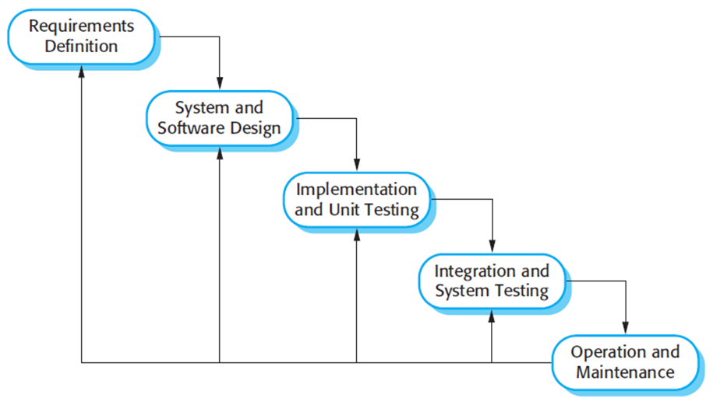

Figure 1 - Waterfall Model

Reference: Page 30, chapter 2, Software process model, SOFTWARE ENGINEERING 9th Edition, by Ian Sommerville.

### 2.2 Roles and Responsibilities

|  |  |  |  |
| --- | --- | --- | --- |
| **No** | **Full Name** | **Role** | **Responsibilities** |
| 1 | Lại Đức Hùng | Project manager | * Specify user requirement * Control development process * Give out technique and business analysis support |
| 2 | Nguyễn Thanh Tiến | Team leader, BA, Dev | * Managing process * Designing database * Clarifying requirements * Prepare document * Coding |
| 3 | Bùi Quang Nhật Châu | BA, Dev, Tester | * Coding * Clarifying requirements * Creating test plan * Testing |
| 4 | Nguyễn Huy Hoàng | BA, Designer, Tester | * Design GUI * Clarifying requirements * Design Diagram * Prepare document * Testing |
| 5 | Trịnh Thanh Hậu | BA , Dev, Tester | * Coding * Clarifying requirements * Prepare document * Testing |
| 6 | Đoàn Trọng Lam Điền | BA , Dev, Tester | * Coding * Prepare document * Clarifying requirements * Testing |

Table 4 - Role and Responsibilities

### 2.3 Tools and Techniques

|  |  |
| --- | --- |
| Tool/Technical | Name/Version |
| Front-end | HTML, CSS, VueJS |
| Back-end | NodeJS |

Table 5 - Tools and Techniques

We use VueJS framework, which has these great features:

* **Templates:** Vue uses an HTML-based template syntax that allows you to declaratively bind the rendered DOM to the underlying Vue instance’s data. All Vue templates are valid HTML that can be parsed by spec-compliant browsers and HTML parsers. Under the hood, Vue compiles the templates into virtual DOM render functions. Combined with the reactivity system, Vue is able to calculate the minimal number of components to re-render and apply the minimal amount of DOM manipulations when the app state changes. [1]
* **Reactivity:** One of Vue’s most distinctive features is the unobtrusive reactivity system. Models are just plain JavaScript objects. When you modify them, the view updates. It makes state management very simple and intuitive. Each component keeps track of its reactive dependencies during its render, so the system knows precisely when to re-render, and which components to re-render. [2]
* **Components:** Components are one of the most powerful features of Vue. In a large application, it is necessary to divide the whole app into small, self-contained, and often reusable components to make development manageable. Components extend basic HTML elements to encapsulate reusable code. [3]

## 3. Project management plan

### 3.1 Software development life cycle

|  |  |  |  |  |  |
| --- | --- | --- | --- | --- | --- |
| Phase | **Description** | **Deliverables** | **Resource needed** | **Dependencies and Constrains** | **Risk** |
| Requirements Definition | Identify and clarify system requirements. | Report No.1 Introduction. | 6 man-days | N/A | - Missing requirement.  - Project’s scope can be unclear.  - Lack of member share and understand. |
| System and Software Design | - Identify hardware and software requirements.  - Decide software architect and clarify software detail design.  - Design database. | Report No.2 Software Project Management Plan, Report No. 3 Software Requirement Specification and  Report No. 4 Software Design Description. | 5 man-days | Depend on Requirements Definition. | - Misunderstood or unclear system’s requirement.  - Lack of practical experience leading to unreasonable design. |
| Implementation and Unit Testing | - Implements all functions of the system.  - Create test plan.  - Perform Unit testing. | Software package. | 60 man-days | - Base on Software Requirement Specification and Software Design Description.  - Coding try to follow coding convention. | - Member does not perform unit test.  - Lack of practical experience. |
| Integration and System Testing | - Perform integration test and system test. | Report No. 5 System Implementation & Test | 30 man-days | Implementation and Unit Testing are finished. | - Lack of testing experience leading to lack of test cases.  - Not enough time for performing test. |
| Operation and Maintenance | - Deploy the system  - Create the user’s manuals.  - Do routine maintenance activities. | Report No.6 Software User’s Manual | 15 man-days | Integration and System Testing are finished. | User’s manual may be difficult for user to understand and confuse. |

Table 6 - Software development life cycle

### 3.2 Phase Detail

* + 1. Requirements Definition

|  |  |  |
| --- | --- | --- |
| Task | Description | Author |
| Identify and clarify system requirements. | Research current systems to collect requirements.  Define main and needed functions the system must include. | Nguyễn Thanh Tiến  Nguyễn Huy Hoàng  Bùi Quang Nhật Châu  Trịnh Thanh Hậu  Đoàn Trọng Lam Điền |

Table 7 - Requirements Definition

* + 1. System and Software Design

|  |  |  |
| --- | --- | --- |
| Task | Description | Author |
| Identify hardware and software requirements. | Find out the suitable hardware and software for the system, as well as its minimum and recommended requirements. | Nguyễn Thanh Tiến  Nguyễn Huy Hoàng  Bùi Quang Nhật Châu  Trịnh Thanh Hậu  Đoàn Trọng Lam Điền |
| Decide software architect and clarify software detail design. | Define the major software components and interfaces.  Draw core flow diagram, use case diagram, prototype …  Group meeting to review and modify. | Nguyễn Thanh Tiến  Nguyễn Huy Hoàng  Bùi Quang Nhật Châu  Trịnh Thanh Hậu  Đoàn Trọng Lam Điền |
| Design database. | Design database for the system. | Nguyễn Thanh Tiến  Nguyễn Huy Hoàng  Bùi Quang Nhật Châu  Trịnh Thanh Hậu  Đoàn Trọng Lam Điền |

Table 8 - System and Software Design

* + 1. Implementation and Unit Testing

|  |  |  |
| --- | --- | --- |
| Task | Description | Author |
| Implements all functions of the system. | Coding all the components. | Nguyễn Thanh Tiến  Nguyễn Huy Hoàng  Bùi Quang Nhật Châu  Trịnh Thanh Hậu  Đoàn Trọng Lam Điền |
| Create test plan. | Planning for testing. | Nguyễn Thanh Tiến  Nguyễn Huy Hoàng  Bùi Quang Nhật Châu  Trịnh Thanh Hậu  Đoàn Trọng Lam Điền |
| Perform Unit testing. | Write Unit test cases.  Implement Unit tests. | Nguyễn Thanh Tiến  Nguyễn Huy Hoàng  Bùi Quang Nhật Châu  Trịnh Thanh Hậu  Đoàn Trọng Lam Điền |

Table 9 - Implementation and Unit Testing

* + 1. Integration and System Testing

|  |  |  |
| --- | --- | --- |
| Task | Description | Author |
| Perform integration test and system test. | Test groups of modules and test whole the system. | Nguyễn Thanh Tiến  Nguyễn Huy Hoàng  Bùi Quang Nhật Châu  Trịnh Thanh Hậu  Đoàn Trọng Lam Điền |

Table 10 - Integration and System Testing

* + 1. Operation and Maintenance

|  |  |  |
| --- | --- | --- |
| Task | Description | Author |
| Deploy the system | Deploy the system in client environment. | Nguyễn Thanh Tiến  Nguyễn Huy Hoàng  Bùi Quang Nhật Châu  Trịnh Thanh Hậu  Đoàn Trọng Lam Điền |
| Create the user’s manuals. | Create a guideline to instruct users using system. | Nguyễn Thanh Tiến  Nguyễn Huy Hoàng  Bùi Quang Nhật Châu  Trịnh Thanh Hậu  Đoàn Trọng Lam Điền |
| Do routine maintenance activities. | Do routine maintenance activities for client system. | Nguyễn Thanh Tiến  Nguyễn Huy Hoàng  Bùi Quang Nhật Châu  Trịnh Thanh Hậu  Đoàn Trọng Lam Điền |

Table 11 - Operation and Maintenance

### 3.3 Meeting Minutes

All meeting documents could be found here:

https://trello.com/c/brnwa4sU/14-all-meeting-minutes

## 4. Convention Rules

NodeJS: Using to develop web API.

* Line length:Maximum line length is 80 characters.
* Indentation:Indent your code blocks with 4 spaces.
* Braces - “{“: opening on the same line.
* Whitespace:Put a single space in front of “(“for anything other than a function call. Also use a single space wherever it makes things more readable.
* Constant names should be all uppercase with words separated by underscore.
* Comments:Use // for both single line and multi-line comments.
* Class name:should be capitalized using UpperCamelCase.
* Variables, properties and function names should use lowerCamelCase.
* Imports formatting:Imports should be on separate lines.
* Statements:Generally, only one statement per line.

# C. Software Requirement Specification

## 1. User Requirement Specification

### 1.1 Unauthorized User Requirement

Unauthorized User can use a function in the system. Unauthorized User must be registered for an account and login to use some functions. Unauthorized User has this following ability:

* Login

### 1.2 Admin Requirement

Admin can manage account, view equipment, view schedule, view work order, edit the configuration, and edit profile.

* View Schedule
* View Work Order
* View Equipment
* View Location
* Edit Profile
* Edit Configuration
* Manage Account
* Log out

### 1.3 Manager Requirement

The manager is responsible for checking the equipment proposal to allocate if it meets the needs of use and confirming the request, managing location. Moreover, the manager can view work order, team, equipment and schedule.

* View Work Order
* View Equipment
* View Schedule
* View Location
* Approve Work Order
* Reject Work Order
* Manage Location
* Manage Team
* Edit Profile
* Log out

### 1.4 Maintainer Requirement

The maintainer is responsible for the practical repair and manages work order.

* View Scheduler
* View Work Order
* View Equipment
* View Location
* Edit Maintenance Order
* Edit Profile
* Create Maintenance Order
* Log out

### 1.5 Equipment Staff Requirement

The equipment staff is responsible for manage equipment, view location, close work order, check equipment in work order and deliver items in work order.

* View Scheduler
* View Work Order
* View Equipment
* Manage Equipment
* Manage Vendor
* Manage Unit
* Manage Maintenance Duration
* View Location
* Edit Profile
* Close Work Order
* Check Work Order
* Deliver Work Order
* Log out

### 1.6 Team Leader Requirement

The team leader is responsible for create working order, edit working order.

* View Scheduler
* View Work Order
* View Equipment
* Edit Working Order
* View Location
* Edit Profile
* Create Working Order
* Log out

## 2. System Requirement Specification

### 2.1 External Interface Requirement

#### 2.1.1 User Interface

* The user interface must be friendly and easy to use.
* The website must be responsive, suitable for all devices such as a laptop, tablet or smartphone.
* All functions are arranged and displayed clearly.
* The interface design is an iterated process includes design, sketching and user assessment.

#### 2.1.2 Hardware Interface

* The system will use the standard hardware and data communications resources of a standard computer.
* Desktop, laptop, smartphone or tablet has the ability to connect to the Internet.

#### 2.1.3 Software Interface

* The website work with Chrome (v25 or above), Firefox (v46.1) and Safari (v4 or above).



#### 2.1.4 Communication Protocol

* Use the HTTP protocol for communication between web browser and web server.

### 2.2 System Overview Use Case

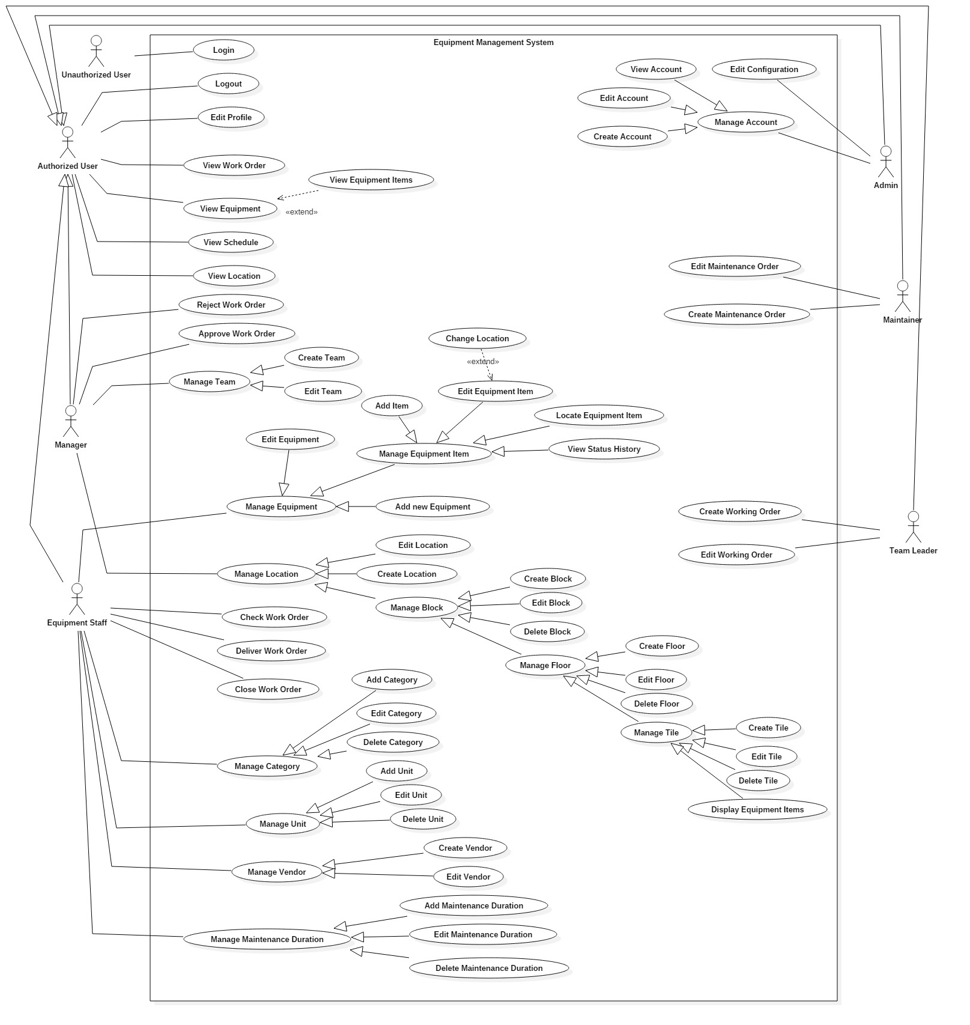

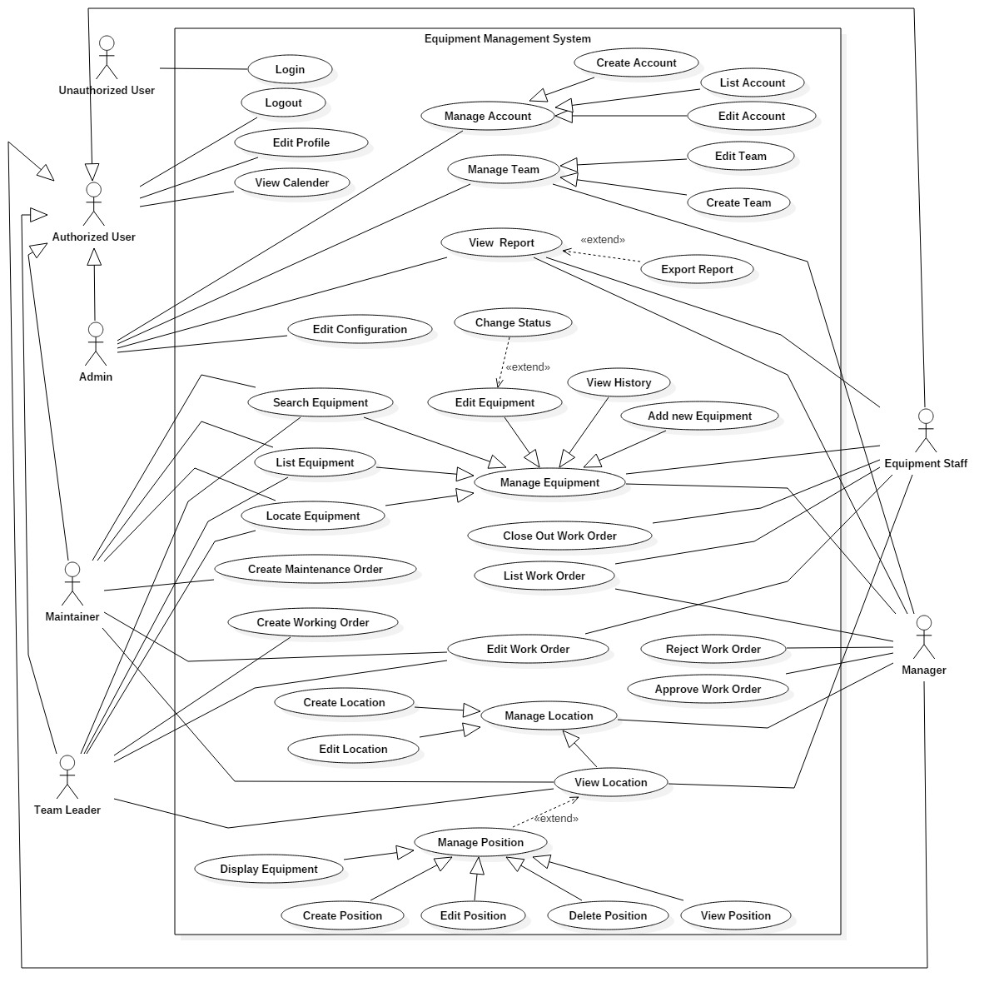

Figure 2 - System Overview Use Case

### 2.3 List of Use Case

#### 2.3.1 < Unauthorized User>Overview Use Case

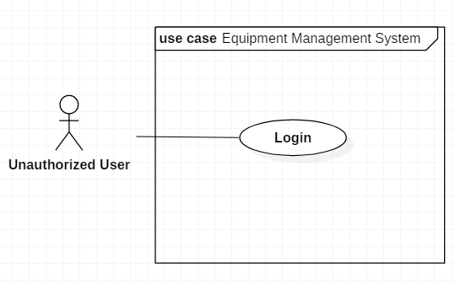

Figure 3 - < Unauthorized User>Overview Use Case

##### 2.3.1.1< Unauthorized User> Login

Use Case Diagram



Figure 4 - < Unauthorized User> Login

Use Case Specification

|  |  |  |  |
| --- | --- | --- | --- |
| **USE CASE - UC_01** | | | |
| **Use Case No.** | 01 | **Use Case Version** | 2.0 |
| **Use Case Name** | Login | | |
| **Author** | Nguyễn Huy Hoàng | | |
| **Date** | 08/06/2018 | **Priority** | Normal |
| **Actor:**   * Unauthorized User   **Summary:**   * This use case allows Unauthorized User to login in the system.   **Goal:**   * User logged in the system.   **Triggers:**   * User clicks “Login” button.   **Preconditions:**   * User at “Login” page.   **Post Conditions:**   * **Success:** User login into system. * **Fail:** Systemshows error message.   **Main Success Scenario:**   |  |  |  | | --- | --- | --- | | Step | Actor Action | System Response | | 1 | User goes to Login page by clicking “Login”. | System requires information:   * Username: text input. * Password: text input with least 6 characters. | | 2 | User inputs information (Username and password)  User clicks “Login” button.  [Alternative 1] | User will login the system with roles of this account.  [Exception 1,2,3,4,5] |   **Alternative:**   |  |  |  | | --- | --- | --- | | Step | Actor action | System Response | | 1 | User clicks “Remember password” checkbox. | System will direct to Home Page next login time. |   **Exceptions:**   |  |  |  | | --- | --- | --- | | No | Cause | System Response | | 1 | Username is empty. | Show error message. | | 2 | Password is empty. | Show error message. | | 3 | Username is not correct | Show error message. | | 4 | Password is not correct. | Show error message. | | 5 | Network problem exception. | Show message “Error! Try again!” |   **Relationships:**  N/A  **Business Rules:**   * After logged in, system will redirect to dashboard page. | | | |

Table 12 - Login specification

#### 2.3.2 < Authorized User>Overview Use Case

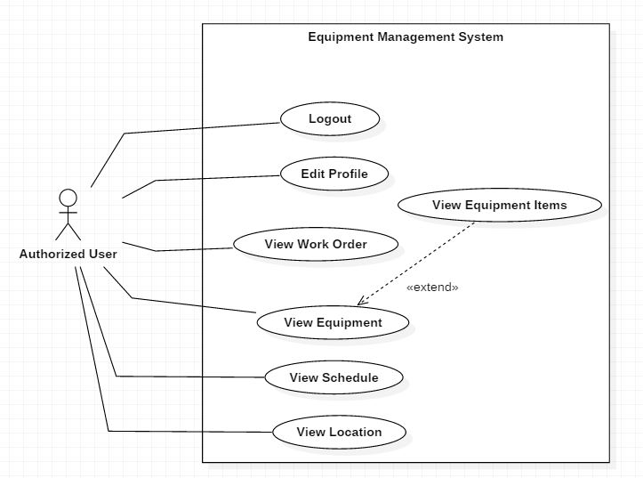

Figure 5 - < Authorized User>Overview Use Case

##### 2.3.2.1< Authorized User> Logout

Use Case Diagram

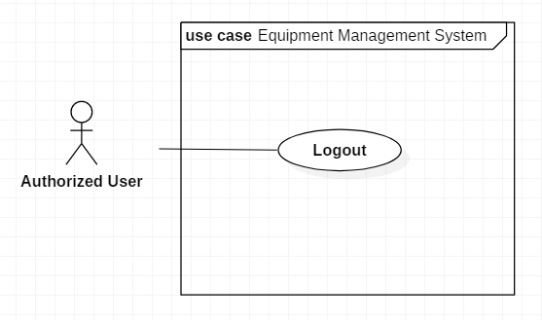

Figure 6 - < Authorized User> Logout

Use Case Specification

|  |  |  |  |
| --- | --- | --- | --- |
| **USE CASE - UC_02** | | | |
| **Use Case No.** | 02 | **Use Case Version** | 2.0 |
| **Use Case Name** | Logout | | |
| **Author** | Nguyễn Huy Hoàng | | |
| **Date** | 08/06/2018 | **Priority** | Normal |
| **Actor:**   * Authorized user.   **Summary:**   * This use case allows user to leave of the system.   **Goal:**   * User goes out of the system.   **Triggers:**   * User send the command do logout.   **Preconditions:**   * User must have logged in system.   **Post Conditions:**   * **Success:** User logged out. * **Fail:** Systemshows error message.   **Main Success Scenario:**   |  |  |  | | --- | --- | --- | | Step | Actor Action | System Response | | 1 | User clicks on Profile picture. | Show “Logout” button. | | 2 | User clicks on “Logout” button. | Return to Login page.  [Exception 1] |   **Alternative: N/A**  **Exceptions:**   |  |  |  | | --- | --- | --- | | No | Cause | System Response | | 1 | Network problem exception. | Show message “Error! Try again!” |   **Relationships:**  N/A.  **Business Rules:** N/A. | | | |

Table 13 - Logout specification

##### 2.3.2.2< Authorized User> Edit Profile

Use Case Diagram

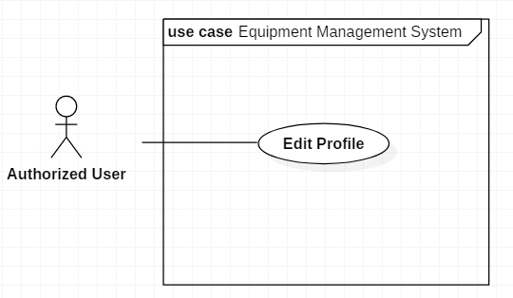

Figure 7 - < Authorized User> Edit Profile

Use Case Specification

|  |  |  |  |
| --- | --- | --- | --- |
| **USE CASE - UC_03** | | | |
| **Use Case No.** | 03 | **Use Case Version** | 2.0 |
| **Use Case Name** | Edit Profile | | |
| **Author** | Nguyễn Huy Hoàng | | |
| **Date** | 08/06/2018 | **Priority** | Normal |
| **Actor:**   * Authorized user.   **Summary:**   * This use case allows authorized user to edit profile’s information.   **Goal:**   * Edit profile’s information.   **Triggers:**   * User clicks on edit icon.   **Preconditions:**   * User must have logged in system.   **Post Conditions:**   * **Success:** Account is updated successfully, and system displays the user profile page. * **Fail:** Show error message.   **Main Success Scenario:**   |  |  |  | | --- | --- | --- | | Step | Actor Action | System Response | | 1 | User clicks on Profile picture. | Show “Edit Profile” button. | | 2 | User clicks on “Edit Profile” button. | Show edit form:   * Full name: Text Input * Phone: Text Input * Email: Text Input * Current Password: Text Input * New Password: Text Input * Confirm Password: Text Input * Profile Picture: Image selector | | 3 | User input all require field. Then click button “Save changes”.  [Alternative] | Show success message. Show profile’s information.  [Exception 1,2] |   **Alternative 1:**   |  |  |  | | --- | --- | --- | | Step | Actor Action | System Response | | 1 | User clicks button “Close”. | Close edit form |   **Exceptions:**   |  |  |  | | --- | --- | --- | | No | Cause | System Response | | 1 | User does not input required fields. | System notices that user need to input all these field:   * “Full name”: System displays warning message: “Use from 6 to 50 characters for your full name”. * “Phone”: System displays warning message: “Use from 9 to 13 characters for your phone number”. * “Email”: System displays warning message: “Enter your email”. * “New Password”: System displays warning message: “Use from 6 to 50 characters for your new password”. * “Confirm Password”: System displays warning message: “Use from 6 to 50 characters for confirm password”. | | 2 | Network problem exception. | Show message “Error! Try again!” |   **Relationships:** N/A.  **Business Rules:**   * User already logged in the system. * If user wants to update password, he/she has to enter correct current password, and confirm password. * User can update Full name, Phone, Email, Profile Picture without enter current password. * Full name is not null and in range of 6-250 characters. * Phone is not null and in range of 10-17 characters. * Email is not null and maximum is 250 characters. * Password must be in rage of 6-50 characters. | | | |

Table 14 - Edit Profile specification

##### 2.3.2.3< Authorized User> View Schedule

Use Case Diagram

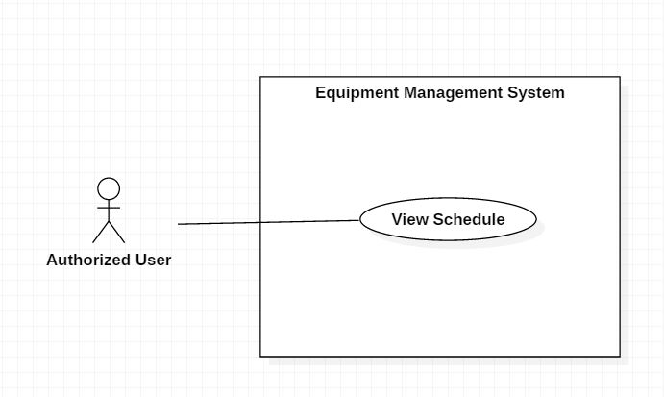

Figure 8 - < Authorized User> View Schedule

Use Case Specification

|  |  |  |  |
| --- | --- | --- | --- |
| **USE CASE - UC_04** | | | |
| **Use Case No.** | 04 | **Use Case Version** | 2.0 |
| **Use Case Name** | View Schedule | | |
| **Author** | Nguyễn Huy Hoàng | | |
| **Date** | 11/06/2018 | **Priority** | Normal |
| **Actor:**   * Authorized user   **Summary:**   * This use case allows user to view schedule of work order that they are following.   **Goal:**   * View schedule of work order that they are following.   **Triggers:**   * User clicks “Schedule” tab.   **Preconditions:**   * Actor login successfully with Authorized user role.   **Post Conditions:**   * **Success:** Show schedule of work order that they are following. * **Fail:** Show error message.   **Main Success Scenario:**   |  |  |  | | --- | --- | --- | | Step | Actor Action | System Response | | 1 | User clicks on “Schedule” tab | Show schedule of work order that they are following.  The system displays the schedule as a Gantt chart with:   * Work Order Name * Start Date * Estimated completion date   [Exception 1] |   **Exceptions:**   |  |  |  | | --- | --- | --- | | No | Cause | System Response | | 1 | Network problem exception. | Show message “Error! Try again!” |   **Relationships:** N/A  **Business Rules:**  Depends on the role, the system will display different schedules.   * If logged account as “Team Leader”, “Maintainer” role, the system only shows the schedule of work orders that created by them. * If logged account as “Equipment Staff”, “Admin” or “Manager” role, the system shows the schedule of all work orders. | | | |

Table 15 - View Schedule specification

##### 2.3.2.4< Authorized User> View Work Order

Use Case Diagram

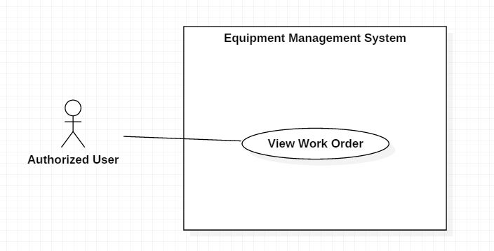

Figure 9 - < Authorized User> View Work Order

Use Case Specification

|  |  |  |  |
| --- | --- | --- | --- |
| **USE CASE - UC_04** | | | |
| **Use Case No.** | 04 | **Use Case Version** | 2.0 |
| **Use Case Name** | View Work Order | | |
| **Author** | Bùi Quang Nhật Châu | | |
| **Date** | 17/06/2018 | **Priority** | Normal |
| **Actor:**   * Authorized User   **Summary:**   * This use case allows user to view work orders that created by them.   **Goal:**   * List of work orders will be displayed.   **Triggers:**   * User clicks on “Work Order” tab.   **Preconditions:**   * User must be login to the system.   **Post Conditions:**   * **Success:** System shows list of work order. * **Fail:** System shows “Error!” message.   **Main Success Scenario:**   |  |  |  | | --- | --- | --- | | Step | Actor Action | System Response | | 1 | User clicks on “Work Order” tab. | System displays page which include:   * Work Order’s Name * Priority * Requested User * Created Date * Status * Location   [Exception 1] |   **Alternative:** N/A  **Exceptions:**   |  |  |  | | --- | --- | --- | | No | Cause | System Response | | 1 | System List work order fail | System shows “Error!” message. |   **Relationships:**  N/A  **Business Rules:**  Depends on the role, the system will display different work orders.   * If logged account as “Team Leader”, “Maintainer” role, the system only shows the list of orders that created by them. * If logged account as “Equipment Staff”, “Admin” or “Manager” role, the system shows the list of all work orders. | | | |

Table 16 - View Work Order specification

##### 2.3.2.5< Authorized User> View Equipment

Use Case Diagram

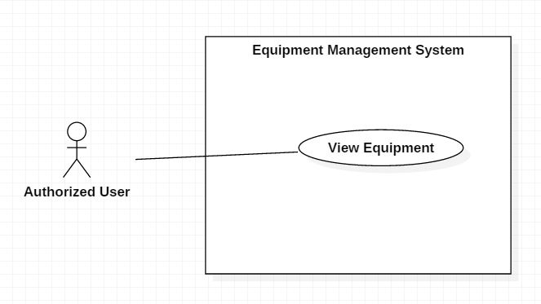

Figure 10 - < Authorized User> View Equipment

Use Case Specification

|  |  |  |  |
| --- | --- | --- | --- |
| **USE CASE - UC_05** | | | |
| **Use Case No.** | 05 | **Use Case Version** | 2.0 |
| **Use Case Name** | View Equipment | | |
| **Author** | Nguyễn Thanh Tiến | | |
| **Date** | 17/06/2018 | **Priority** | Normal |
| **Actor:**   * Authorized User   **Summary:**   * This use case allows user to view list of equipment.   **Goal:**   * List of equipment will be displayed.   **Triggers:**   * User clicks on “Equipment” tab.   **Preconditions:**   * User must be login to the system.   **Post Conditions:**   * **Success:** System shows list of equipment. * **Fail:** System shows “Error!” message.   **Main Success Scenario:**   |  |  |  | | --- | --- | --- | | Step | Actor Action | System Response | | 1 | User clicks on “Equipment” tab. | System displays page which include:   * Equipment Name * Available * Vendor Name * Status * Category * Description   [Exception 1] |   **Alternative:** N/A  **Exceptions:**   |  |  |  | | --- | --- | --- | | No | Cause | System Response | | 1 | System list equipment fail | System shows “Error!” message. |   **Relationships:**  N/A  **Business Rules:**   * The equipment list will be displayed by the “Equipment Name” from a-z. * For the "Available" column, the number of available equipment items must be displayed on the total number of items owned by that equipment. | | | |

Table 17 - View Equipment specification

##### 2.3.2.6< Authorized User> View Equipment Items

Use Case Diagram

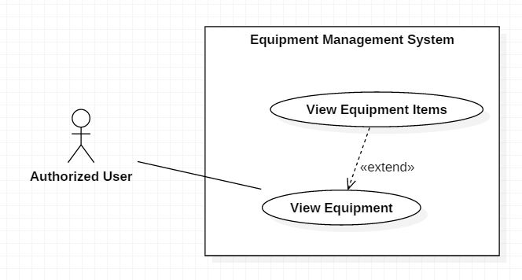

Figure 11 - < Authorized User> View Equipment Items

Use Case Specification

|  |  |  |  |
| --- | --- | --- | --- |
| **USE CASE - UC_06** | | | |
| **Use Case No.** | 06 | **Use Case Version** | 2.0 |
| **Use Case Name** | View Equipment Item | | |
| **Author** | Nguyễn Thanh Tiến | | |
| **Date** | 17/06/2018 | **Priority** | Normal |
| **Actor:**   * Authorized User   **Summary:**   * This use case allows user to view list of equipment items.   **Goal:**   * List of equipment items will be displayed.   **Triggers:**   * User clicks on the equipment's row that wants to view equipment items.   **Preconditions:**   * User at “Equipment” page.   **Post Conditions:**   * **Success:** System shows list of equipment items. * **Fail:** System shows “Error!” message.   **Main Success Scenario:**   |  |  |  | | --- | --- | --- | | Step | Actor Action | System Response | | 1 | User clicks on the equipment's row that wants to view equipment items. | System displays page which include:  Equipment’s Information:   * Equipment Name * Vendor * Quantity * Status * Category * Unit * Image * Description   Equipment Items Information:   * Serial Number * Imported Date * Warranty * Runtime Days * Last-Maintenance Date * Next-Maintenance Date * Status * Description   [Exception 1] |   **Alternative:** N/A  **Exceptions:**   |  |  |  | | --- | --- | --- | | No | Cause | System Response | | 1 | System list equipment fail | System shows “Error!” message. |   **Relationships:**   * Extend from: View Equipment   **Business Rules:**   * List of equipment items will be displayed by the "Serial Number" ascending. | | | |

Table 18 - View Equipment Items specification

##### 2.3.2.7< Authorized User> View Location

Use Case Diagram

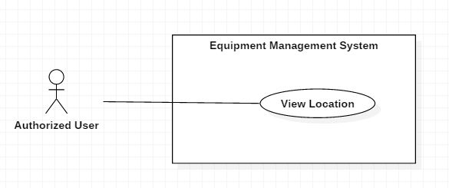

Figure 12 - < Authorized User> View Location

Use Case Specification

|  |  |  |  |
| --- | --- | --- | --- |
| **USE CASE - UC_29** | | | |
| **Use Case No.** | 29 | **Use Case Version** | 2.0 |
| **Use Case Name** | View Location | | |
| **Author** | Trịnh Thanh Hậu | | |
| **Date** | 11/06/2018 | **Priority** | Normal |
| **Actor:**   * Authorized user   **Summary:**   * This use case allows user to view locations that they are following.   **Goal:**   * View location they are following.   **Triggers:**   * User clicks “Location” tab.   **Preconditions:**   * Actor login successfully with Authorized user role.   **Post Conditions:**   * **Success:** Show locations that they are following. * **Fail:** Show error message.   **Main Success Scenario:**   |  |  |  | | --- | --- | --- | | Step | Actor Action | System Response | | 1 | User clicks on “Location” tab | Show locations that they are following.   * Name * Address * Status * Maps   [Exception 1] |   **Exceptions:**   |  |  |  | | --- | --- | --- | | No | Cause | System Response | | 1 | Network problem exception. | Show message “Error! Try again!” |   **Relationships:** N/A  **Business Rules:**  Depends on the role, the system will display different locations.   * If logged account as “Team Leader”, “Maintainer” role, the system only show locations that they are following, working. * If logged account as “Equipment Staff”, “Admin” or “Manager” role, the system show all locations in the system. | | | |

Table 19 - View Location specification

#### 2.3.3 < Admin>Overview Use Case

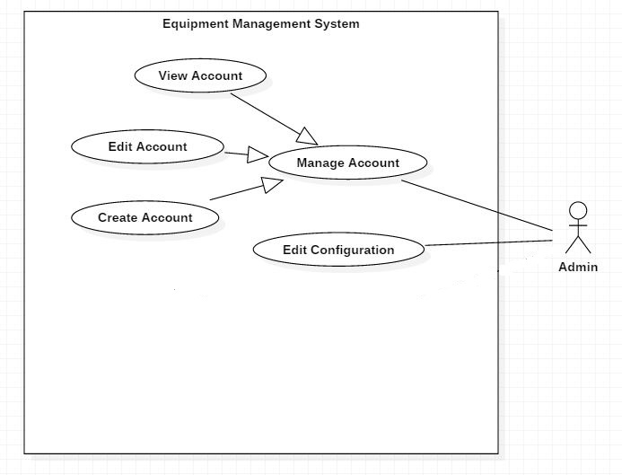

Figure 13 - < Admin>Overview Use Case

##### 2.3.3.3< Admin> Create Account

Use Case Diagram

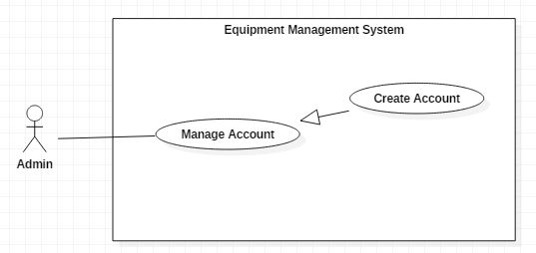

Figure 14 - < Admin> Create Account

Use Case Specification

|  |  |  |  |
| --- | --- | --- | --- |
| **USE CASE - UC_09** | | | |
| **Use Case No** | 09 | **Use Case Version** | 2.0 |
| **Use Case Name** | Create account | | |
| **Author** | Đoàn Trọng Lam Điền | | |
| **Date** | 02/06/2018 | **Priority** | Normal |
| **Actor:**   * Admin   **Summary:**   * This use case allows Admin to create a new account in the system.   **Goal:**   * A new account created successfully.   **Triggers:**   * Admin clicks on “Add account” button.   **Preconditions:**   * Authenticated user must be login to the system with Admin role.   **Post Conditions:**   * **Success:** System shows “Add new account success!” message. * **Fail:** System shows error messages.   **Main Success Scenario:**   |  |  |  | | --- | --- | --- | | Step | Actor Action | System Response | | 1 | Admin clicks on “Add account”. | The system requests information in form:   * Username: Text input. * Password: Text input. * Full Name: Text input. * Email: Text input. * Role: Select option. * Phone: Text input. * Status: Radio Button | | 2 | Admin clicks on “Add Account” button | System shows “Add new account success!” message.  [Exception 1] |   **Alternative:**   |  |  |  | | --- | --- | --- | | Step | Actor Action | System Response | | 1 | Admin clicks button “Cancel”. | Close this form |   **Exceptions:**   |  |  |  | | --- | --- | --- | | No | Cause | System Response | | 1 | Admin created fail | System shows “Add new account failed!” message. |   **Relationships:**  N/A  **Business Rules:**   * The information is encrypted and sent to the server. * After create account success. Admin will return to the “Account” page. * Username is not null and in range of 6-50 characters. * Password is not null and in range of 6-50 characters. * Full name is not null and in range of 6-250 characters. * Email is not null and maximum is 250 characters. * Role is not null. * Phone is not null and in range of 10-17 characters. * Status is automatically set to "Active". * Drop-down fields should have the first entry as blank or text like ‘Select a role’. | | | |

Table 20 - Create Account specification

##### 2.3.3.4< Admin> Edit Account

Use Case Diagram

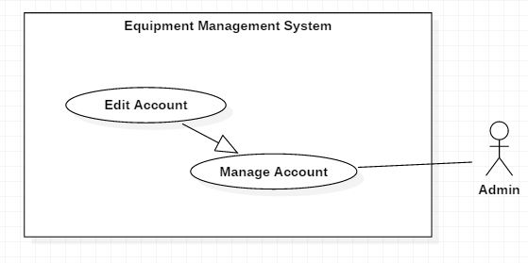

Figure 15 - < Admin> Edit Account

Use Case Specification

|  |  |  |  |
| --- | --- | --- | --- |
| **USE CASE - UC_10** | | | |
| **Use Case No.** | 10 | **Use Case Version** | 2.0 |
| **Use Case Name** | Edit account | | |
| **Author** | Đoàn Trọng Lam Điền | | |
| **Date** | 11/06/2018 | **Priority** | Normal |
| **Actor:**   * Admin   **Summary:**   * This use case allows Admin to update information of account in the system.   **Goal:**   * Information of account was changed.   **Triggers:**   * Admin clicks on the team's row that wants to edit team information. * Admin clicks on “Edit Account” button.   **Preconditions:**   * User must be login to the system with Admin role. * User at “Account” page.   **Post Conditions:**   * **Success:** System shows “Update successfully!” message. * **Fail:** System shows “Update fail!” message.   **Main Success Scenario:**   |  |  |  | | --- | --- | --- | | Step | Actor Action | System Response | | 1 | Admin clicks “Edit Account” button. | The system requests information in form:   * Full Name: Text input. * Password: Text input * Email: Text input. * Role: Select option. * Phone: Text input. * Status: Radio Button | | 2 | Admin inputs information. Admin clicks on “OK” button. | System validates the information and shows confirmation message. | | 3 | Admin clicks on “YES” button | System shows “Update successfully!” message. |   **Alternative:**   |  |  |  | | --- | --- | --- | | Step | Actor Action | System Response | | 1 | Admin clicks button “Cancel”. | Close edit form |   **Exceptions:**   |  |  |  | | --- | --- | --- | | No | Cause | System Response | | 1 | System Updates account fail | System shows “Update fail!” message. |   **Relationships:**  N/A  **Business Rules:**   * Password is not null and in range of 6-50 characters. * Full name is not null and in range of 6-250 characters. * Email is not null maximum is 250 characters. * Role is not null. * Phone is not null and in range of 10-17 characters. * Drop-down fields should have the first entry as blank or text like ‘Select a role’. | | | |

Table 21 - Edit Account specification

##### 2.3.3.5< Admin> View Account

Use Case Diagram

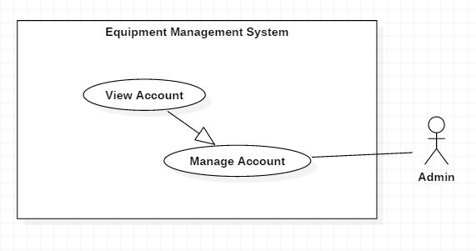

Figure 16 - < Admin> View Account

Use Case Specification

|  |  |  |  |
| --- | --- | --- | --- |
| **USE CASE - UC_11** | | | |
| **Use Case No.** | 11 | **Use Case Version** | 2.0 |
| **Use Case Name** | View account | | |
| **Author** | Đoàn Trọng Lam Điền | | |
| **Date** | 17/06/2018 | **Priority** | Normal |
| **Actor:**   * Admin   **Summary:**   * This use case allows Admin to view account in the system.   **Goal:**   * List of accounts will be displayed.   **Triggers:**   * Admin clicks on “Account & Team” tab.   **Preconditions:**   * User must be login to the system with Admin role.   **Post Conditions:**   * **Success:** System shows list of accounts. * **Fail:** System shows “Error!” message.   **Main Success Scenario:**   |  |  |  | | --- | --- | --- | | Step | Actor Action | System Response | | 1 | Admin clicks “Account & Team” tab. | List accounts will be displayed.  System displays page which include:   * Username * Full name * Email * Phone * Status * Role |   **Alternative:** N/A  **Exceptions:**   |  |  |  | | --- | --- | --- | | No | Cause | System Response | | 1 | System View accounts fail | System shows “Error!” message. |   **Relationships:**  N/A  **Business Rules:**   * The account list will be displayed by the “Username” from a-z. * The account list will be displayed by the “Status” from “Active” to “Inactive” | | | |

Table 22 - View Account specification

#### 2.3.4 < Equipment Staff>Overview Use Case

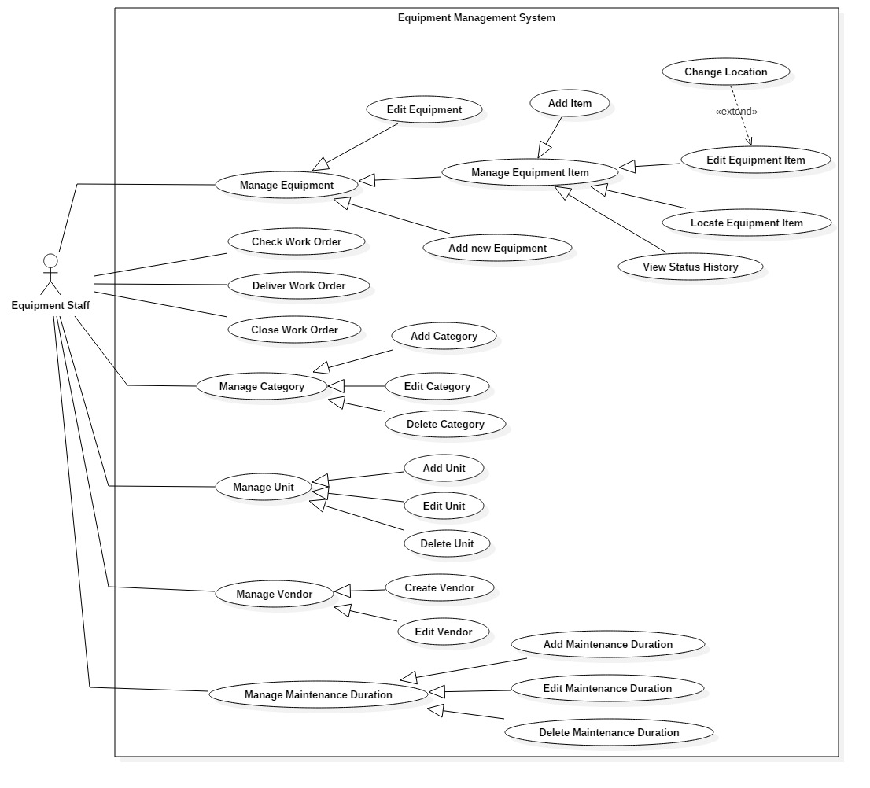

Figure 17 - < Equipment Staff>Overview Use Case

##### 2.3.4.1< Equipment Staff> View Status History

Use Case Diagram

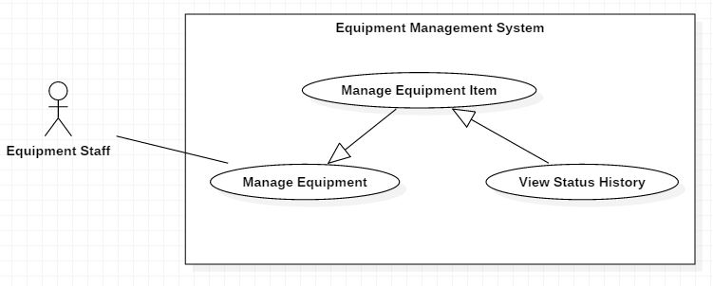

Figure 18 - < Equipment Staff> View Status History

Use Case Specification

|  |  |  |  |
| --- | --- | --- | --- |
| **USE CASE - UC_12** | | | |
| **Use Case No.** | 12 | **Use Case Version** | 2.0 |
| **Use Case Name** | View Status History | | |
| **Author** | Nguyễn Thanh Tiến | | |
| **Date** | 11/06/2018 | **Priority** | Normal |
| **Actor:**   * Equipment Staff   **Summary:**   * This use case allows equipment staff to view equipment’s status history.   **Goal:**   * View the history of equipment’s status.   **Triggers:**   * User click “Status” tab on Equipment Detail page.   **Preconditions:**   * User login successfully with Equipment Staff role.   **Post Conditions:**   * **Success:** Show equipment’s status history. * **Fail:** Show error message.   **Main Success Scenario:**   |  |  |  | | --- | --- | --- | | Step | Actor Action | System Response | | 1 | User go to equipment detail page | Show equipment page  [Exception 1] | | 2 | User clicks on Equipment Item’s row that want to view status history | System displays popup with 5 tabs:   * Details * Status * Work Order * Position * Run-time Days | | 3 | User click on “Status” tab | System displays page which include:   * Current Status * Status Change History * From * To * By User * Description |   **Exceptions:**   |  |  |  | | --- | --- | --- | | No | Cause | System Response | | 1 | Network problem exception. | Show message “Error! Try again!” |   **Relationships:** Extend from Manage Equipment Item use case.  **Business Rules:** N/A | | | |

Table 23 - View Status History specification

##### 2.3.4.2< Equipment Staff> Locate Equipment Item

Use Case Diagram

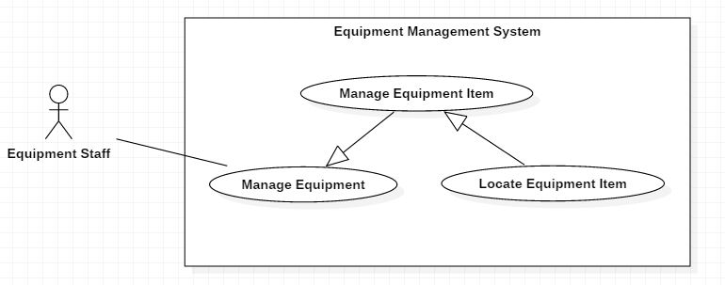

Figure 19 - < Equipment Staff> Locate Equipment Item

Use Case Specification

|  |  |  |  |
| --- | --- | --- | --- |
| **USE CASE - UC_13** | | | |
| **Use Case No.** | 13 | **Use Case Version** | 2.0 |
| **Use Case Name** | Locate Equipment Item | | |
| **Author** | Nguyễn Thanh Tiến | | |
| **Date** | 11/06/2018 | **Priority** | Normal |
| **Actor:**   * Equipment Staff   **Summary:**   * This use case allows equipment staff to view equipment’s position.   **Goal:**   * View the location of equipment that they are choosing.   **Triggers:**   * User clicks “Position” tab on Equipment Detail page.   **Preconditions:**   * User logins successfully with Equipment Staff role.   **Post Conditions:**   * **Success:** Show equipment’s position. * **Fail:** Show error message.   **Main Success Scenario:**   |  |  |  | | --- | --- | --- | | Step | Actor Action | System Response | | 1 | Equipment Staff goes to equipment item page | Show equipment page  [Exception 1] | | 2 | Equipment Staff clicks on Equipment Item’s row that want to locate position | System displays popup with 5 tabs:   * Details * Status * Work Order * Position * Run-time Days | | 3 | Equipment Staff click on “Position” tab | Show the equipment’s position.   * Location Name * Address * Block * Floor * Tile |   **Exceptions:**   |  |  |  | | --- | --- | --- | | No | Cause | System Response | | 1 | Network problem exception. | Show message “Error! Try again!” |   **Relationships:** Extend from Manage Equipment Item use case.  **Business Rules:** N/A | | | |

Table 24 - Locate Equipment Items

##### 2.3.4.3< Equipment Staff> Create Vendor

Use Case Diagram

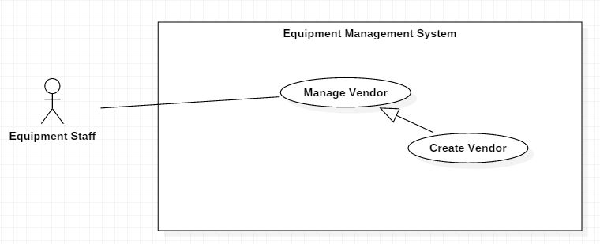

Figure 20 - < Equipment Staff> Create Vendor

Use Case Specification

|  |  |  |  |
| --- | --- | --- | --- |
| **USE CASE - UC_14** | | | |
| **Use Case No.** | 14 | **Use Case Version** | 2.0 |
| **Use Case Name** | Create Vendor | | |
| **Author** | Nguyễn Huy Hoàng | | |
| **Date** | 08/06/2018 | **Priority** | Normal |
| **Actor:**   * Equipment Staff   **Summary:**   * This use case allows user to create a vendor in the system.   **Goal:**   * A new vendor created successfully.   **Triggers:**   * Equipment Staff clicks on “Add Vendor” button.   **Preconditions:**   * Authenticated user must be login to the system with Equipment Staff role. * User at “Vendor” page.   **Post Conditions:**   * **Success:** System shows “Add new vendor successfully!” message. * **Fail:** System shows error messages.   **Main Success Scenario:**   |  |  |  | | --- | --- | --- | | Step | Actor Action | System Response | | 1 | Equipment Staff clicks on “Add Vendor”. | The system requests information in form:   * Business Name: text input * Business Address: text input * Contact Name: text input * Email: text input * Phone: text input * Description: text input | | 2 | Equipment Staff inputs information. Equipment Staff clicks on “Create Vendor” button. | System validates the information and shows “Add new vendor successfully!” message. |   **Alternative Scenario:**   |  |  |  | | --- | --- | --- | | Step | Actor Action | System Response | | 1 | Equipment Staff clicks button “Cancel”. | Close add form |   **Exceptions:**   |  |  |  | | --- | --- | --- | | No | Cause | System Response | | 1 | Network problem exception. | Show message “Error! Try again”. |   **Relationships:** N/A  **Business Rules:**   * Business Name is not null and in range of 6-250 characters. * Business Address is not null and in range of 6-250 characters. * Contact Name is not null and in range of 6-50 characters. * Email is not null and maximum is 250 characters. * Phone is not null and in range of 10-17 characters. | | | |

Table 25 - Create Vendor specification

##### 2.3.4.4< Equipment Staff> Add New Equipment

Use Case Diagram

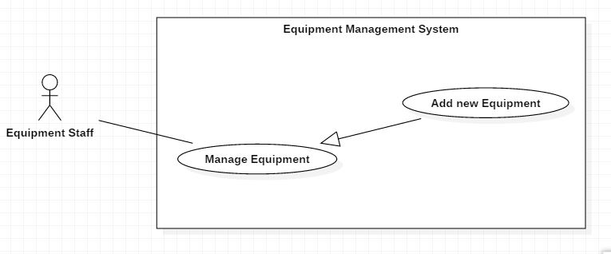

Figure 21 - < Equipment Staff> Add New Equipment

Use Case Specification

|  |  |  |  |
| --- | --- | --- | --- |
| **USE CASE - UC_15** | | | |
| **Use Case No.** | 15 | **Use Case Version** | 2.0 |
| **Use Case Name** | Add New Equipment | | |
| **Author** | Nguyễn Huy Hoàng | | |
| **Date** | 08/06/2018 | **Priority** | Normal |
| **Actor:**   * Equipment Staff   **Summary:**   * This use case allows equipment staff to create new equipment.   **Goal:**   * Equipment Staff create new equipment.   **Triggers:**   * Equipment Staff clicks on “Add New Equipment” button.   **Preconditions:**   * User login successfully with Equipment Staff role. * User at “Equipment” page.   **Post Conditions:**   * **Success:** New equipment is created. * **Fail:** Show error message.   **Main Success Scenario:**   |  |  |  | | --- | --- | --- | | Step | Actor Action | System Response | | 1 | Equipment Staff goes to “Equipment” page. | Show list of all equipment. | | 2 | Equipment Staff click on “Add Equipment” button. | The system requests information in form:   * Equipment Name: text input * Picture: Image choose * Category: Dropdown list * Vendor: Dropdown list * Maintenance Duration: Dropdown list * Unit: Dropdown list * Made In: Text input * Description: Text input | | 3 | Equipment Staff clicks “Create New Equipment” button.  [Alternative 1] | Add new equipment. Show success message. Show new equipment in list.  [Exception 1,2,3] |   **Alternative 1:**   |  |  |  | | --- | --- | --- | | Step | Actor Action | System Response | | 1 | Equipment Staff clicks button “Cancel”. | Return to “Equipment” page. |   **Exceptions:**  [Exception 1]   |  |  |  | | --- | --- | --- | | No | Cause | System Response | | 1 | “Name” is empty | Show error message: “Please fill out this field”. | | 2 | “Vendor” is empty | Show error message: “Please fill out this field”. | | 3 | “Unit” is empty | Show error message: “Please fill out this field”. | | 4 | “Category” is empty | Show error message: “Please choose category”. |   [Exception 2]   |  |  |  | | --- | --- | --- | | No | Cause | System Response | | 1 | “Maintenance Duration” is not in valid format. | Show error message: “Please enter an integer”. |   [Exception 3]   |  |  |  | | --- | --- | --- | | No | Cause | System Response | | 1 | Network problem exception. | Show message “Error! Try again”. |   **Relationships:** N/A.  **Business Rules:**   * Equipment Name is not null and in range of 5-250 characters. * Category, Maintenance Duration, Unit, Vendor are not null. * Drop-down fields should have the first entry as blank or text like ‘Select’. | | | |

Table 26 - Add New Equipment specification

##### 2.3.4.5< Equipment Staff> Edit Vendor

Use Case Diagram

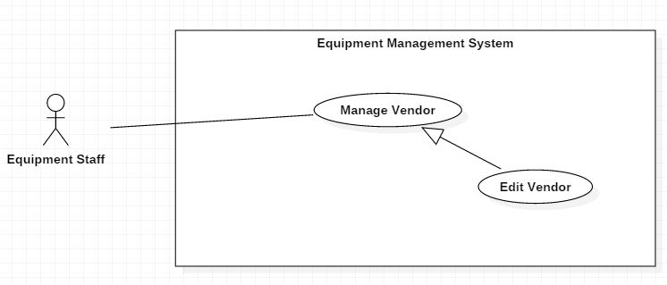

Figure 22 - < Equipment Staff> Edit Vendor

Use Case Specification

|  |  |  |  |
| --- | --- | --- | --- |
| **USE CASE - UC_16** | | | |
| **Use Case No.** | 16 | **Use Case Version** | 2.0 |
| **Use Case Name** | Edit Vendor | | |
| **Author** | Đoàn Trọng Lam Điền | | |
| **Date** | 17/06/2018 | **Priority** | Normal |
| **Actor:**   * Equipment Staff   **Summary:**   * This use case allows Equipment Staff to edit vendor’s information.   **Goal:**   * Information of vendor was changed.   **Triggers:**   * Equipment Staff clicks on the vendor's row that wants to edit vendor information. * Equipment Staff clicks on “Edit” button.   **Preconditions:**   * User must be login to the system with Equipment Staff role. * User at “Vendor” page   **Post Conditions:**   * **Success:** System shows “Update successfully!” message. * **Fail:** System shows “Update fail!” message.   **Main Success Scenario:**   |  |  |  | | --- | --- | --- | | Step | Actor Action | System Response | | 1 | Equipment Staff clicks “Edit” button. | The system requests information in form:   * Business Name: text input * Business Address: text input * Contact Name: text input * Email: text input * Phone: number input * Status: radio button * Description: text input | | 2 | Equipment Staff inputs information. Equipment Staff clicks on “OK” button. | System validates the information and shows confirmation message. | | 3 | Equipment Staff clicks on “YES” button | System shows “Update successfully!” message. |   **Alternative:**   |  |  |  | | --- | --- | --- | | Step | Actor Action | System Response | | 1 | Equipment Staff clicks button “Cancel”. | Close edit form |   **Exceptions:**   |  |  |  | | --- | --- | --- | | No | Cause | System Response | | 1 | System List equipment fail | System shows “Error!” message. |   **Relationships:**  N/A  **Business Rules:**   * Business Name is not null and in range of 6-250 characters. * Business Address is not null and in range of 6-250 characters. * Contact Name is not null and in range of 6-50 characters. * Email is not null and maximum is 250 characters. * Phone is not null and in range of 10-17 characters. * Status: Only vendor that has no equipment can change status from “Active” to “Inactive”. | | | |

Table 27 - Edit Vendor specification

##### 2.3.4.6< Equipment Staff> Edit Equipment

Use Case Diagram

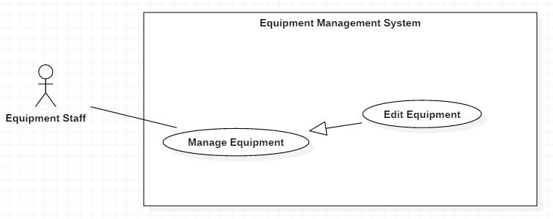

Figure 23 - < Equipment Staff> Edit Equipment

Use Case Specification

|  |  |  |  |
| --- | --- | --- | --- |
| **USE CASE - UC_17** | | | |
| **Use Case No.** | 17 | **Use Case Version** | 2.0 |
| **Use Case Name** | Edit equipment | | |
| **Author** | Bùi Quang Nhật Châu | | |
| **Date** | 11/06/2018 | **Priority** | Normal |
| **Actor:**   * Equipment Staff   **Summary:**   * This use case allows Equipment Staff to update information of equipment in the system.   **Goal:**   * Information of equipment was changed.   **Triggers:**   * Equipment Staff clicks on “Edit” button.   **Preconditions:**   * User must be login to the system with Equipment Staff role.   **Post Conditions:**   * **Success:** System shows “Update successfully!” message. * **Fail:** System shows “Update fail!” message.   **Main Success Scenario:**   |  |  |  | | --- | --- | --- | | Step | Actor Action | System Response | | 1 | Equipment Staff clicks “Edit” button. | The system requests information in form:   * Name: Free text input. * Vendor: Select option. * Made in: Free text input. * Category: Select option. * Unit: Select option. * Maintenance Duration: Select option. * Status: radio button * Picture: Image choose. * Description: Free text input. | | 2 | Equipment Staff inputs information. Equipment Staff clicks on “OK” button. | System validates the information and shows confirmation message. | | 3 | Equipment Staff clicks on “YES” button | System shows “Update successfully!” message. |   **Alternative:**   |  |  |  | | --- | --- | --- | | Step | Actor Action | System Response | | 1 | Equipment Staff clicks button “Cancel”. | Close edit form |   **Exceptions:**   |  |  |  | | --- | --- | --- | | No | Cause | System Response | | 1 | System Updates account fail | System shows “Update fail!” message. |   **Relationships:**  N/A  **Business Rules:**   * Equipment Name is not null and in range of 5-250 characters. * Category, Maintenance Duration, Unit, Vendor are not null. * Drop-down fields should have the first entry as blank or text like ‘Select’. * Status: Only equipment that has no item or all items have an "Archived", "Lost" status, can be changed status from “Active” to “Inactive”. | | | |

Table 28 - Edit Equipment specification

##### 2.3.4.7< Equipment Staff> Add Items

Use Case Diagram

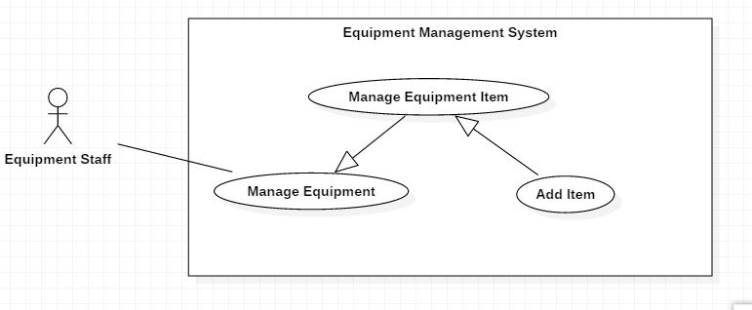

Figure 24 - < Equipment Staff> Add Items

Use Case Specification

|  |  |  |  |
| --- | --- | --- | --- |
| **USE CASE - UC_18** | | | |
| **Use Case No.** | 18 | **Use Case Version** | 2.0 |
| **Use Case Name** | Add Items | | |
| **Author** | Nguyễn Huy Hoàng | | |
| **Date** | 17/06/2018 | **Priority** | Normal |
| **Actor:**   * Equipment Staff   **Summary:**   * This use case allows equipment staff to create new equipment items.   **Goal:**   * Equipment Staff create new equipment items.   **Triggers:**   * Equipment Staff clicks on “Add Items” button.   **Preconditions:**   * User must be login to the system with Equipment Staff Role. * Equipment Staff at “Equipment Detail” page.   **Post Conditions:**   * **Success:** New equipment items are created. * **Fail:** Show error message   **Main Success Scenario:**   |  |  |  | | --- | --- | --- | | Step | Actor Action | System Response | | 1 | Equipment Staff clicks “Add Items” button. | The system requests information in form:   * Quantity: Number input. * Create Serial Number: Button. * Price: Number input. * Warranty: Number input. * Warehouse: select option. * Location: Select option. * Block: Select option. * Floor: Select option. * Tile: Select option.   [Exception 1] |   **Alternative:**   |  |  |  | | --- | --- | --- | | Step | Actor Action | System Response | | 1 | Equipment Staff clicks button “Cancel”. | Close add form |   **Exceptions:**   |  |  |  | | --- | --- | --- | | No | Cause | System Response | | 1 | System List work order fail | System shows “Error!” message. | | 2 | The equipment staff has not clicked "Create Serial Number" button. | System shows “Please create serial number for item(s)!” message. |   **Relationships:**  Extend from Manage Equipment Item use case.  **Business Rules:**   * Quantity is not null. Quantity is an integer. Maximum is 50. * Price is an integer and must be greater 50.000 VND. Maximum is 99.999.999 VND. * Warranty is an integer and must be greater 1 month. Maximum is 999 months. * Warehouse, Location, Block, Floor, Tile are not null. * System cannot create successfully if the serial number is not created for items. * Amount values should be displayed with correct currency symbols. * Drop-down fields should have the first entry as blank or text like ‘Select’. * The serial number is 13 digits. It consists: the first 3 digits are the first 3 digits in the equipment category identifier, the next 4 digits are the first 4 digits in the equipment identifier and the last 6 digits are random by the system. | | | |

Table 29 - Add Items specification

##### 2.3.4.8< Equipment Staff> Close Work Order

Use Case Diagram

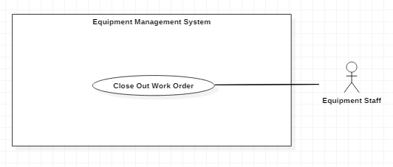

Figure 25 - < Equipment Staff> Close Out Work Order

Use Case Specification

|  |  |  |  |
| --- | --- | --- | --- |
| **USE CASE - UC_19** | | | |
| **Use Case No.** | 19 | **Use Case Version** | 2.0 |
| **Use Case Name** | Close Work Order | | |
| **Author** | Bùi Quang Nhật Châu | | |
| **Date** | 11/07/2018 | **Priority** | Normal |
| **Actor:**   * Equipment Staff   **Summary:**   * This use case allows Equipment Staff to close out work order.   **Goal:**   * Equipment Staff close out a work order.   **Triggers:**   * Equipment Staff send the command close work order.   **Preconditions:**   * Actor login successfully with Equipment Staff role. * User at “Work Order” page   **Post Conditions:**   * **Success:** Close out work order. * **Fail:** Show error message.   **Main Success Scenario:**   |  |  |  | | --- | --- | --- | | Step | Actor Action | System Response | | 1 | Equipment Staff goes to “Work Order” page. | Show list of all work orders. | | 2 | Equipment Staff clicks work order that they want to close. | Show information of work order.  [Exception 1] | | 3 | Equipment Staff clicks “Close” button. | Show confirm dialog with following information:   * Do you want to close this order?: close message * Close: button * Cancel: button | | 4 | Equipment Staff clicks “Close” button  [Alternative 1] | Close Work Order. Show success message. |   **Alternative 1:**   |  |  |  | | --- | --- | --- | | Step | Actor Action | System Response | | 1 | Equipment Staff clicks button “Cancel”. | Close confirm dialog |   **Exceptions:**   |  |  |  | | --- | --- | --- | | No | Cause | System Response | | 1 | Network problem exception. | Show message “Error! Try again”. |   **Relationships:** N/A.  **Business Rules:**   * After the working order is closed, the equipment staff must re-position for the items in that work order. * In order to close an order, it is necessary to check the status of the equipment and to change the status of the equipment to the appropriate status, such as "Available", "Damaged", and “Lost". | | | |

Table 30 - Close Work Order

##### 2.3.4.9< Equipment Staff> Change Location

Use Case Diagram

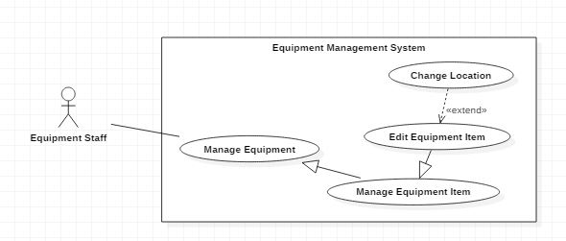

Figure 26 - < Equipment Staff> Change Location

Use Case Specification

|  |  |  |  |
| --- | --- | --- | --- |
| **USE CASE - UC_20** | | | |
| **Use Case No.** | 20 | **Use Case Version** | 2.0 |
| **Use Case Name** | Change Location | | |
| **Author** | Nguyễn Huy Hoàng | | |
| **Date** | 11/06/2018 | **Priority** | Normal |
| **Actor:**   * Equipment Staff   **Summary:**   * This use case allows equipment staff to change location of equipment.   **Goal:**   * Change location where equipment is located.   **Triggers:**   * Equipment staff clicks “Position” tab.   **Preconditions:**   * Actor login successfully with equipment staff role. * Equipment staff at “Equipment Detail” page.   **Post Conditions:**   * **Success:** Equipment Item’s Position is updated successfully, and system displays the Equipment Item Detail popup. * **Fail:** Show error message.   **Main Success Scenario:**   |  |  |  | | --- | --- | --- | | Step | Actor Action | System Response | | 1 | Equipment staff click “Edit” button. | The system requests information in form:   * Location: Select option. * Address: Label * Block: Select option. * Floor: Select option. * Tile: Select option.   [Exception 1] |   **Alternative 1:**   |  |  |  | | --- | --- | --- | | Step | Actor Action | System Response | | 1 | Equipment staff clicks button “Cancel”. | Return to “Equipment Detail” page. |   **Exceptions 1:**   |  |  |  | | --- | --- | --- | | No | Cause | System Response | | 1 | Network problem exception. | Show message “Error! Try again!” |   **Relationships:** Extend from Edit Equipment Item use case.  **Business Rules:**   * The address cannot be inputted. It is only changed when the user changes the location selection. * Location, Block, Floor, Tile are not null. * The user cannot select block, floor and tile without location. * After the user changes the location, the Address, Block, Floor, and Tile fields are reloaded. The user must select the Block, Floor and Tile for the item. * Drop-down fields should have the first entry as blank or text like ‘Select’. | | | |

Table 31 - Change Location specification

##### 2.3.4.10< Equipment Staff> Edit Equipment Item

Use Case Diagram

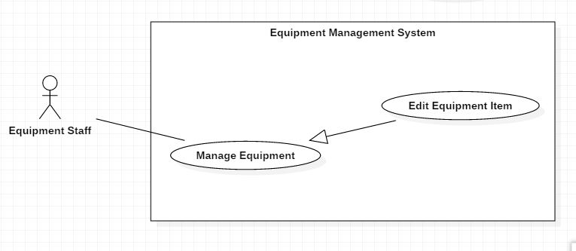

Figure 27 - < Equipment Staff> Edit Equipment Item

Use Case Specification

|  |  |  |  |
| --- | --- | --- | --- |
| **USE CASE - UC_24** | | | |
| **Use Case No.** | 24 | **Use Case Version** | 2.0 |
| **Use Case Name** | Edit Equipment Item | | |
| **Author** | Nguyễn Huy Hoàng | | |
| **Date** | 11/06/2018 | **Priority** | Normal |
| **Actor:**   * Equipment Staff   **Summary:**   * This use case allows Equipment Staff to edit equipment item’s information.   **Triggers:**   * Equipment Staff click “Edit” button.   **Preconditions:**   * Equipment Staff logins successfully with Equipment Staff role. * Equipment Staff at “Equipment Detail” page.   **Post Conditions:**   * **Success:** Equipment Item Information is updated successfully. * **Fail:** Show error message.   **Main Success Scenario:**   |  |  |  | | --- | --- | --- | | Step | Actor Action | System Response | | 1 | Equipment Staff clicks any equipment item row. | Show information of item. | | 2 | Equipment Staff clicks “Edit” button. | The system requests information in form:   * Serial Number: label. * Price: Number input. * Warranty: Number input. * Warehouse: Select option. * Run-times: label. * Imported Date: label. * Last-Maintain Date: label. * Next-Maintain Date: text input. * Description: Text input. |   **Exceptions:**   |  |  |  | | --- | --- | --- | | No | Cause | System Response | | 1 | Network problem exception. | Show message “Error! Try again!” |   **Relationships:** Extend from Manage Location use case.  **Business Rules:**   * Price is an integer and must be greater 50.000 VND. Maximum is 99.999.999 VND. * Warranty is an integer and must be greater 1 month. Maximum is 999 months. * Serial number, run-time, imported date, last-maintain date are not editable. * Warehouse is not null. | | | |

Table 32 - Edit Equipment Item specification

#### 2.3.5 < Manager>Overview Use Case

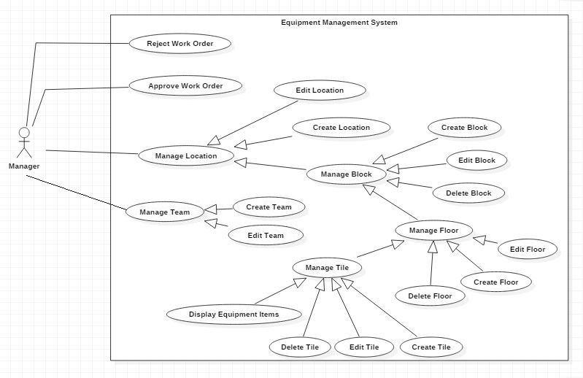

Figure 28 - < Manager>Overview Use Case

##### 2.3.5.1< Manager> Approve Work Order

Use Case Diagram

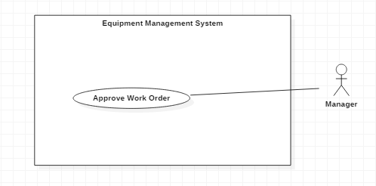

Figure 29 - < Manager> Approve Work Order

Use Case Specification

|  |  |  |  |
| --- | --- | --- | --- |
| **USE CASE - UC_25** | | | |
| **Use Case No.** | 25 | **Use Case Version** | 2.0 |
| **Use Case Name** | Approve Work Order | | |
| **Author** | Bùi Quang Nhật Châu | | |
| **Date** | 08/06/2018 | **Priority** | Normal |
| **Actor:**   * Manager   **Summary:**   * This use case allows manager to approve work order.   **Goal:**   * Approve work order.   **Triggers:**   * Manager clicks on “Approve” button.   **Preconditions:**   * Actor login successfully with Manager Role. * Team Leader/ Maintainer have created an order and have checked by an equipment staff.   **Post Conditions:**   * **Success:** Work Order status had been changed from “Checked” to “Approved”. * **Fail:** Show error message   **Main Success Scenario:**   |  |  |  | | --- | --- | --- | | Step | Actor Action | System Response | | 1 | Manager goes to “Work Order” page. | Show list of all work order. | | 2 | Manager clicks on button “Approve" | Show confirm message   * Yes: button * No: button * Do you want to approve this order?: message | | 3 | Manager clicks button “Yes”.  [Alternative 1] | Show success message. Update work order status.  [Exception 1] |   **Alternative 1:**   |  |  |  | | --- | --- | --- | | Step | Actor Action | System Response | | 1 | Manager clicks button “No”. | Close confirm dialog |   **Exceptions:**   |  |  |  | | --- | --- | --- | | No | Cause | System Response | | 1 | Network problem exception. | Show message “Error! Try again”. |   **Relationships:** N/A.  **Business Rules:**   * Work Order has 7 statuses: “Requested”, “Checked”, “Approved”, “Rejected”, “In progress”, “Cancelled”, “Closed”. * After being approved, the order will go into the “Approved” status. | | | |

Table 33 - Approve Work Order specification

##### 2.3.5.2< Manager> Reject Work Order

Use Case Diagram

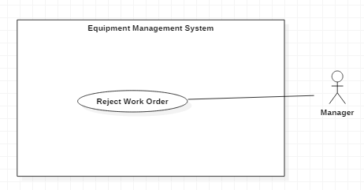

Figure 30 - < Manager> Reject Work Order

Use Case Specification

|  |  |  |  |
| --- | --- | --- | --- |
| **USE CASE - UC_26** | | | |
| **Use Case No.** | 26 | **Use Case Version** | 2.0 |
| **Use Case Name** | Reject Work Order | | |
| **Author** | Bùi Quang Nhật Châu | | |
| **Date** | 08/06/2018 | **Priority** | Normal |
| **Actor:**   * Manager   **Summary:**   * This use case allows manager to reject work order.   **Goal:**   * Reject work order.   **Triggers:**   * Manager clicks on “Reject” button.   **Preconditions:**   * Actor login successfully with Manager Role. * Team Leader/ Maintainer have created an order and have checked by an equipment staff.   **Post Conditions:**   * **Success:** Work Order status had been changed from “Checked” to “Reject”. * **Fail:** Show error message   **Main Success Scenario:**   |  |  |  | | --- | --- | --- | | Step | Actor Action | System Response | | 1 | Manager goes to “Work Order” page. | Show list of all work order. | | 2 | Manager clicks on button “Reject" | Show confirm message   * Yes: button * No: button * Do you want to reject this order?: message | | 3 | Manager clicks button “Yes”.  [Alternative 1] | Show success message. Update work order status.  [Exception 1] |   **Alternative 1:**   |  |  |  | | --- | --- | --- | | Step | Actor Action | System Response | | 1 | Manager clicks button “No”. | Close confirm dialog |   **Exceptions:**   |  |  |  | | --- | --- | --- | | No | Cause | System Response | | 1 | Network problem exception. | Show message “Error! Try again”. |   **Relationships:** N/A.  **Business Rules:**   * Work Order has 7 statuses: “Requested”, “Checked”, “Approved”, “Rejected”, “In progress”, “Cancelled”, “Closed”. * After being rejected, the order will go into the “Rejected” status. | | | |

Table 34 - Reject Work Order specification

##### 2.3.5.3< Manager> Create Location

Use Case Diagram

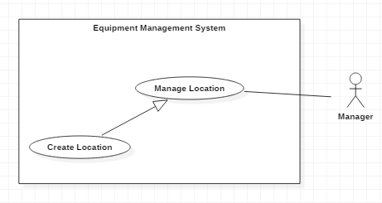

Figure 31 - < Manager> Create Location

Use Case Specification

|  |  |  |  |
| --- | --- | --- | --- |
| **USE CASE - UC_27** | | | |
| **Use Case No.** | 27 | **Use Case Version** | 2.0 |
| **Use Case Name** | Create Location | | |
| **Author** | Trịnh Thanh Hậu | | |
| **Date** | 08/06/2018 | **Priority** | Normal |
| **Actor:**   * Manager   **Summary:**   * This use case allows manager to create location.   **Goal:**   * Manager creates location.   **Triggers:**   * Manager clicks on “Add Location” button.   **Preconditions:**   * Actor login successfully with Manager Role.   **Post Conditions:**   * **Success:** New Location is created. * **Fail:** Show error message   **Main Success Scenario:**   |  |  |  | | --- | --- | --- | | Step | Actor Action | System Response | | 1 | Manager goes to “Location” page. | Show list locations. | | 2 | Manager clicks “Add Location” button. | The system requests information in form:   * Location Name: text input * Address: text input * Maps * Team: Select option. * Description: Text input. | | 3 | Manager clicks “Create Location” button. [Alternative 1] | Add new location. Show success message. Show new location in list.  [Exception 1,2] |   **Alternative 1:**   |  |  |  | | --- | --- | --- | | Step | Actor Action | System Response | | 1 | Manager clicks button “Cancel”. | Return to “Location” page. |   **Exceptions:**  [Exception 1]   |  |  |  | | --- | --- | --- | | No | Cause | System Response | | 1 | “Name” is empty | Show error message: “Please fill out this field”. | | 2 | “Address” is empty | Show error message: “Please fill out this field”. |   [Exception 2]   |  |  |  | | --- | --- | --- | | No | Cause | System Response | | 1 | Network problem exception. | Show message “Error! Try again”. |   **Relationships:** N/A.  **Business Rules:**   * Location Name is not null and in range of 6-50 characters. * Address and Location Name matching are not allowed. * Team: Only shows teams that have "Active" status. | | | |

Table 35 - Create Location specification

##### 2.3.5.4< Manager> Edit Location

Use Case Diagram

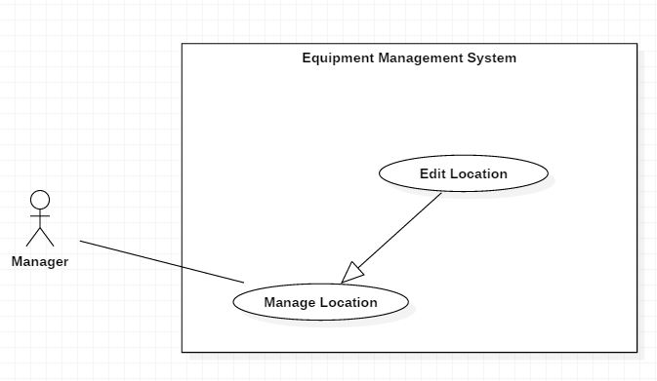

Figure 32 - < Manager> Edit Location

Use Case Specification

|  |  |  |  |
| --- | --- | --- | --- |
| **USE CASE - UC_28** | | | |
| **Use Case No.** | 28 | **Use Case Version** | 2.0 |
| **Use Case Name** | Edit location | | |
| **Author** | Trịnh Thanh Hậu | | |
| **Date** | 11/06/2018 | **Priority** | Normal |
| **Actor:**   * Manager   **Summary:**   * This use case allows Manager to update information of location in the system.   **Goal:**   * Information of location was changed.   **Triggers:**   * Manager clicks on “Edit” button.   **Preconditions:**   * User must be login to the system with Manager Role.   **Post Conditions:**   * **Success:** System shows “Update successfully!” message. * **Fail:** System shows “Update fail!” message.   **Main Success Scenario:**   |  |  |  | | --- | --- | --- | | Step | Actor Action | System Response | | 1 | Manager clicks “Edit” button. | The system requests information in form:   * Name: Text input. * Status: Select option. * Team: Select option. * Description: Text input. | | 2 | Manager inputs information. Equipment Staff clicks on “OK” button. | System validates the information and shows confirmation message. | | 3 | Manager clicks on “YES” button | System shows “Update successfully!” message. |   **Alternative:**   |  |  |  | | --- | --- | --- | | Step | Actor Action | System Response | | 1 | Manager clicks button “Cancel”. | Close edit form |   **Exceptions:**   |  |  |  | | --- | --- | --- | | No | Cause | System Response | | 1 | System Updates account fail | System shows “Update fail!” message. |   **Relationships:**  N/A  **Business Rules:**   * Address is not editable. * Location Name is not null and in range of 6-50 characters. * Address and Location Name matching are not allowed. * Team: Only shows teams that have "Active" status. * Teams that have work orders in the "Requested", "Checked", "Approved" and "In Progress" status can not be dropped out. * Status: Only location that has no item can be changed status from “Active” to “Inactive”. | | | |

Table 36 - Edit Location specification

##### 2.3.5.5< Manager> Create Team

Use Case Diagram

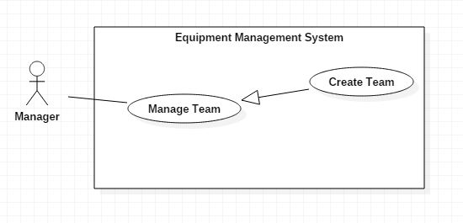

Figure 33 - < Manager> Create Team



Use Case Specification

|  |  |  |  |
| --- | --- | --- | --- |
| **USE CASE - UC_07** | | | |
| **Use Case No.** | 07 | **Use Case Version** | 2.0 |
| **Use Case Name** | Create Team | | |
| **Author** | Trịnh Thanh Hậu | | |
| **Date** | 05/06/2018 | **Priority** | Normal |
| **Actor:**   * Manager   **Summary:**   * This use case allows Manager to create a new team in the system.   **Goal:**   * A new team created successfully.   **Triggers:**   * Manager clicks on “Add Team” button.   **Preconditions:**   * Authenticated user must be login to the system with Manager Role. * User at “Team” page.   **Post Conditions:**   * **Success:** System shows “Add new team successfully!” message. * **Fail:** System shows error messages.   **Main Success Scenario:**   |  |  |  | | --- | --- | --- | | Step | Actor Action | System Response | | 1 | Manager clicks on “Add Team”. | The system requests information in form:   * Team Name: text input * Member: Dropdown list | | 2 | Manager inputs information. Manager clicks on “Add Team” button. | System validates the information and shows “Add new team successfully!” message.  [Exception 1] |   **Alternative:**   |  |  |  | | --- | --- | --- | | Step | Actor Action | System Response | | 1 | User clicks button “Cancel”. | Return “Team” page. |   **Exceptions:**   |  |  |  | | --- | --- | --- | | No | Cause | System Response | | 1 | Manager creates team fail | System shows “Add new team failed!” message. |   **Relationships:**  N/A  **Business Rules:**   * Team Name is not null and in range of 6-50 characters. * Drop-down fields should have the first entry as blank or text like ‘Select’. * Name must not be identical. | | | |

Table 37 - Create Team specification

##### 2.3.5.6< Manager> Edit Team

Use Case Diagram

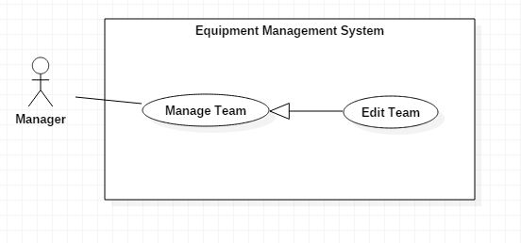

Figure 34 - < Manager> Edit Team

Use Case Specification

|  |  |  |  |
| --- | --- | --- | --- |
| **USE CASE - UC_08** | | | |
| **Use Case No.** | 08 | **Use Case Version** | 2.0 |
| **Use Case Name** | Edit Team | | |
| **Author** | Trịnh Thanh Hậu | | |
| **Date** | 08/06/2018 | **Priority** | Normal |
| **Actor:**   * Manager.   **Summary:**   * This use case allows manager to edit team’s information.   **Goal:**   * Edit team’s information.   **Triggers:**   * Manager clicks on the team's row that wants to edit team information.   **Preconditions:**   * Authenticated user must be login to the system with Manager role. * User at “Team” page.   **Post Conditions:**   * **Success:** New profile information is updated. * **Fail:** Show error message.   **Main Success Scenario:**   |  |  |  | | --- | --- | --- | | Step | Actor Action | System Response | | 1 | Manager clicks on “Team” tab. | System displays list of teams | | 2 | Manager clicks on the team's row that wants to edit team information. | System displays team’s information. | | 3 | Manager clicks on “Edit” button. | Show edit form:   * Team Name: Text input * Created Date: Label * Member: Dropdown list * Set to Leader: Button * Remove: Button * Status: Select option | | 4 | Manager input all require field. Then clicks button “Save changes”.  [Alternative] | Show success message. Show team’s information.  [Exception 1] |   **Alternative 1:**   |  |  |  | | --- | --- | --- | | Step | Actor Action | System Response | | 1 | Manager clicks button “Cancel”. | Close edit form |   **Exceptions:**   |  |  |  | | --- | --- | --- | | No | Cause | System Response | | 1 | Network problem exception. | Show message “Error! Try again!” |   **Relationships:** N/A.  **Business Rules:**   * Team Name is not null and in range of 6-50 characters. * Created Date is not editable. * Team members cannot be set as a team leader while the current team leader is still holding "Approved", “Rquested”, “Checked “or “In progress” orders. * Drop-down fields should have the first entry as blank or text like ‘Select’. * Name must not be identical. * Status: Only team that has no order can be changed status from “Active” to “Inactive”. | | | |

Table 38 - Edit Team specification

#### 2.3.6 < Team Leader>Overview Use Case

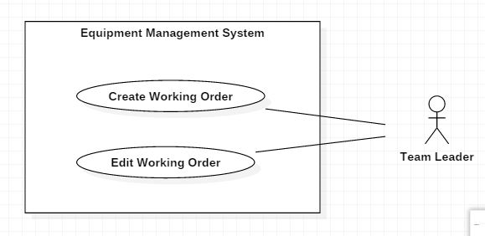

Figure 35 - < Team Leader>Overview Use Case

##### 2.3.6.1< Team Leader> Create Working Order

Use Case Diagram

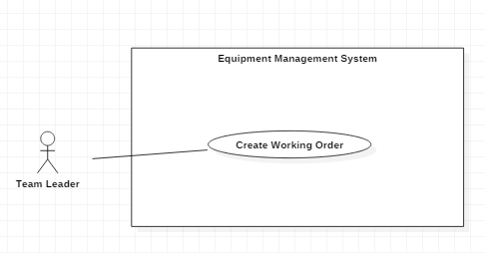

Figure 36 - < Team Leader> Create Working Order

Use Case Specification

|  |  |  |  |
| --- | --- | --- | --- |
| **USE CASE - UC_30** | | | |
| **Use Case No.** | 30 | **Use Case Version** | 2.0 |
| **Use Case Name** | Create Working Order | | |
| **Author** | Bùi Quang Nhật Châu | | |
| **Date** | 08/06/2018 | **Priority** | Normal |
| **Actor:**   * Team Leader   **Summary:**   * This use case allows team leader to create working order.   **Goal:**   * Team Leader creates working order.   **Triggers:**   * Team Leader clicks on “Create Work Order” button.   **Preconditions:**   * Actor login successfully with Team Leader role.   **Post Conditions:**   * **Success:** Working Order is created. * **Fail:** Show error message   **Main Success Scenario:**   |  |  |  | | --- | --- | --- | | Step | Actor Action | System Response | | 1 | Team Leader goes to “Work Order” page. | Show list order | | 2 | Team Leader clicks “New Work Order” button. | The system requests information in form:   * Work Order Name: Text input * Equipment: Select option * Quantity: Number input * Location: Select option * Team: Select option * From: Datetime picker * To: Datetime picker * Priority: Radio button * Description: Text input | | 3 | Team Leader clicks “Create Work Order” button. [Alternative 1] | Show success message. Show new working order in list.  [Exception 1,2] |   **Alternative 1:**   |  |  |  | | --- | --- | --- | | Step | Actor Action | System Response | | 1 | Team Leader clicks button “Cancel”. | Return to “Work Order” page. |   **Exceptions:**  [Exception 1]   |  |  |  | | --- | --- | --- | | No | Cause | System Response | | 1 | “Name” is empty | Show error message: “Please fill out this field”. | | 2 | “Equipment” is empty | Show error message: “Please fill out this field”. | | 3 | “Quantity” is empty | Show error message: “Please fill out this field”. | | 4 | “From” is empty | Show error message: “Please choose start date”. | | 5 | “To” is empty | Show error message: “Please choose return date”. | | 6 | “Location” is empty | Show error message: “Please choose location”. | | 7 | “Team” is empty | Show error message: “Please choose team”. |   [Exception 2]   |  |  |  | | --- | --- | --- | | No | Cause | System Response | | 1 | “Quantity” is not in valid format. | Show error message: “Please enter an integer”. |   [Exception 2]   |  |  |  | | --- | --- | --- | | No | Cause | System Response | | 1 | Network problem exception. | Show message “Error! Try again”. |   **Relationships:** N/A.  **Business Rules:**   * Priority has three levels: “High”, “Medium” and “Low”. Priority is automatically set to "Low". * Drop-down fields should have the first entry as blank or text like ‘Select’. * Work Order Name is not null and in range of 6-50 characters. * Quantity is not null. Quantity is a natural number. * “From”: Start date must be greater than or equal to the current date. * “To”: End date must be greater than the start date. * For users to create working order, the user must be the leader of the project team assigned to that location. * Only items that are in "Available" status are allowed to be borrowed. * The duration of an order can be configured. * An order number that duplicates the item for that time period and it has not been approved yet can be configured. | | | |

Table 39 - Create Working Order specification

##### 2.3.6.2< Team Leader> Edit Working Order

Use Case Diagram

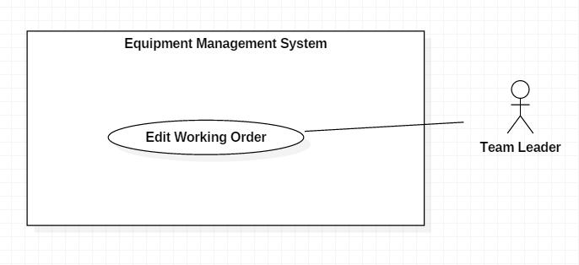

Figure 37 - < Team Leader > Edit Working Order

Use Case Specification

|  |  |  |  |
| --- | --- | --- | --- |
| **USE CASE - UC_31** | | | |
| **Use Case No.** | 31 | **Use Case Version** | 2.0 |
| **Use Case Name** | Edit Working Order | | |
| **Author** | Bùi Quang Nhật Châu | | |
| **Date** | 11/06/2018 | **Priority** | Normal |
| **Actor:**   * Team Leader   **Summary:**   * This use case allows Team Leader to update information of work order that they created.   **Goal:**   * Information of work order was changed.   **Triggers:**   * Team Leader clicks on “Edit” button.   **Preconditions:**   * User must be login to the system with Team Leader role. * Work Order is in the “Requested” or “Rejected” status.   **Post Conditions:**   * **Success:** System shows “Update successfully!” message. * **Fail:** System shows “Update fail!” message.   **Main Success Scenario:**   |  |  |  | | --- | --- | --- | | Step | Actor Action | System Response | | 1 | Team Leader clicks “Edit” button. | The system requests information in form:   * Work Order Name: Text input * Equipment: Select option * Quantity: Number input * Location: Select option * Team: Select option * From: Datetime picker * To: Datetime picker * Priority: Radio button * Description: text input | | 2 | Team Leader inputs information. Team Leader clicks on “OK” button. | System validates the information and shows confirmation message. | | 3 | Team Leader clicks on “YES” button | System shows “Update successfully!” message. |   **Alternative:**   |  |  |  | | --- | --- | --- | | Step | Actor Action | System Response | | 1 | Team Leader clicks button “Cancel”. | Return to “Work Order” page. |   **Exceptions:**   |  |  |  | | --- | --- | --- | | No | Cause | System Response | | 1 | System Updates account fail | System shows “Update fail!” message. |   **Relationships:**  N/A  **Business Rules:**   * Priority has three levels: “High”, “Medium” and “Low”. Priority is automatically set to "Low". * Work Order Name is not null and in range of 6-50 characters. * Quantity is not null. Quantity is a natural number. * “From”: Start date must be greater than or equal to the current date. * “To”: End date must be greater than the start date. * For users to create working order, the user must be the leader of the project team assigned to that location. * Only items that are in "Available" status are allowed to be borrowed. * Drop-down fields should have the first entry as blank or text like ‘Select’. * The duration of an order can be configured. | | | |

Table 40 - Edit Working Order specification

#### 2.3.7 < Maintainer>Overview Use Case

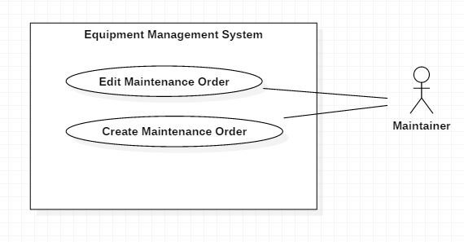

Figure 38 - < Maintainer>Overview Use Case

##### 2.3.7.1< Maintainer> Create Maintenance Order

Use Case Diagram

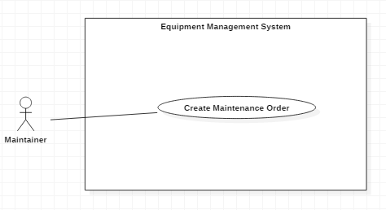

Figure 39 - < Maintainer> Create Maintenance Order

Use Case Specification

|  |  |  |  |
| --- | --- | --- | --- |
| **USE CASE - UC_32** | | | |
| **Use Case No.** | 32 | **Use Case Version** | 2.0 |
| **Use Case Name** | Create Maintenance Order | | |
| **Author** | Nguyễn Thanh Tiến | | |
| **Date** | 08/06/2018 | **Priority** | Normal |
| **Actor:**   * Maintainer   **Summary:**   * This use case allows Maintainer to create maintenance order.   **Goal:**   * Maintainer creates maintenance order.   **Triggers:**   * Maintainer clicks on “Create Work Order” button.   **Preconditions:**   * Actor login successfully with Maintainer role.   **Post Conditions:**   * **Success:** Maintenance Order is created. * **Fail:** Show error message   **Main Success Scenario:**   |  |  |  | | --- | --- | --- | | Step | Actor Action | System Response | | 1 | Maintainer goes to “Work Order” page. | Show list order | | 2 | Maintainer clicks “New Work Order” button. | The system requests information in form:   * Work Order Name: Text input * Equipment: Select option * Quantity: Number input * From: Datetime picker * To: Datetime picker * Priority: Radio button * Description: Text input | | 3 | Maintainer clicks “Create Work Order” button. [Alternative 1] | Show success message. Show new working order in list.  [Exception 1,2] |   **Alternative 1:**   |  |  |  | | --- | --- | --- | | Step | Actor Action | System Response | | 1 | Maintainer clicks button “Cancel”. | Return to “Work Order” page. |   **Exceptions:**  [Exception 1]   |  |  |  | | --- | --- | --- | | No | Cause | System Response | | 1 | “Name” is empty | Show error message: “Please fill out this field”. | | 2 | “Equipment” is empty | Show error message: “Please fill out this field”. | | 3 | “Quantity” is empty | Show error message: “Please fill out this field”. | | 4 | “From” is empty | Show error message: “Please choose start date”. | | 5 | “To” is empty | Show error message: “Please choose return date”. |   [Exception 2]   |  |  |  | | --- | --- | --- | | No | Cause | System Response | | 1 | “Quantity” is not in valid format. | Show error message: “Please enter an integer”. |   [Exception 2]   |  |  |  | | --- | --- | --- | | No | Cause | System Response | | 1 | Network problem exception. | Show message “Error! Try again”. |   **Relationships:** N/A.  **Business Rules:**   * Priority has three levels: “High”, “Medium” and “Low”. Priority is automatically set to "Low". * Work Order Name is not null and in range of 6-50 characters. * Quantity is not null. Quantity is a natural number. * “From”: Start date must be greater than or equal to the current date. * “To”: End date must be greater than the start date. * Only items that are in "Available", “Checked” or “Damaged” status are allowed to be created. * Drop-down fields should have the first entry as blank or text like ‘Select’. * The duration of an order can be configured. * An order number that duplicates the item for that time period and it has not been approved yet can be configured. | | | |

Table 41 - Create Maintenance Order specification

##### 2.3.7.2< Maintainer> Edit Maintenance Order

Use Case Diagram

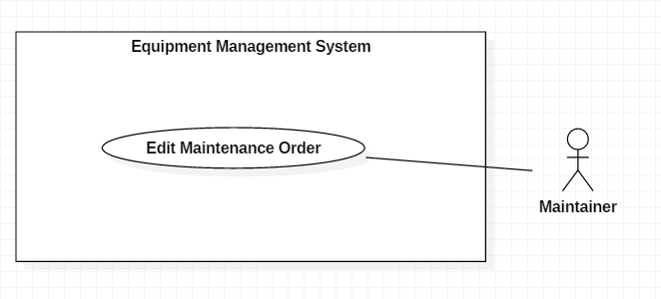

Figure 40 - < Maintainer> Edit Maintenance Order

Use Case Specification

|  |  |  |  |
| --- | --- | --- | --- |
| **USE CASE - UC_33** | | | |
| **Use Case No.** | 33 | **Use Case Version** | 2.0 |
| **Use Case Name** | Edit Maintenance Order | | |
| **Author** | Nguyễn Thanh Tiến | | |
| **Date** | 11/06/2018 | **Priority** | Normal |
| **Actor:**   * Maintainer   **Summary:**   * This use case allows Maintainer to update information of maintenance order that they created.   **Goal:**   * Information of maintenance order was changed.   **Triggers:**   * Maintainer clicks on “Edit” button.   **Preconditions:**   * User must be login to the system with Maintainer role.   **Post Conditions:**   * **Success:** System shows “Update successfully!” message. * **Fail:** System shows “Update fail!” message.   **Main Success Scenario:**   |  |  |  | | --- | --- | --- | | Step | Actor Action | System Response | | 1 | Maintainer clicks “Edit” button. | The system requests information in form:   * Work Order Name: Text input * Equipment: Select option * Quantity: Number input * From: Datetime picker * To: Datetime picker * Priority: Radio button * Description: text input | | 2 | Maintainer inputs information. Maintainer clicks on “OK” button. | System validates the information and shows confirmation message. | | 3 | Maintainer clicks on “YES” button | System shows “Update successfully!” message. |   **Alternative:**   |  |  |  | | --- | --- | --- | | Step | Actor Action | System Response | | 1 | Maintainer clicks button “Cancel”. | Return to “Work Order” page. |   **Exceptions:**   |  |  |  | | --- | --- | --- | | No | Cause | System Response | | 1 | System Updates account fail | System shows “Update fail!” message. |   **Relationships:**  N/A  **Business Rules:**   * Priority has three levels: “High”, “Medium” and “Low”. Priority is automatically set to "Low". * Work Order Name is not null and in range of 6-50 characters. * Quantity is not null. Quantity is a natural number. * “From”: Start date must be greater than or equal to the current date. * “To”: End date must be greater than the start date. * Only items that are in "Available", “Checked” or “Damaged” status are allowed to be borrowed. * Drop-down fields should have the first entry as blank or text like ‘Select’. * The duration of an order can be configured. | | | |

Table 42 - Edit Maintenance Order specification

## 3. Software System Attribute

### 3.1 Usability

* The system usability is easy to use. It takes about 8 hours to get acquainted and use the EMS.
* Icons that indicate the actions should be easy to understand and users will not meet any troubles to recognize the feature of page.

### 3.2 Reliability

* The rate of failure occurrence shall be 1/200 (1 occurrence in 200 days).
* The number of sending notification failure is 1 time per 200 notifications.
* Timer tasks run at configured time with 100% execution rate.
* The data should be backed up every day.

### 3.3 Availability

* System should take at most 6 hours per month for backup or repairing.
* System will be maintained at 23:55 pm every Sunday.

### 3.4 Security

* Privacy: Each role of user has a specific permission to interact with system.
* System always checks authorization and authenticated before doing anything.
* Only admin can grant permission to other roles.

### 3.5 Maintainability

* The system is divided into separated modules.
* The code is easy to maintain and upgrade.

### 3.6 Portability

* The web application is running on Windows 7 or above.
* Providing easy installation.

### 3.7 Performance

* All requests are handling in maximum time of 12 seconds.

## 4. Conceptual Diagram

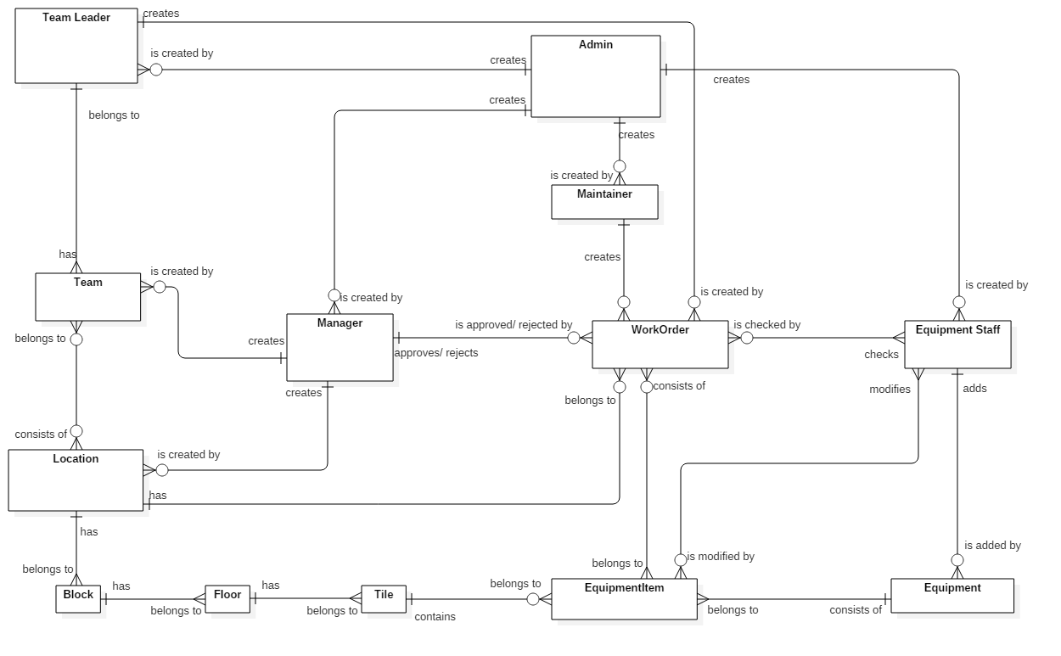

Figure 41 - Conceptual Diagram

# D. Software Design Description

## 1. Design Overview

This document describes the technical and user interface design of Equipment Management System. It includes the architectural design, the detailed design of common functions and business functions and the design of database model.

The architectural design describes the overall architecture of the system and the architecture of each main component and subsystem.

The detailed design describes static and dynamic structure for each component and functions. It includes class diagrams, class explanations and sequence diagrams for each use cases.

The database design describes the relationships between entities and details of each entity.

Document overview:

Section 2: gives an overall description of the system architecture design.

Section 3: gives component diagrams that describe the connection and integration of the system.

Section 4: gives the detail design description which includes class diagram, class explanation, and sequence diagram to details the application functions.

Section 5: describe screens design.

Section 6: describe a fully attributed ERD.

Section 7: describe algorithms.

## 2. System Architectural Design

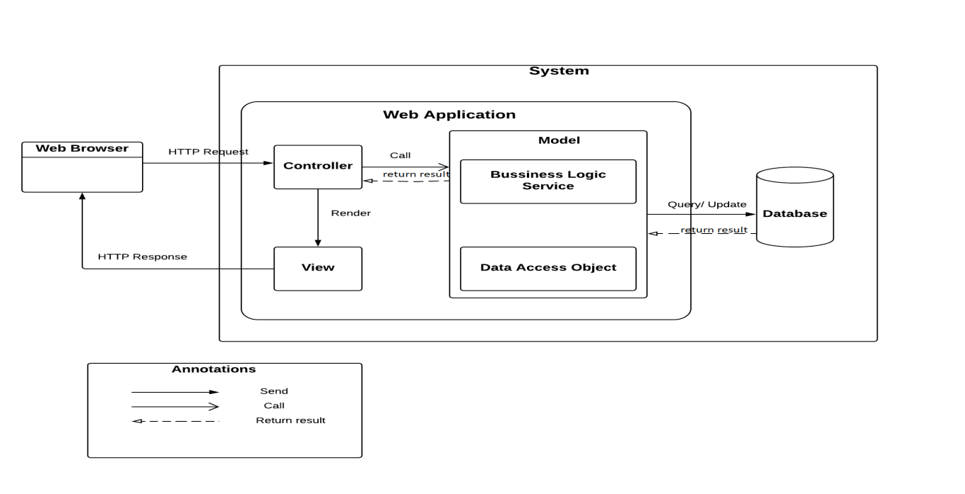

Figure 42 - System Architectural Design

Our application is developed mainly on Play Framework 2.5 which follows the MVC architectural pattern. We choose this framework for web application because of following advantages:

* Hot reload: Make a change, refresh the page and we can see the change immediately. As a result, we don’t waste time to redeploy the application.
* Open source: Play framework is open source; we can see how everything works in the open source code. There is also a large community using it, contributing plugins, asking questions on StackOverflow, and so on.
* Reactive: play is built on top of Akka and Netty, so it’s fully asynchronous: that is, you can use non-blocking I/O when making calls to remote services. This makes it possible to support many concurrent connections without dealing with thread pools.

This pattern splits the application into separate layers: The model layer, view layer, and controller layer.

* The model layer: Contains data structures and operations that needed for system to operate. Whenever model objects need to be saved into database, they contain JPA annotation for making these operations easier and more flexible.
* The view layer: a HTML file that presents the content and interaction with user. In play framework, views are generated using a templating system. The Controller gets data from the model layer, and then applies a template to render these objects.
* The controller responds to user actions and processes them. For more details, the controller listens for HTTP requests, then extracts relevant data from the request, such as parameter, request headers… and invokes the suitable methods that contains read, update or create the model object. After finishing the process, controllers render the view and then written as an HTTP Response to the user.

Thus, MVC design pattern is a surely the great approach to building software applications. The MVC framework is easy to implement as it offers above given numerous advantages. Projects that are developed with the help of MVC model can be easily developed with lesserexpenditure and within less time too. Above all, its power to manage multiple views makes MVC the best architecture pattern for developing web applications.

## 3. Component Diagram

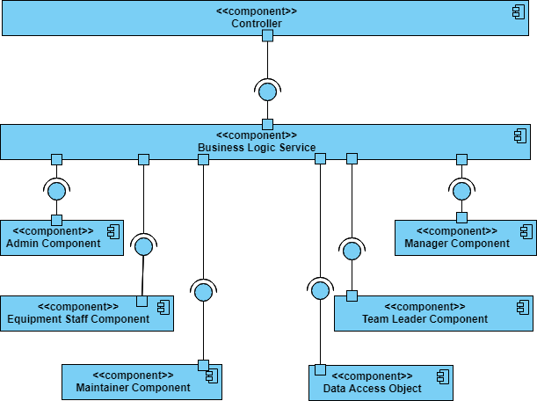

Figure 43 - Component Diagram

|  |  |
| --- | --- |
| COMPONENT DICTIONARY: DESCRIBES COMPONENTS | |
| EMS | Equipment Management System |
| Controller | Component to handle HTTP request |
| Business Logic Service | Component to handle system’s business operations |
| Maintainer Component | Component to handle maintainer activities in the system |
| Equipment Staff Component | Component to handle equipment staff activities in the system |
| Manager Component | Component to handle manager activities in the system |
| Admin Component | Component to handle admin activities in the system |
| Team Leader Component | Component to handle team leader activities in the system |
| Data access object | Component to handle interaction between the system and database |

Table 43 - Component Dictionary

## 4. Detail Description

### 4.1 Class Diagram

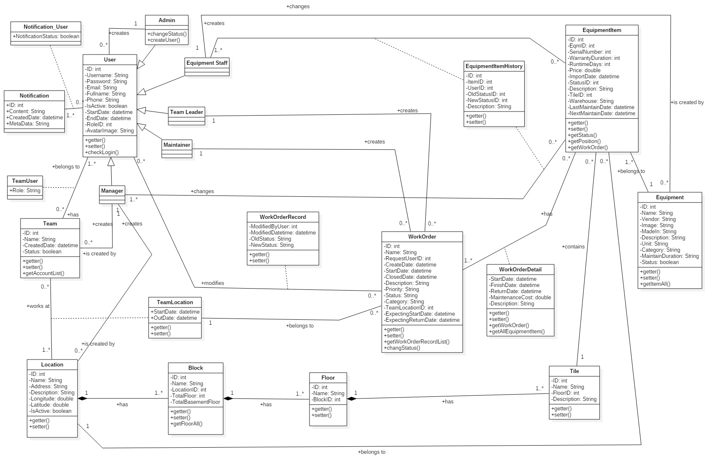

Figure 44 - Class Diagram

|  |  |  |
| --- | --- | --- |
| **CLASS DICTIONARY: DESCRIBE CLASS** | | |
| **Class Name** | **Mapping column with Conceptual diagram** | **Description** |
| **User** | N/A | Contains the user information |
| **Admin** | Admin | Contains the admin information |
| **Equipment Staff** | Equipment Staff | Contains the equipment staff information |
| **Team Leader** | Team Leader | Contains the team leader information |
| **Maintainer** | Maintainer | Contain the maintainer information |
| **Manager** | Manager | Contains the manager information |
| **Team** | Team | Contains the Team information |
| **Location** | Location | Contains the Location information |
| **Block** | Block | Contains the Block information |
| **Floor** | Floor | Contains the Floor information |
| **TeamLocation** | N/A | Not exist in the conceptual diagram but need this table to contain the information of a team in a specific location |
| **Tile** | Tile | Contains the tile information |
| **WorkOrderRecord** | N/A | Not exist in the conceptual diagram but need this table to contain the information when user modifies a work order |
| **Equipment** | Equipment | Contains the equipment information |
| **Equipment Item** | Equipment Item | Contains the equipment item information |
| **Work Order Detail** | N/A | Not exist in conceptual diagram but need this table to contain the information of a work order |
| **Work Order** | Work Order | Contains the information of work order |
| **Team User** | N/A | Not exist in the conceptual diagram but need this table to contain the information when user joins a work order |
| **EquipmentItemHistory** | N/A | Not exist in the conceptual diagram but need this table to contain the history information of equipment item |
| **Notification** | N/A | Not exist in the conceptual diagram but need this table to contain the notification information |
| **Notification User** | N/A | Not exist in the conceptual diagram but need this table to contain the information when user received a notification |

Table 44 - Class Dictionary

### 4.2 Class Diagram Explanation

#### 4.2.1 User

|  |  |  |  |
| --- | --- | --- | --- |
| **Attribute** | **Type** | **Visibility** | **Description** |
| id | Integer | Private | Unique identifier of a user |
| username | String | Private | User’s username |
| password | String | Private | User’s password |
| fullName | String | Private | User’s full name |
| image | String | Private | User’s avatar |
| phone | String | Private | User’s phone |
| email | String | Private | User’s email |
| startdate | Datetime | Private | User’s start date |
| enddate | Datetime | Private | User’s end date |
| roleId | Integer | Private | Id of user’s role |
| isActive | Boolean | Private | User’s status |
| **Method** | **Return Type** | **Visibility** | **Description** |
| getter | Attribute type | Public | Get value of attribute |
| setter | Void | Public | Set value for attribute |

Table 45 - Class Diagram Explanation <User>

#### 4.2.2 Admin

|  |  |  |  |
| --- | --- | --- | --- |
| **Attribute** | **Type** | **Visibility** | **Description** |
| id | Integer | Private | Unique identifier of a user |
| username | String | Private | User’s username |
| password | String | Private | User’s password |
| fullName | String | Private | User’s full name |
| image | String | Private | User’s avatar |
| phone | String | Private | User’s phone |
| email | String | Private | User’s email |
| startdate | Datetime | Private | User’s start date |
| enddate | Datetime | Private | User’s end date |
| roleId | Integer | Private | Id of user’s role |
| isActive | Boolean | Private | User’s status |
| **Method** | **Return Type** | **Visibility** | **Description** |
| getter | Attribute type | Public | Get value of attribute |
| setter | Void | Public | Set value for attribute |

Table 46 - Class Diagram Explanation <Admin>

#### 4.2.3 Manager

|  |  |  |  |
| --- | --- | --- | --- |
| **Attribute** | **Type** | **Visibility** | **Description** |
| id | Integer | Private | Unique identifier of a user |
| username | String | Private | User’s username |
| password | String | Private | User’s password |
| fullName | String | Private | User’s full name |
| image | String | Private | User’s avatar |
| Phone | String | Private | User’s phone |
| email | String | Private | User’s email |
| startdate | Datetime | Private | User’s start date |
| enddate | Datetime | Private | User’s end date |
| roleId | Integer | Private | Id of user’s role |
| isActive | Boolean | Private | User’s status |
| **Method** | **Return Type** | **Visibility** | **Description** |
| getter | Attribute type | Public | Get value of attribute |
| setter | Void | Public | Set value for attribute |

Table 47 - Class Diagram Explanation <Manager>

#### 4.2.4 Equipment Staff

|  |  |  |  |
| --- | --- | --- | --- |
| **Attribute** | **Type** | **Visibility** | **Description** |
| id | Integer | Private | Unique identifier of a user |
| username | String | Private | User’s username |
| password | String | Private | User’s password |
| fullName | String | Private | User’s full name |
| image | String | Private | User’s avatar |
| Phone | String | Private | User’s phone |
| email | String | Private | User’s email |
| startdate | Datetime | Private | User’s start date |
| enddate | Datetime | Private | User’s end date |
| roleId | Integer | Private | Id of user’s role |
| isActive | Boolean | Private | User’s status |
| **Method** | **Return Type** | **Visibility** | **Description** |
| getter | Attribute type | Public | Get value of attribute |
| setter | Void | Public | Set value for attribute |

Table 48 - Class Diagram Explanation <Equipment Staff>

#### 4.2.5 Maintainer

|  |  |  |  |
| --- | --- | --- | --- |
| **Attribute** | **Type** | **Visibility** | **Description** |
| id | Integer | Private | Unique identifier of a user |
| username | String | Private | User’s username |
| password | String | Private | User’s password |
| fullName | String | Private | User’s full name |
| image | String | Private | User’s avatar |
| phone | String | Private | User’s phone |
| email | String | Private | User’s email |
| startdate | Datetime | Private | User’s start date |
| enddate | Datetime | Private | User’s end date |
| roleId | Integer | Private | Id of user’s role |
| isActive | Boolean | Private | User’s status |
| **Method** | **Return Type** | **Visibility** | **Description** |
| getter | Attribute type | Public | Get value of attribute |
| setter | Void | Public | Set value for attribute |

Table 49 - Class Diagram Explanation <Maintainer>

#### 4.2.6 Team Leader

|  |  |  |  |
| --- | --- | --- | --- |
| **Attribute** | **Type** | **Visibility** | **Description** |
| id | Integer | Private | Unique identifier of a user |
| username | String | Private | User’s username |
| password | String | Private | User’s password |
| fullName | String | Private | User’s full name |
| image | String | Private | User’s avatar |
| phone | String | Private | User’s phone |
| email | String | Private | User’s email |
| startdate | Datetime | Private | User’s start date |
| enddate | Datetime | Private | User’s end date |
| roleId | Integer | Private | Id of user’s role |
| isActive | Boolean | Private | User’s status |
| **Method** | **Return Type** | **Visibility** | **Description** |
| getter | Attribute type | Public | Get value of attribute |
| setter | Void | Public | Set value for attribute |

Table 50 - Class Diagram Explanation <Team Leader>

#### 4.2.7 Team

|  |  |  |  |
| --- | --- | --- | --- |
| **Attribute** | **Type** | **Visibility** | **Description** |
| id | Integer | Private | Unique identifier of a Team |
| name | String | Private | Team’s name |
| createDate | datetime | Private | Team’s created date |
| **Method** | **Return Type** | **Visibility** | **Description** |
| getter | Attribute type | Public | Get value of attribute |
| setter | Void | Public | Set value for attribute |
| getAccountList() | List | Public | Get all account of team |

Table 51 - Class Diagram Explanation <Team>

#### 4.2.7 Location

|  |  |  |  |
| --- | --- | --- | --- |
| **Attribute** | **Type** | **Visibility** | **Description** |
| id | Integer | Private | Unique identifier of a location |
| name | String | Private | Location’s name |
| description | String | Private | Location’s description |
| address | String | Private | Location’s address |
| longitude | Float | Private | Location’s longitude |
| latitude | Float | Private | Location’s latitude |
| isActive | Boolean | Private | Location’s Status |
| **Method** | **Return Type** | **Visibility** | **Description** |
| getter | Attribute type | Public | Get value of attribute |
| setter | Void | Public | Set value for attribute |

Table 52 - Class Diagram Explanation <Location>

#### 4.2.8 TeamUser

|  |  |  |  |
| --- | --- | --- | --- |
| **Attribute** | **Type** | **Visibility** | **Description** |
| role | String | Private | User’s role in team |
| **Method** | **Return Type** | **Visibility** | **Description** |

Table 53 - Class Diagram Explanation <TeamUser>

#### 4.2.8 Block

|  |  |  |  |
| --- | --- | --- | --- |
| **Attribute** | **Type** | **Visibility** | **Description** |
| id | Integer | Private | Unique identifier of a Block |
| name | String | Private | Block’s name |
| locationId | Integer | Private | Id of location that the block belongs to |
| totalFLoor | Integer | Private | Total floor of the block |
| totalBasementFloor | Integer | Private | Total basement floor of the block |
| **Method** | **Return Type** | **Visibility** | **Description** |
| getter | Attribute type | Public | Get value of attribute |
| setter | Void | Public | Set value for attribute |
| getFloorAll() | List | Public | Get all floor of a block |

Table 54 - Class Diagram Explanation <Block>

#### 4.2.9 Floor

|  |  |  |  |
| --- | --- | --- | --- |
| **Attribute** | **Type** | **Visibility** | **Description** |
| id | Integer | Private | Unique identifier of a Floor |
| Name | String | Private | Floor’s name |
| blockID | Integer | Private | Id of block that the floor belongs to |
| **Method** | **Return Type** | **Visibility** | **Description** |
| getter | Attribute type | Public | Get value of attribute |
| setter | Void | Public | Set value for attribute |

Table 55 - Class Diagram Explanation <Floor>

#### 4.2.10 Tile

|  |  |  |  |
| --- | --- | --- | --- |
| **Attribute** | **Type** | **Visibility** | **Description** |
| id | Integer | Private | Unique identifier of a Tile |
| name | String | Private | Tile’s name |
| floorID | Integer | Private | Id of floor that the tile belongs to |
| **Method** | **Return Type** | **Visibility** | **Description** |
| getter | Attribute type | Public | Get value of attribute |
| setter | Void | Public | Set value for attribute |

Table 56 - Class Diagram Explanation <Tile>

#### 4.2.11 TeamLocation

|  |  |  |  |
| --- | --- | --- | --- |
| **Attribute** | **Type** | **Visibility** | **Description** |
| startdate | Datetime | Private | Start date of team is working in a location |
| outdate | Datetime | Private | Out date of team is leaving in a location |
| **Method** | **Return Type** | **Visibility** | **Description** |
| getter | Attribute type | Public | Get value of attribute |
| setter | Void | Public | Set value for attribute |

Table 57 - Class Diagram Explanation <TeamLocation>

#### 4.2.12 Equipment

|  |  |  |  |
| --- | --- | --- | --- |
| **Attribute** | **Type** | **Visibility** | **Description** |
| id | Integer | Private | Unique identifier of an Equipment |
| name | Long | Private | Equipment’s name |
| vendor | String | Private | Equipment’s vendor |
| image | String | Private | Equipment’s image |
| madein | String | Private | Equipment’s made in |
| unit | String | Private | Equipment’s unit |
| description | String | Private | Equipment’s description |
| category | String | Private | Equipment’s category |
| maintainDuration | String | Private | Equipment’s maintain duration information |
| **Method** | **Return Type** | **Visibility** | **Description** |
| getter | Attribute type | Public | Get value of attribute |
| setter | Void | Public | Set value for attribute |
| getItemAll() | List | Public | Get all items of an equipment |

Table 58 - Class Diagram Explanation <Equipment>

#### 4.2.13 EquipmentItem

|  |  |  |  |
| --- | --- | --- | --- |
| **Attribute** | **Type** | **Visibility** | **Description** |
| id | Integer | Private | Unique identifier of an item |
| eqmID | Integer | Private | Equipment’s identifier |
| serialnumber | Integer | Private | Equipment Item’s serial number |
| warrantyduration | Integer | Private | Equipment Item’s warranty duration |
| runtimeday | Integer | Private | Equipment Item’s runtime days |
| price | Double | Private | Equipment Item’s price |
| importedDate | Datetime | Private | Equipment Item’s imported date |
| status | String | Private | Equipment Item’s status |
| description | String | Private | Equipment Item’s description |
| tileID | Integer | Private | Equipment Item’s position |
| warehouse | String | Private | Equipment Item’s warehouse |
| last-MaintainDate | Datetime | Private | Equipment Item’s Last-Maintain Date |
| next-MaintainDate | Datetime | Private | Equipment Item’s Next-Maintain Date |
| **Method** | **Return Type** | **Visibility** | **Description** |
| getter | Attribute type | Public | Get value of attribute |
| setter | Void | Public | Set value for attribute |
| getStatus | String | Public | Get status of an Equipment Item |
| getPosition | List | Public | Get position of an Equipment Item |

Table 59 - Class Diagram Explanation <EquipmentItem>

#### 4.2.14 WorkOrder

|  |  |  |  |
| --- | --- | --- | --- |
| **Attribute** | **Type** | **Visibility** | **Description** |
| id | Integer | Private | Unique identifier of WorkOrder |
| name | String | Private | WorkOrder’s name |
| requetedUserID | Integer | Private | WorkOrder’s requested user id |
| createDate | Datetime | Private | WorkOrder’s created date |
| duedate | Datetime | Private | WorkOrder’s due date |
| closeddate | Datetime | Private | WorkOrder’s closed date |
| description | String | Private | WorkOrder’s description |
| priority | String | Private | WorkOrder’s priority |
| status | String | Private | WorkOrder’s status |
| category | String | Private | WorkOrder’s category |
| teamLocationID | Integer | Private | WorkOrder’s using team and locate in |
| expectingStartDate | Datetime | Private | WorkOrder’s expecting Start Date |
| expectingReturnDate | Datetime | Private | WorkOrder’s expecting Return Date |
| **Method** | **Return Type** | **Visibility** | **Description** |
| getter | Attribute type | Public | Get value of attribute |
| setter | Void | Public | Set value for attribute |

Table 60 - Class Diagram Explanation <WorkOrder>

#### 4.2.15 WorkOrderDetail

|  |  |  |  |
| --- | --- | --- | --- |
| **Attribute** | **Type** | **Visibility** | **Description** |
| startdate | Datetime | Private | Equipment’s start date in Work Order |
| finishdate | Datetime | Private | Equipment’s finish date in Work Order |
| returndate | Datetime | Private | Equipment’s return date in Work Order |
| mantenanceCost | Double | Private | WorkOrderDetail’s maintenance cost |
| description | String | Private | WorkOrderDetail’s description |
| **Method** | **Return Type** | **Visibility** | **Description** |
| getter | Attribute type | Public | Get value of attribute |
| setter | Void | Public | Set value for attribute |

Table 61 - Class Diagram Explanation <WorkOrderDetail>

#### 4.2.18 WorkOrderRecord

|  |  |  |  |
| --- | --- | --- | --- |
| **Attribute** | **Type** | **Visibility** | **Description** |
| modifiedbyUser | Integer | Private | User that modifies work order |
| modifiedbyDate | Datetime | Private | Date that work order is modified |
| oldStatus | String | Private | Work order’s old status |
| newStatus | String | Private | Work order’s new status |
| **Method** | **Return Type** | **Visibility** | **Description** |
| getter | Attribute type | Public | Get value of attribute |
| setter | Void | Public | Set value for attribute |

Table 62 - Class Diagram Explanation <WorkOrderRecord>

#### 4.2.19 EquipmentItemHistory

|  |  |  |  |
| --- | --- | --- | --- |
| **Attribute** | **Type** | **Visibility** | **Description** |
| id | Integer | Private | Unique identifier of Equipment Item History |
| itemID | Integer | Private | Unique identifier of Equipment Item |
| userID | Integer | Private | Unique identifier of User |
| newStatusID | Integer | Private | Unique identifier of new status |
| oldStatusID | Integer | Private | Unique identifier of old status |
| description | String | Private | Equipment Item History’s description |
| **Method** | **Return Type** | **Visibility** | **Description** |
| getter | Attribute type | Public | Get value of attribute |
| setter | Void | Public | Set value for attribute |

Table 32 - Class Diagram Explanation < EquipmentItemHistory>

#### 4.2.20 Notification

|  |  |  |  |
| --- | --- | --- | --- |
| **Attribute** | **Type** | **Visibility** | **Description** |
| id | Integer | Private | Identifier of notification |
| content | String | Private | Notification’s content |
| createdDate | Datetime | Private | Created date’s notification |
| **Method** | **Return Type** | **Visibility** | **Description** |
| getter | Attribute type | Public | Get value of attribute |
| setter | Void | Public | Set value for attribute |

Table 33 - Class Diagram Explanation <Notification>

#### 4.2.21 NotificationUser

|  |  |  |  |
| --- | --- | --- | --- |
| **Attribute** | **Type** | **Visibility** | **Description** |
| notificationStatus | String | Private | Noification Status of User |
| **Method** | **Return Type** | **Visibility** | **Description** |

Table 34 - Class Diagram Explanation <NotificationUser>

### 4.3 Interactive Diagram

#### 4.3.1 System Admin

##### 4.3.1.1 Create User

Summary: this diagram shows process of creating a user

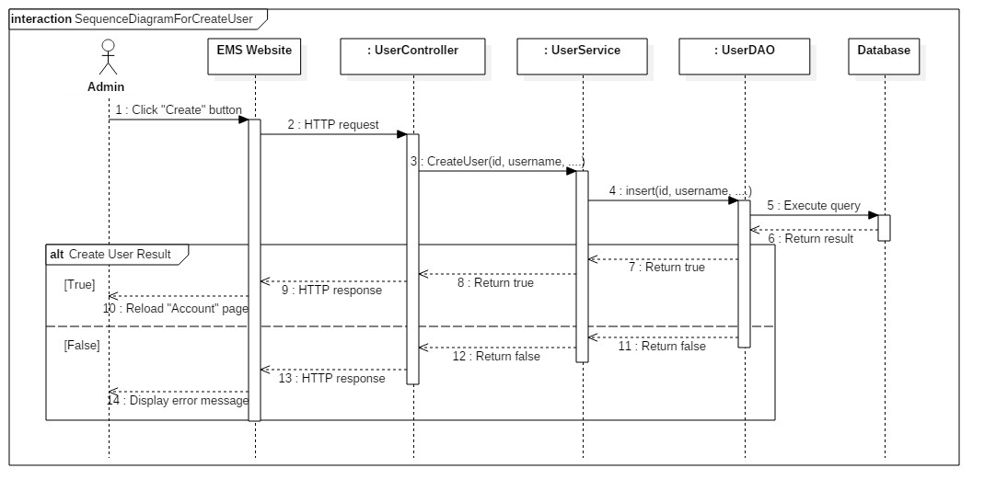

*Figure 45 - Sequence Diagram for Create User <Admin>*

#### 4.3.2 Unauthorized User

##### 4.3.2.1 Login

Summary: this diagram shows process for login.

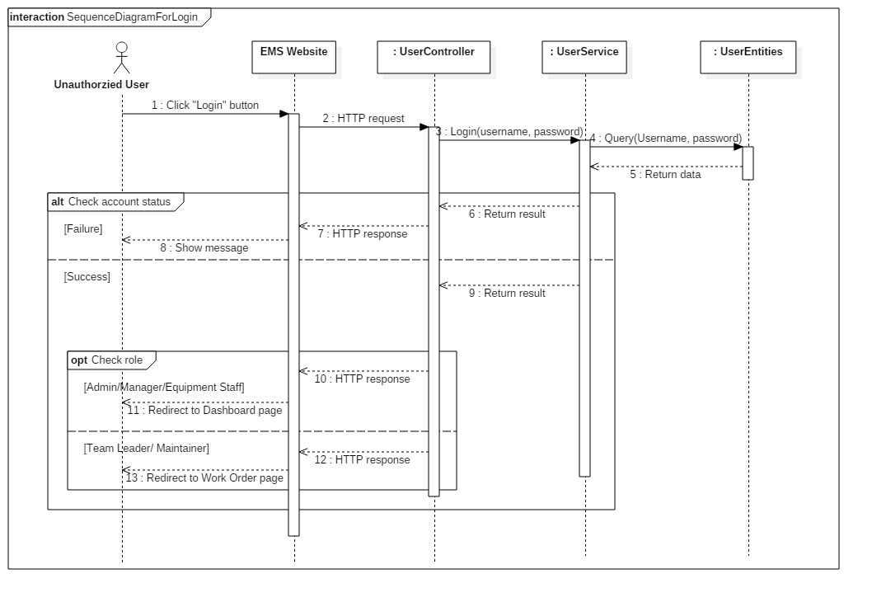

Figure 46 - Sequence Diagram for Login < Unauthorized User >

#### 4.3.3 Manager

##### 4.3.3.1 Approve Work Order

Summary: this diagram shows process of approving work order.

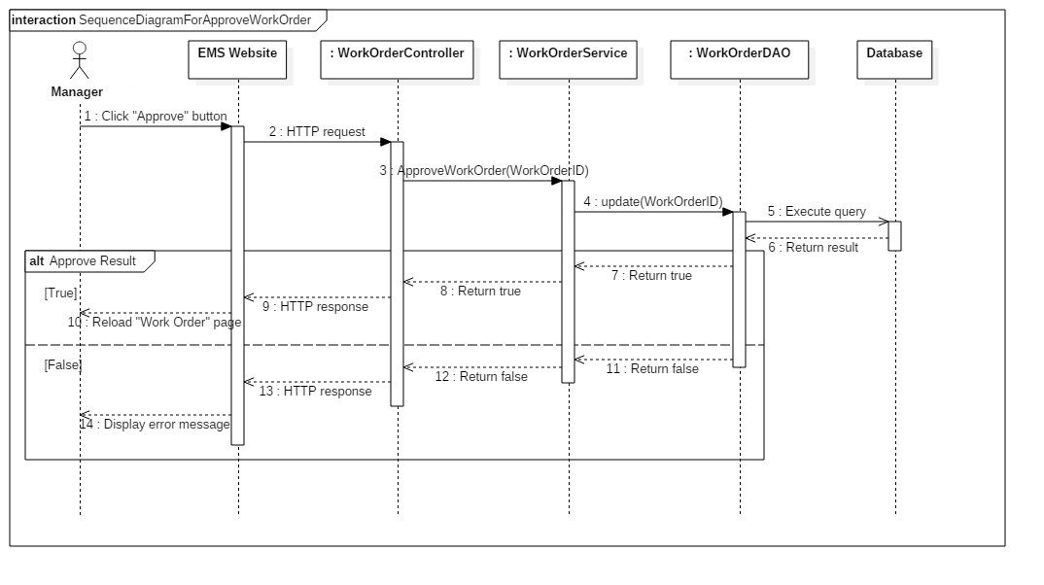

Figure 47 - Sequence Diagram for Approve Work Order < Manager >

##### 4.3.3.2 Reject Work Order

Summary: this diagram shows process of rejecting work order

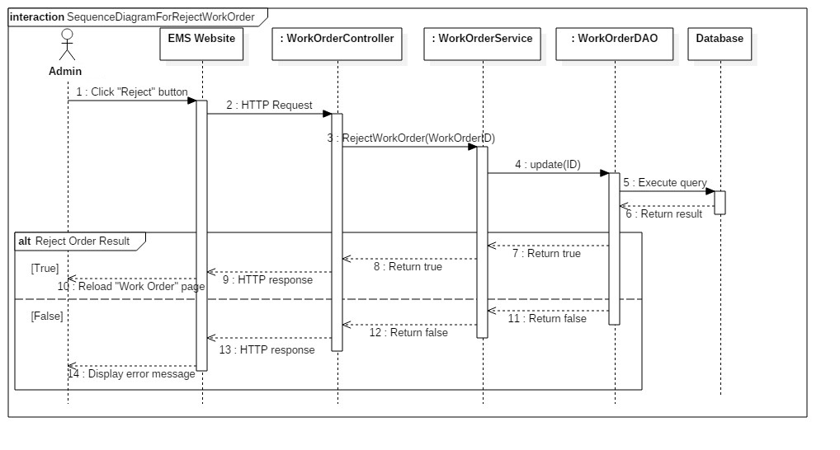

Figure 48 - Sequence Diagram for Reject Work Order < Manager >

##### 4.3.1.3 Create Team

Summary: this diagram shows process of creating a team

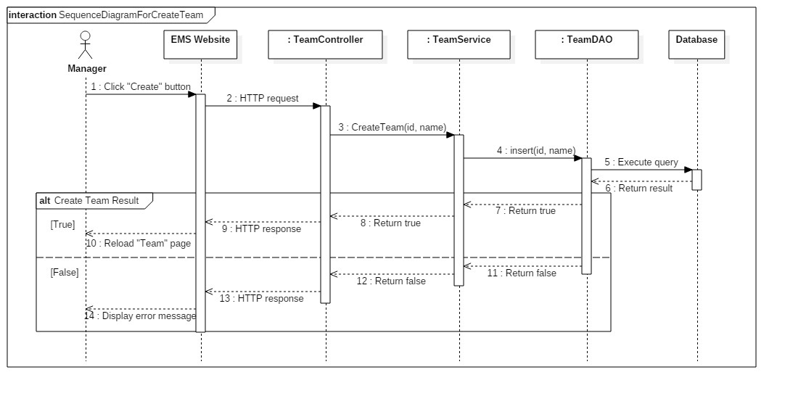

Figure 49 - Sequence Diagram for Create Team < Manager >

#### 4.3.4 Equipment Staff

##### 4.3.4.1 Change Status Work Order

Summary: this diagram shows process of changing status work order

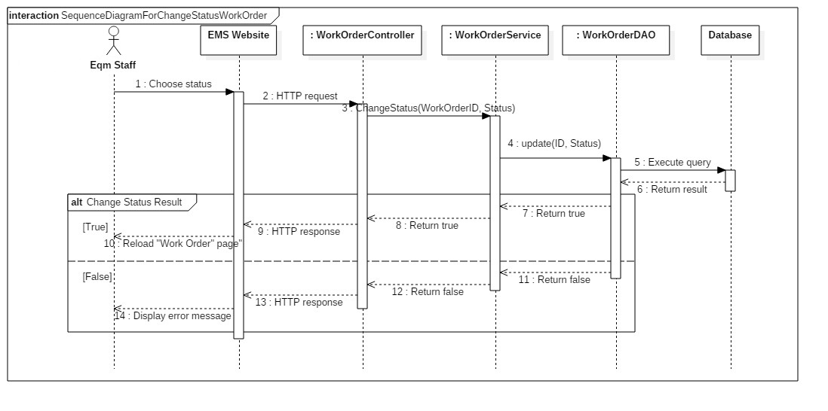

Figure 50 - Sequence Diagram for Change Status Work Order < Equipment Staff >

##### 4.3.4.2 List Work Order

Summary: this diagram shows process of listing work order

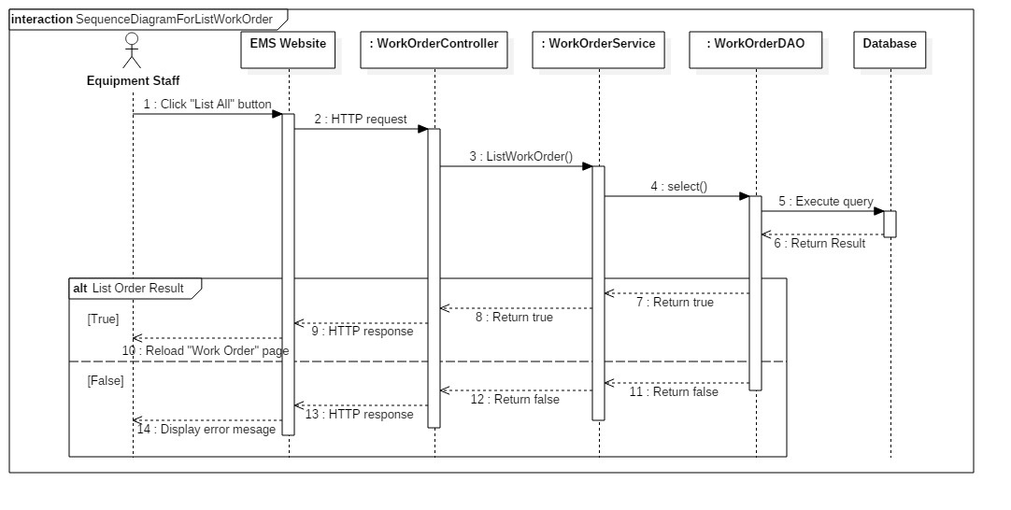

Figure 51 - Sequence Diagram for List Work Order < Equipment Staff >

##### 4.3.4.3 Create Vendor

Summary: this diagram shows process of creating a vendor

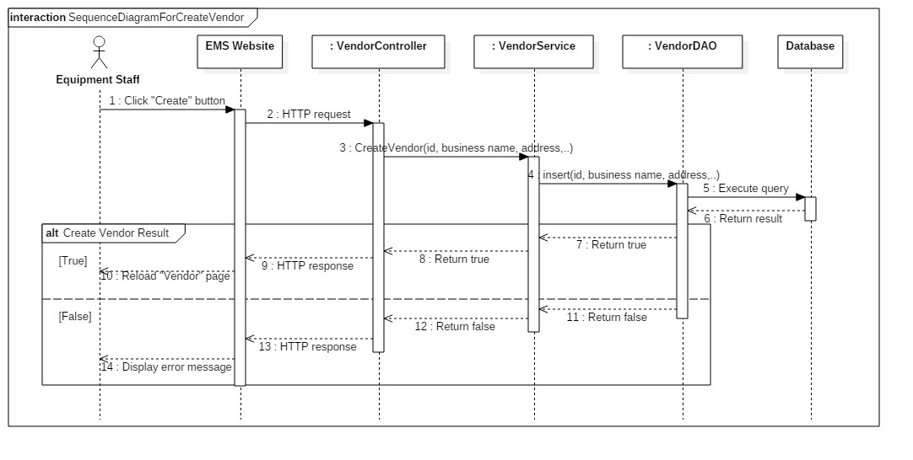

Figure 52 - Sequence Diagram for Create Vendor < Equipment Staff >

##### 4.3.4.4 Create Equipment Category

Summary: this diagram shows process of creating an equipment category

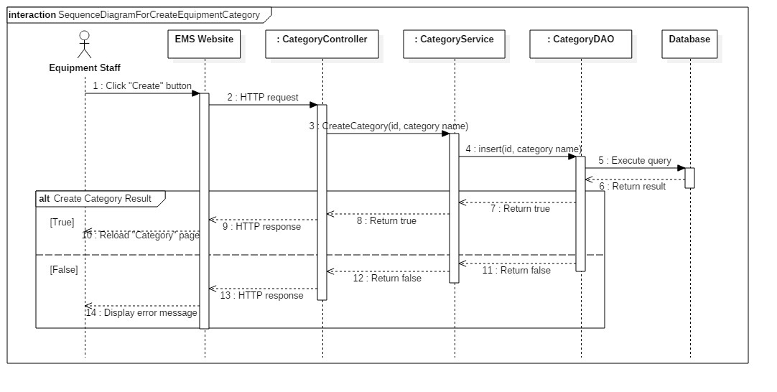

Figure 53 - Sequence Diagram for Create Equipment Category < Equipment Staff >

##### 4.3.4.5 Create Equipment Items

Summary: this diagram shows process of creating equipment items

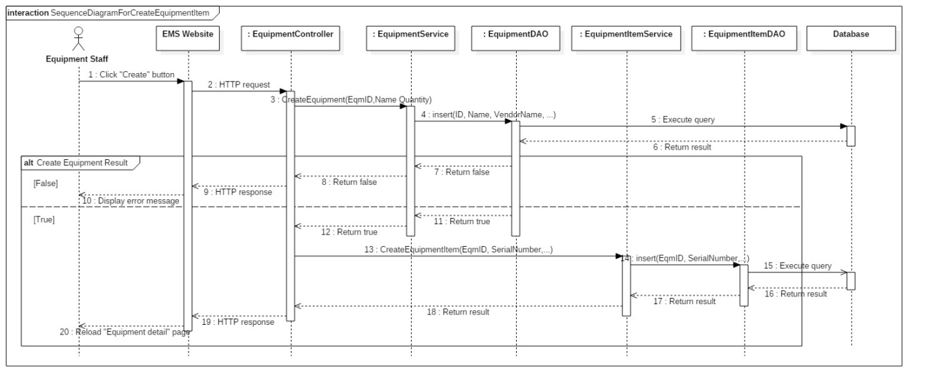

Figure 54 - Sequence Diagram for Create Equipment Items < Equipment Staff >

#### 4.3.5 Authorized User

##### 4.3.5.1 Logout

Summary: this diagram shows process of leaving system

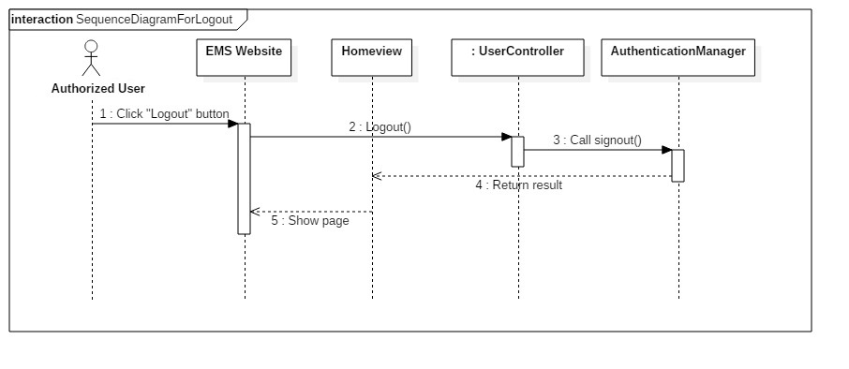

Figure 55 - Sequence Diagram for Logout < Authorized User >

#### 4.3.6 Team Leader/ Maintainer

##### 4.3.6.1 Create Work Order

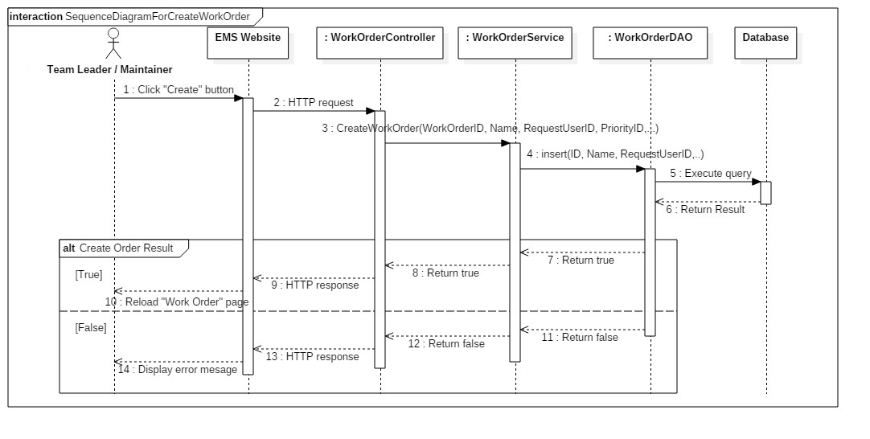Summary: this diagram shows process of creating work order

Figure 56 - Sequence Diagram for Create Work Order < Team Leader/ Maintainer >

##### 4.3.6.2 Edit Work Order

Summary: this diagram shows process of editing work order

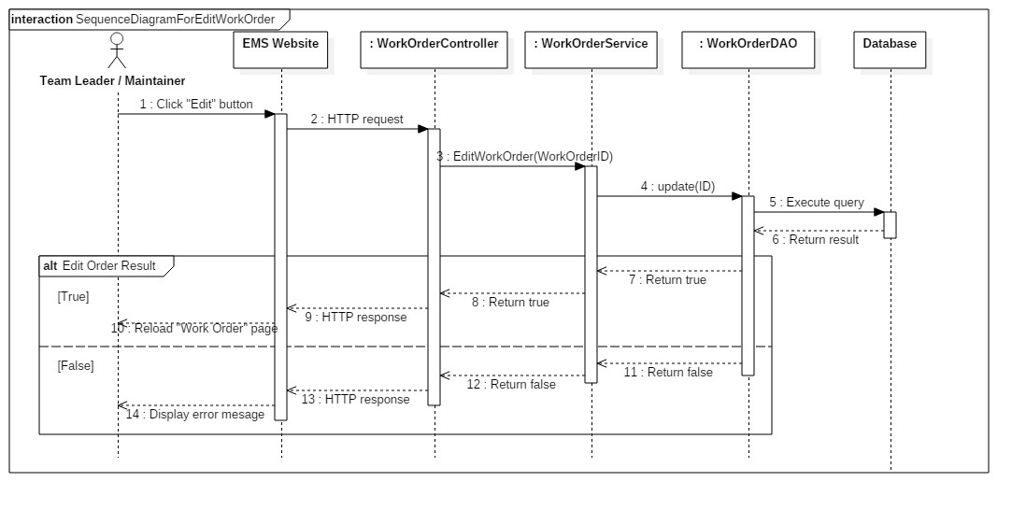

Figure 57 - Sequence Diagram for Edit Work Order < Team Leader/ Maintainer >

### 4.4 State Machine Diagram

#### 4.4.1 State Machine Diagram of Work Order

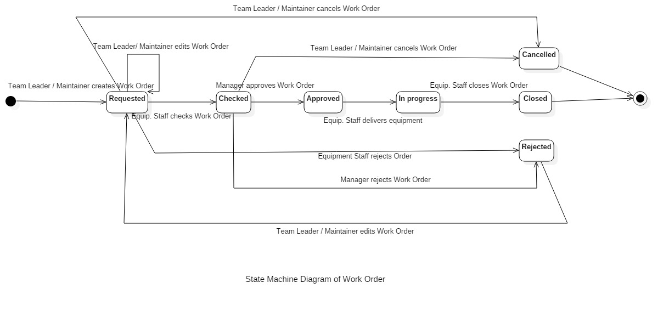

Figure 58 - State Machine Diagram of Work Order

#### 4.4.2 State Machine Diagram of Equipment Item

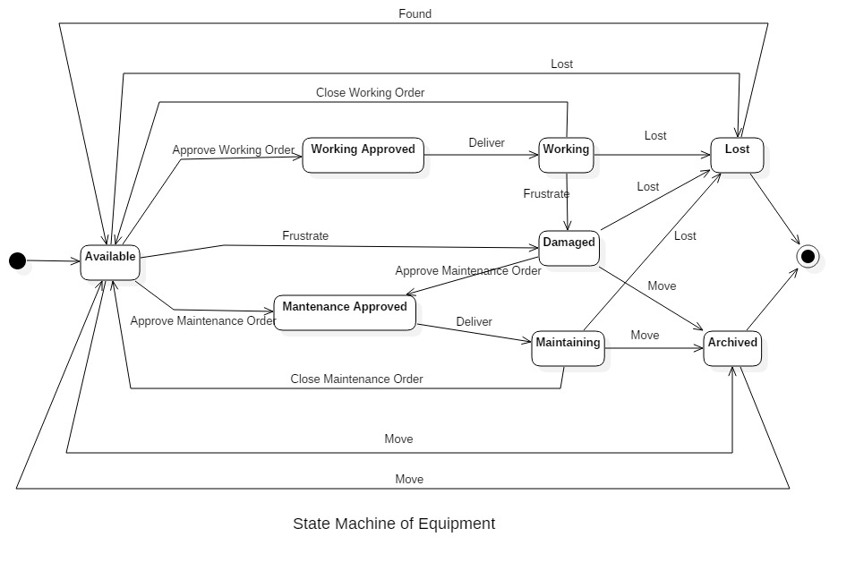

Figure 59 - State Machine Diagram of Equipment Item

## 5. User Interface Design

### 5.1. Web application user interface

#### 5.1.1 Login

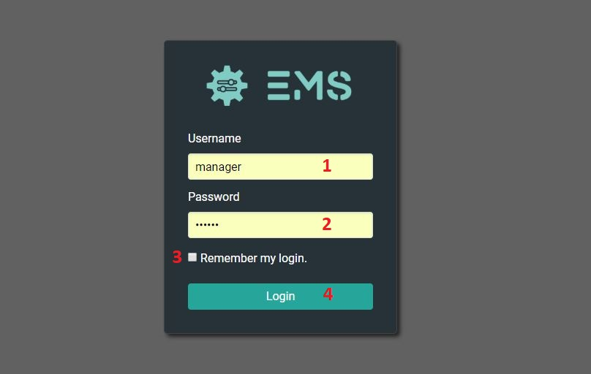

Figure 60 - User Interface <Login>

**Field**

|  |  |  |  |  |  |  |  |
| --- | --- | --- | --- | --- | --- | --- | --- |
| **No** | **Field Name** | **Description** | **Read only** | **Mandatory** | **Control Type** | **Data Type** | **Length** |
| 1 | Username | Username to login | No | Yes | Textbox | String |  |
| 2 | Password | Password to login | No | Yes | Textbox | String |  |
| 3 | Remember login | Auto log in | No | No | Checkbox | Boolean |  |

Table 63 - Login <Field>

**Buttons/Hyperlinks:**

|  |  |  |  |  |
| --- | --- | --- | --- | --- |
| **No** | **Function** | **Description** | **Validation** | **Outcome** |
| 4 | Login | Login into system | Validate all required fields | Navigate to page |

Table 64 - Login <Buttons/Hyperlinks>

#### 5.1.2 View Dashboard

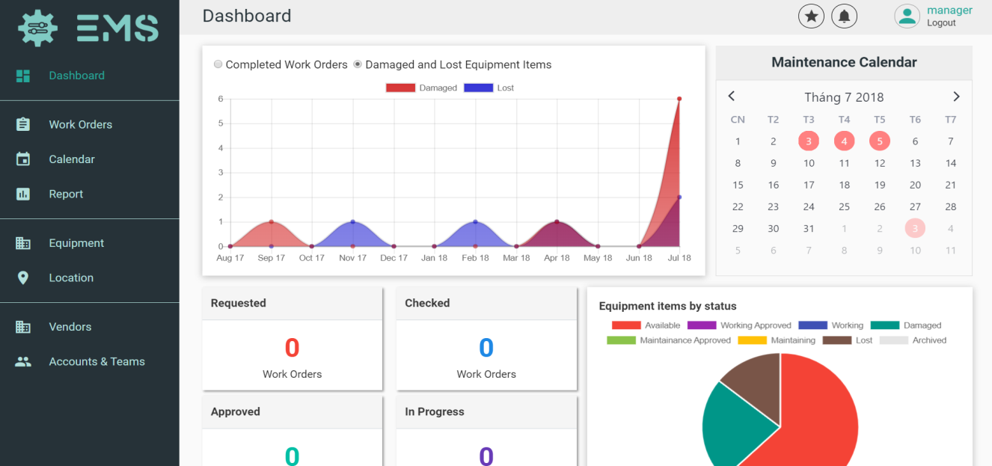

Figure 61 - User Interface <View Dashboard>

#### 5.1.3 Manage Work Order

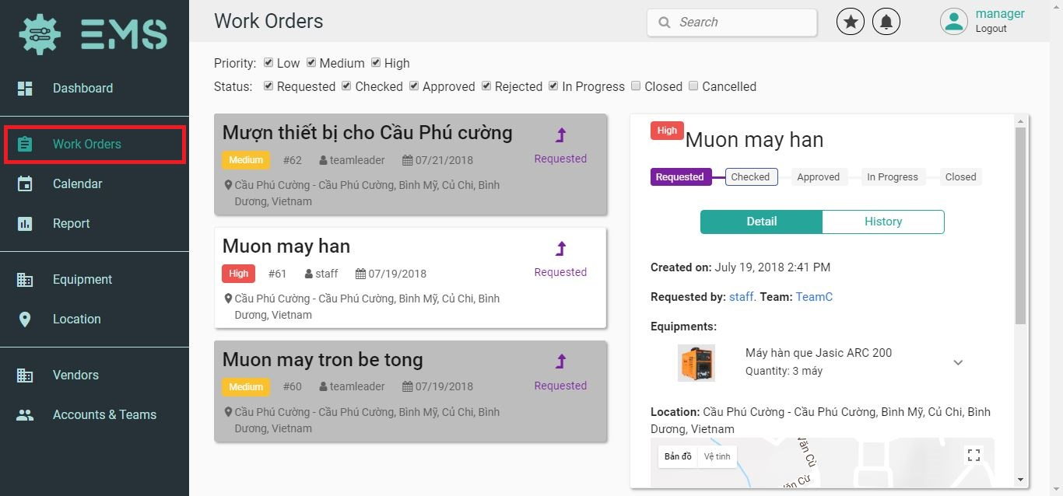

Figure 62 - User Interface <Manage Work Order>

#### 5.1.4 Manage Equipment

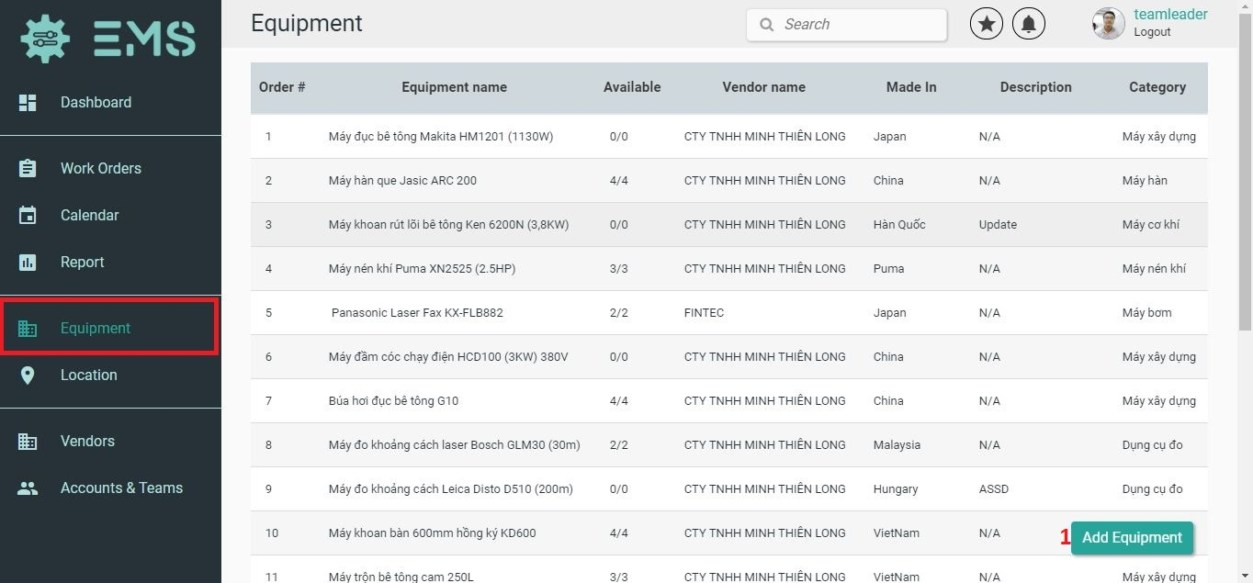

Figure 63 - User Interface <Manage Equipment>

**Buttons/Hyperlinks:**

|  |  |  |  |  |
| --- | --- | --- | --- | --- |
| **No** | **Function** | **Description** | **Validation** | **Outcome** |
| 1 | Add Equipment | Add an Equipment | N/A | Go to Add Equipment page. |

Table 65 - Manage Equipment <Buttons/Hyperlinks>

#### 5.1.5 View Schedule

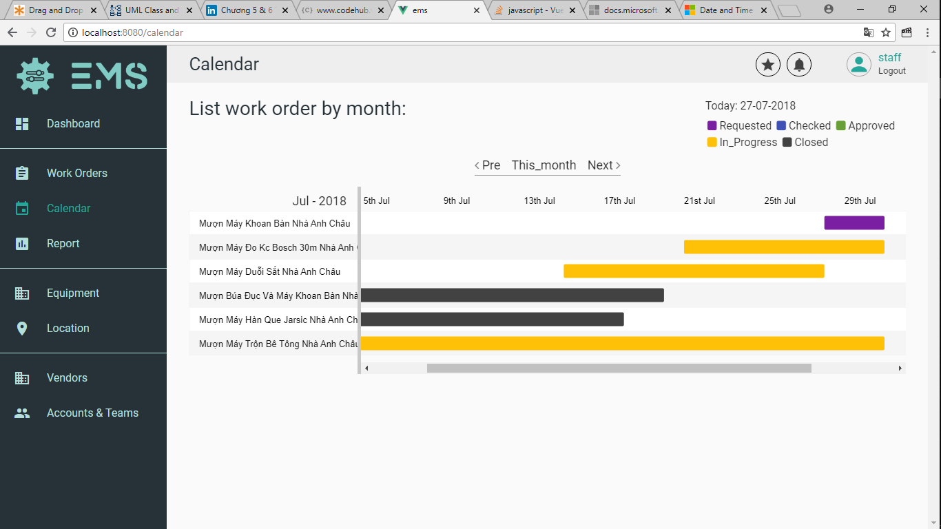

Figure 64 - User Interface <View Schedule>

#### 5.1.6 Add an Equipment

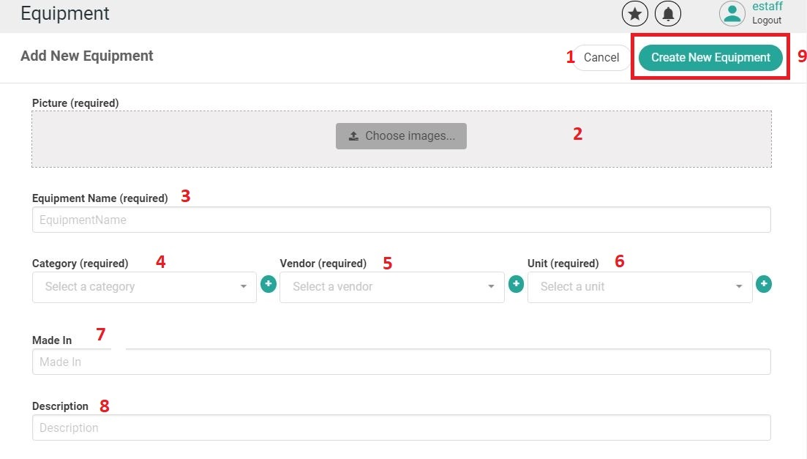

Figure 65 - User Interface <Add an Equipment>

**Field**

|  |  |  |  |  |  |  |  |
| --- | --- | --- | --- | --- | --- | --- | --- |
| **No** | **Field Name** | **Description** | **Read only** | **Mandatory** | **Control Type** | **Data Type** | **Length** |
| 3 | Equipment name | Equipment Name | No | Yes | Textbox | String |  |
| 4 | Category | Equipment Category | No | Yes | Dropdown list | String |  |
| 5 | Vendor | Equipment Vendor | No | Yes | Dropdown list | String |  |
| 6 | Unit | Equipment Unit | No | Yes | Dropdown list | String |  |
| 7 | Made on | Equipment Made In | No | Yes | Textbox | String |  |
| 8 | Description | Description | No | Yes | Textbox | String |  |

Table 66 - Add an Equipment <Field>

**Buttons/Hyperlinks:**

|  |  |  |  |  |
| --- | --- | --- | --- | --- |
| **No** | **Function** | **Description** | **Validation** | **Outcome** |
| 1 | Cancel | Cancel | N/A | Close add form |
| 2 | Choose image | Choose equipment image | N/A | Change equipment image |
| 9 | Create New Equipment | Create Equipment | Validate all required info | Go to equipment information page |

Table 67 - Add an Equipment <Buttons/Hyperlinks>

#### 5.1.7 Edit an Equipment

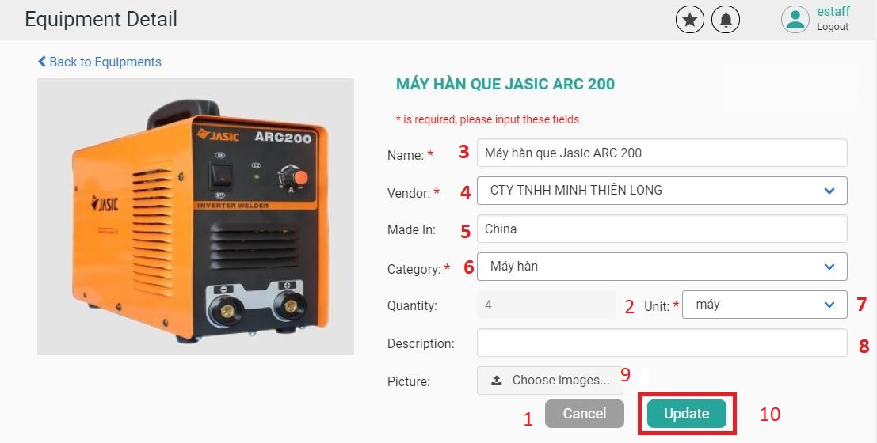

Figure 66 - User Interface <Edit Equipment>

**Field**

|  |  |  |  |  |  |  |  |
| --- | --- | --- | --- | --- | --- | --- | --- |
| **No** | **Field Name** | **Description** | **Read only** | **Mandatory** | **Control Type** | **Data Type** | **Length** |
| 2 | Quantity | Equipment Quantity | Yes | Yes | Label | Int |  |
| 3 | Name | Equipment Name | No | Yes | Textbox | String |  |
| 4 | Vendor | Equipment Vendor | No | Yes | Textbox | String |  |
| 5 | Made in | Equipment Made in | No | Yes | Textbox | String |  |
| 6 | Category | Equipment Category | No | Yes | Dropdown  list | String |  |
| 7 | Unit | Equipment Unit | No | Yes | Dropdown list | String |  |
| 8 | Description | Description | No | Yes | Textbox | String |  |

Table 68 - Edit Equipment <Field>

**Buttons/Hyperlinks:**

|  |  |  |  |  |
| --- | --- | --- | --- | --- |
| **No** | **Function** | **Description** | **Validation** | **Outcome** |
| 1 | Cancel | Cancel | N/A | Close edit form |
| 9 | Choose image | Choose equipment image | N/A | Change equipment image |
| 10 | Update | Save changes | Validate all required info | Update equipment information |

Table 69 - Edit Equipment <Buttons/Hyperlinks>

#### 5.1.8 Create Equipment Items

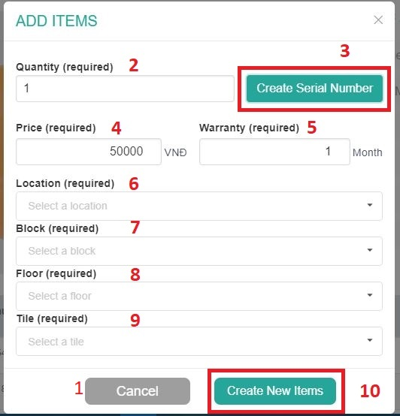

Figure 67 - User Interface <Create Equipment Item>

**Field**

|  |  |  |  |  |  |  |  |
| --- | --- | --- | --- | --- | --- | --- | --- |
| **No** | **Field Name** | **Description** | **Read only** | **Mandatory** | **Control Type** | **Data Type** | **Length** |
| 2 | Quantity | Equipment Quantity | No | Yes | Textbox | Int |  |
| 4 | Price | Equipment Item Price | No | Yes | Textbox | Float |  |
| 5 | Warranty | Equipment Item Warranty | No | Yes | Textbox | Int |  |
| 6 | Location | Equipment Item Location | No | Yes | Dropdown list | String |  |
| 7 | Block | Equipment Item Block | No | Yes | Dropdown list | String |  |
| 8 | Floor | Equipment Item Floor | No | Yes | Dropdown list | String |  |
| 9 | Tile | Equipment Item Tile | No | Yes | Dropdown list | String |  |

Table 70 - Create Equipment Items <Field>

**Buttons/Hyperlinks:**

|  |  |  |  |  |
| --- | --- | --- | --- | --- |
| **No** | **Function** | **Description** | **Validation** | **Outcome** |
| 1 | Cancel | Cancel | N/A | Close add form |
| 3 | Create Serial  Number | Create Serial Number | N/A | Create serial number |
| 10 | Create New Items | Create Items | Validate all required info | Go to equipment detail information page |

Table 71 - Create Equipment Items <Buttons/Hyperlinks>

#### 5.1.9 Manage Location <List View>

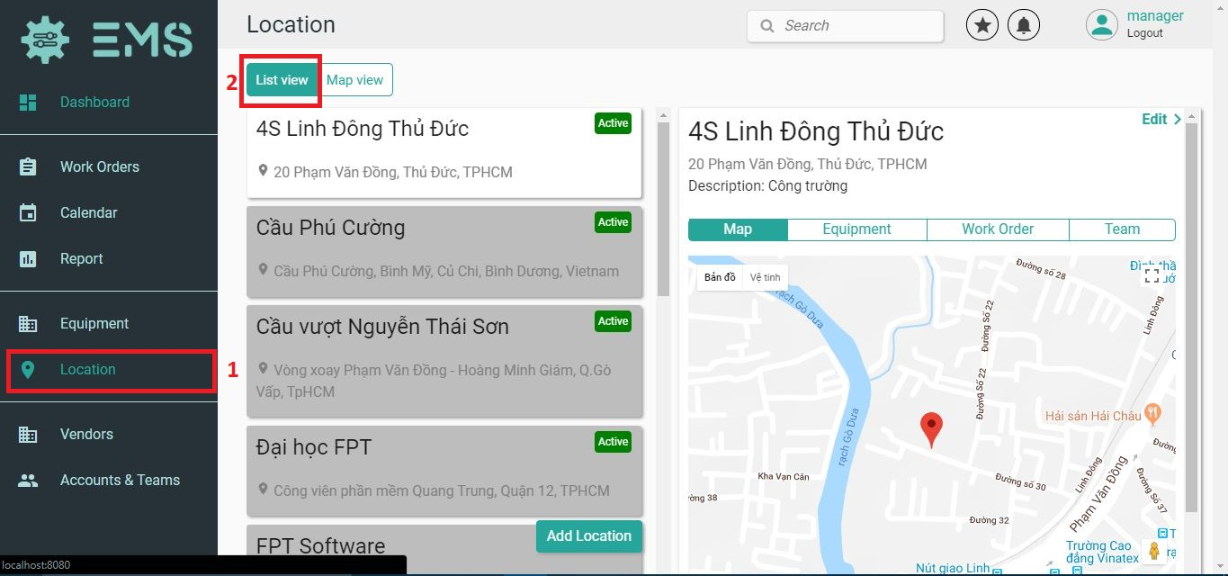

Figure 68 - User Interface <Manage Location List View>

**Buttons/Hyperlinks:**

|  |  |  |  |  |
| --- | --- | --- | --- | --- |
| **No** | **Function** | **Description** | **Validation** | **Outcome** |
| 2 | List View | View list Location | N/A | Show List of Location |

Table 72 - Manage Location List View <Field>

#### 5.1.10 Manage Location <Map View>

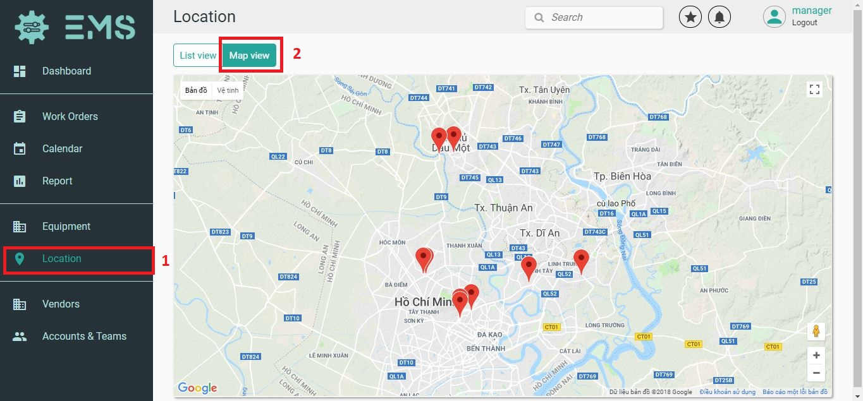

Figure 69 - User Interface <Manage Location Map View>

**Buttons/Hyperlinks:**

|  |  |  |  |  |
| --- | --- | --- | --- | --- |
| **No** | **Function** | **Description** | **Validation** | **Outcome** |
| 2 | Map View | Show list of location on maps | N/A | Show List of Team |

Table 73 - Manage Location Map View <Field>

#### 5.1.11 Create a Vendor

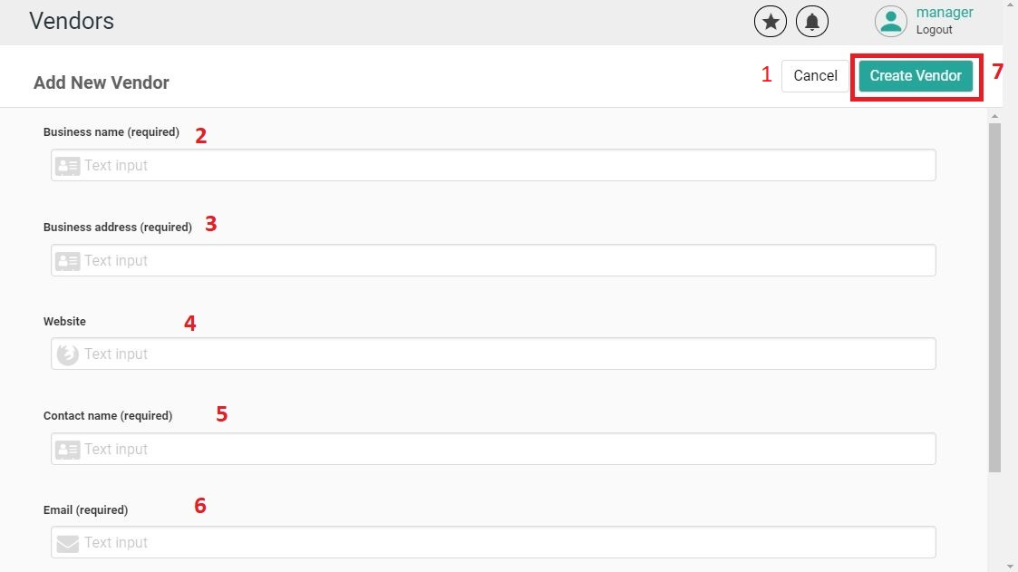

Figure 70 - User Interface <Create a Vendor>

**Field**

|  |  |  |  |  |  |  |  |
| --- | --- | --- | --- | --- | --- | --- | --- |
| **No** | **Field Name** | **Description** | **Read only** | **Mandatory** | **Control Type** | **Data Type** | **Length** |
| 2 | Business Name | Vendor Business Name | No | Yes | Textbox | String |  |
| 3 | Business Address | Vendor Business Address | No | Yes | Textbox | String |  |
| 4 | Website | Vendor Website | No | Yes | Textbox | String |  |
| 5 | Contact Name | Vendor Contact Name | No | Yes | Textbox | String |  |
| 6 | Email | Vendor Email | No | Yes | Textbox | String |  |

Table 74 - Create a Vendor <Field>

**Buttons/Hyperlinks:**

|  |  |  |  |  |
| --- | --- | --- | --- | --- |
| **No** | **Function** | **Description** | **Validation** | **Outcome** |
| 1 | Cancel | Cancel | N/A | Close add form |
| 7 | Create Vendor | Create Vendor | Validate all required info | Go to vendor information page |

Table 75 - Create a Vendor <Buttons/Hyperlinks>

#### 5.1.12 Edit a Vendor

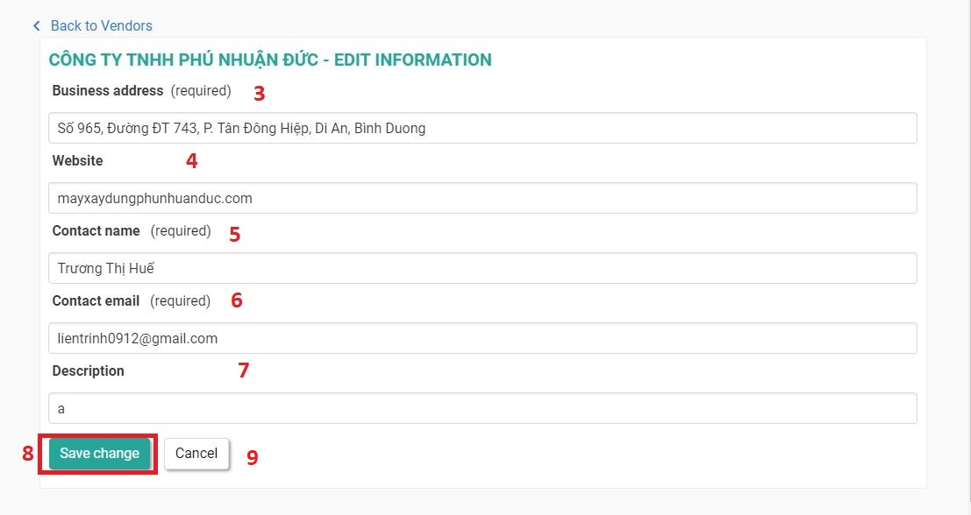

Figure 71 - User Interface <Edit a Vendor>

**Field**

|  |  |  |  |  |  |  |  |
| --- | --- | --- | --- | --- | --- | --- | --- |
| **No** | **Field Name** | **Description** | **Read only** | **Mandatory** | **Control Type** | **Data Type** | **Length** |
| 3 | Business Address | Vendor Business Address | No | Yes | Textbox | String |  |
| 4 | Website | Vendor Website | No | Yes | Textbox | String |  |
| 5 | Contact Name | Vendor Contact Name | No | Yes | Textbox | String |  |
| 6 | Email | Vendor Email | No | Yes | Textbox | String |  |
| 7 | Description | Description | No | Yes | Textbox | String |  |

Table 76 - Edit a Vendor <Field>

**Buttons/Hyperlinks:**

|  |  |  |  |  |
| --- | --- | --- | --- | --- |
| **No** | **Function** | **Description** | **Validation** | **Outcome** |
| 8 | Save Changes | Save Changes | Validate all required info | Update vendor information |
| 9 | Cancel | Cancel | N/A | Close edit form |

Table 77 - Edit a Vendor <Buttons/Hyperlinks>

#### 5.1.13 Create an Account

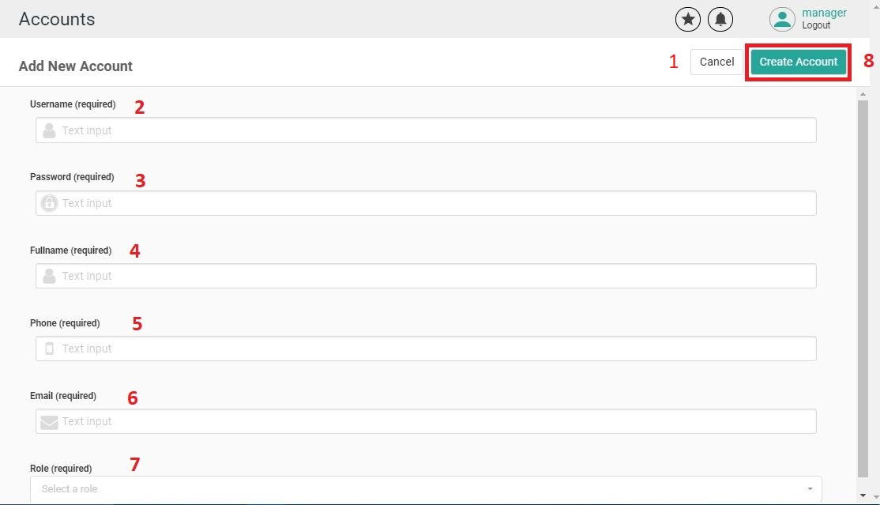

Figure 72 - User Interface <Create an Account>

**Field**

|  |  |  |  |  |  |  |  |
| --- | --- | --- | --- | --- | --- | --- | --- |
| **No** | **Field Name** | **Description** | **Read only** | **Mandatory** | **Control Type** | **Data Type** | **Length** |
| 2 | Username | Account Username | No | Yes | Textbox | String |  |
| 3 | Password | Account Password | No | Yes | Textbox | String |  |
| 4 | Fullname | Account Full name | No | Yes | Textbox | String |  |
| 5 | Phone | Account Phone | No | Yes | Textbox | String |  |
| 6 | Email | Account Email | No | Yes | Textbox | String |  |
| 7 | Role | Account Role | No | Yes | Drop down list | String |  |

Table 78 - Create an Account <Field>

**Buttons/Hyperlinks:**

|  |  |  |  |  |
| --- | --- | --- | --- | --- |
| **No** | **Function** | **Description** | **Validation** | **Outcome** |
| 1 | Cancel | Cancel | N/A | Close add form |
| 8 | Create Account | Create Account | Validate all required info | Go to account information page |

Table 79 - Create an Account <Buttons/Hyperlinks>

#### 5.1.14 Edit an Account

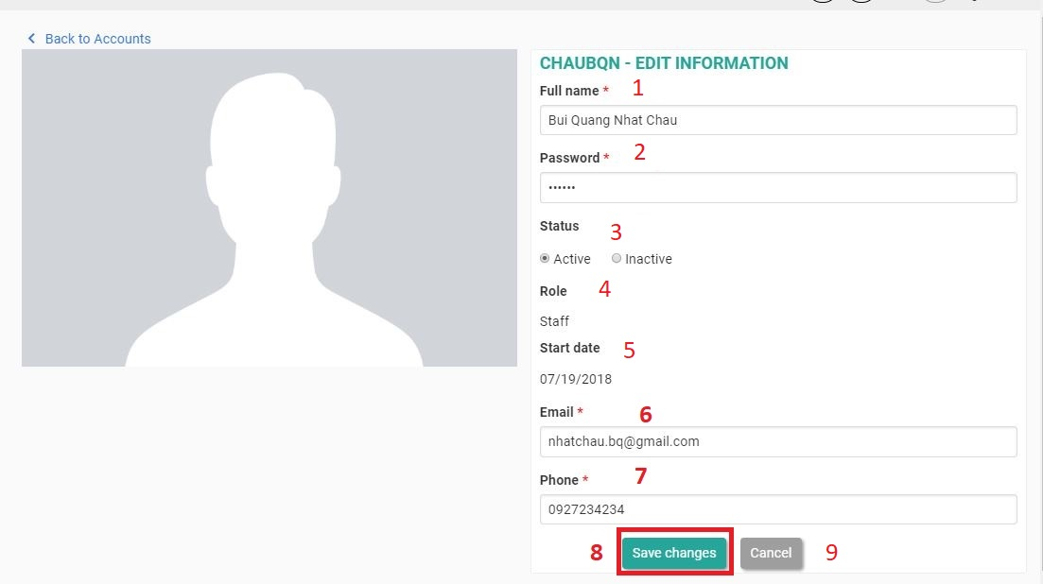

Figure 73 - User Interface <Edit an Account>

**Field**

|  |  |  |  |  |  |  |  |
| --- | --- | --- | --- | --- | --- | --- | --- |
| **No** | **Field Name** | **Description** | **Read only** | **Mandatory** | **Control Type** | **Data Type** | **Length** |
| 1 | Fullname | Account Name | No | Yes | Textbox | String |  |
| 2 | Password | Account Password | No | Yes | Textbox | String |  |
| 4 | Role | Account Role | Yes | Yes | Label | String |  |
| 5 | Start date | Account Start Date | Yes | Yes | Label | String |  |
| 6 | Email | Account Email | No | Yes | Textbox | String |  |
| 7 | Phone | Account Phone | No | Yes | Textbox | String |  |

Table 80 - Edit an Account <Field>

**Buttons/Hyperlinks:**

|  |  |  |  |  |
| --- | --- | --- | --- | --- |
| **No** | **Function** | **Description** | **Validation** | **Outcome** |
| 3 | Status | Account Status | N/A | Change account status |
| 8 | Save Changes | Save Changes | Validate all required info | Update account information |
| 9 | Cancel | Cancel | N/A | Close edit form |

Table 81 - Edit an Account <Buttons/Hyperlinks>

#### 5.1.15 Manage Team

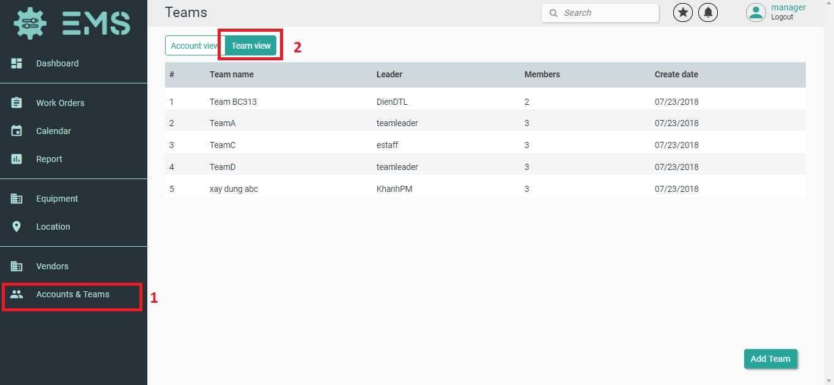

Figure 74 - User Interface <Manage Team>

**Buttons/Hyperlinks:**

|  |  |  |  |  |
| --- | --- | --- | --- | --- |
| **No** | **Function** | **Description** | **Validation** | **Outcome** |
| 2 | Team View | View all Team | N/A | Show List of Team |

Table 82 - Manage Team <Field>

#### 5.1.16 Create a Team

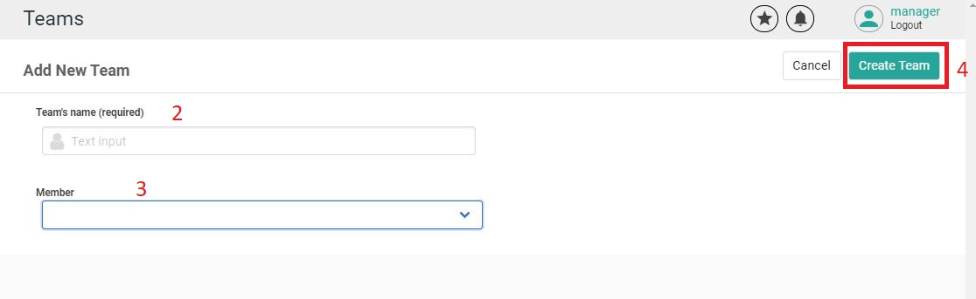

Figure 75 - User Interface <Create a Team>

**Field**

|  |  |  |  |  |  |  |  |
| --- | --- | --- | --- | --- | --- | --- | --- |
| **No** | **Field Name** | **Description** | **Read only** | **Mandatory** | **Control Type** | **Data Type** | **Length** |
| 2 | Team Name | Name of Team | No | Yes | Textbox | String |  |
| 3 | Member | Member | No | Yes | Dropdown list | String |  |

Table 83 - Create a Team <Field>

**Buttons/Hyperlinks:**

|  |  |  |  |  |
| --- | --- | --- | --- | --- |
| **No** | **Function** | **Description** | **Validation** | **Outcome** |
| 4 | Create Team | Add a team | N/A | Go to Team page. |

Table 84 - Create a Team <Buttons/Hyperlinks>

#### 5.1.17 Edit a Team

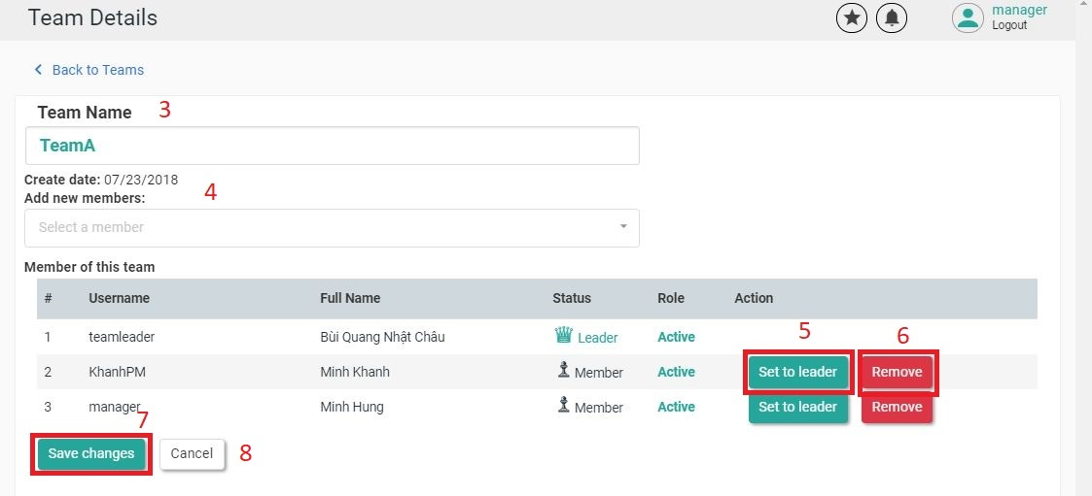

Figure 76 - User Interface <Edit a Team>

**Field**

|  |  |  |  |  |  |  |  |
| --- | --- | --- | --- | --- | --- | --- | --- |
| **No** | **Field Name** | **Description** | **Read only** | **Mandatory** | **Control Type** | **Data Type** | **Length** |
| 3 | Team Name | Name of Team | No | Yes | Textbox | String |  |
| 4 | Member | Member | No | Yes | Dropdown list | String |  |

Table 85 - Edit a Team <Field>

**Buttons/Hyperlinks:**

|  |  |  |  |  |
| --- | --- | --- | --- | --- |
| **No** | **Function** | **Description** | **Validation** | **Outcome** |
| 5 | Set to Leader | Set this user to leader | N/A | Go to Team Detail page. |
| 6 | Remove | Drop this user from team | N/A | Go to Team Detail page. |
| 7 | Save changes | Save all information | N/A | Go to Team Detail page. |
| 8 | Cancel | Cancel | N/A | Edit form will close. Go to Team Detail page. |

Table 86 - Edit a Team <Buttons/Hyperlinks>

## 6. Database Design

### 6.1 Entity relationship diagram (ERD)

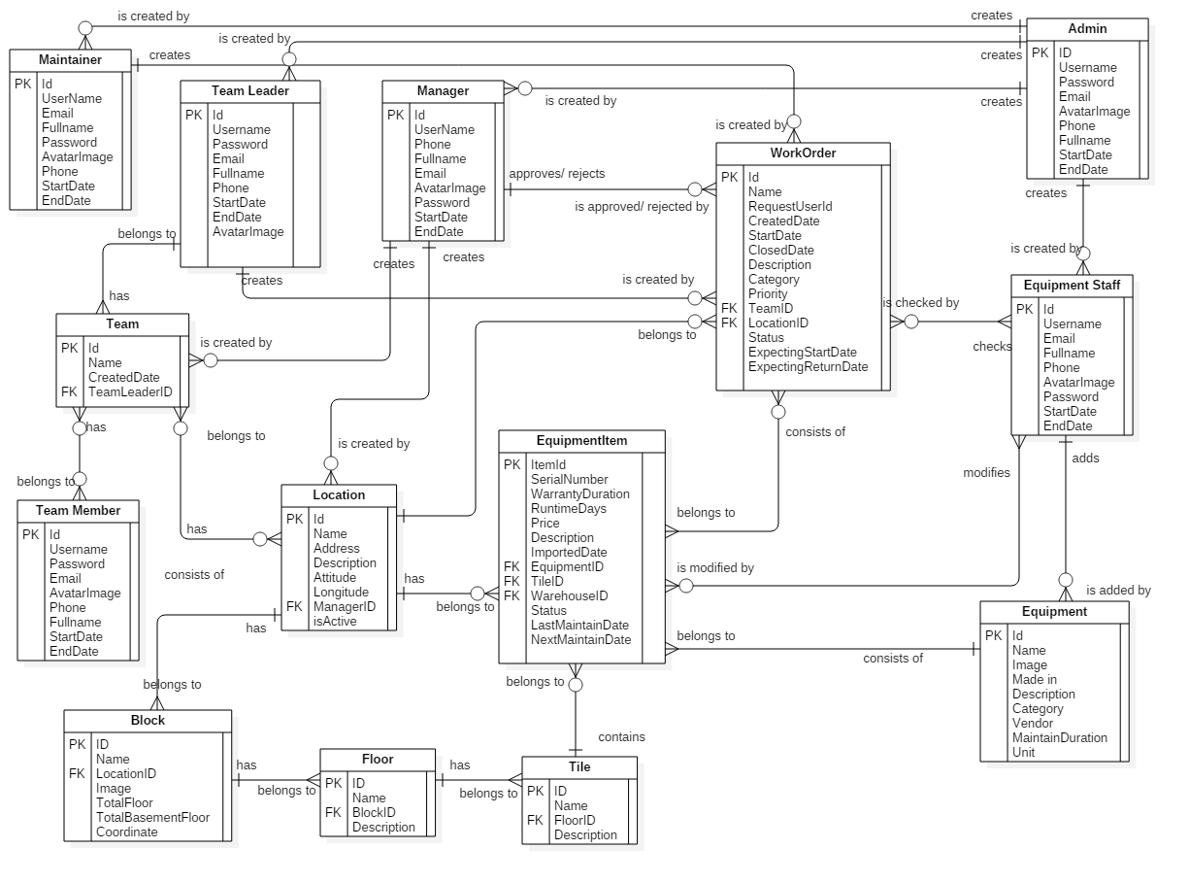

Figure 77 - Entity Relationship Diagram

### 6.2 Entity dictionary

|  |  |
| --- | --- |
| Entity Data Dictionary: describe content of all entities | |
| Entity name | Description |
| Maintainer | Contains the maintainer’s information |
| Team Leader | Contains the system team leader’s information |
| Team Member | Contains the system team member’s information |
| Team | Contains the team’s information |
| Admin | Contains the admin’s information |
| Manager | Contains the manager’s information |
| Location | Contains the location’s information |
| Block | Contains the block’s information |
| Floor | Contains the floor’s information |
| Tile | Contains the tile’s information |
| Equipment | Contains the equipment’s information |
| Equipment Item | Contains the equipment item’s information |
| Work Order | Contains the work order’s information |
| Equipment Staff | Contains the equipment staff’s information |

Table 87 - Entity Dictionary

## 7. Algorithms

### 7.1. Optimal Equipment Suggestion

#### 7.1.1 Definition

When a user creates a list of borrowed items for using, the system will propose the optimal equipment items.

#### 7.1.2 Define problem

Each working order has its own equipment. When your working order includes the same items with other ones, it shall be rejected. In case of items borrowed for a long time, they need to be kept in good conditions to avoid damage. For using more effectively; avoiding the items used over capacity and items that have not been used for a long time, we need an algorithm to make optimal suggestions for users.

#### 7.1.3 Solution

For optimizing the management and allotment of equipment, we propose the following solution.

Factors that will affect the proposal for each working order:

1. Run-time of an equipment item.

2. The distance between the warehouse of the item and the location of the item is put into operation.

3. Other working order that contained the equipment item.

Let N be the proposed priority of an item in each order.

Let A0 is the number of days since the equipment item is entered into the system.

Let A is the run-time of an equipment item (by date).

Let B is the distance between the warehouse of the item and the location of the item is put into operation.

Let C is an order number that duplicates the item for that time period and it has not been approved yet.

$$N=\left(X*\frac{A0-A}{A0}+Y*\frac{|sin(\frac{√(B)}{2.5})|}{\frac{√(B)}{2.5}} \right)*\frac{1}{C+1} ( X+Y=1;X,Y∈N )$$

*X, Y may vary.*

For examples:

For urgency orders (i.e., the interval between order creation date and item usage date is less than 3 days), **X = 0.3** and **Y = 0.7**, so N is calculated as follows:

$$N=\left(0.3*\frac{A0-A}{A0}+0.7*\frac{|sin(\frac{√(B)}{2.5})|}{\frac{√(B)}{2.5}} \right)*\frac{1}{C+1} ( X+Y=1;X,Y∈N )$$

For the remaining cases, **X = 0.7** and **Y = 0.3,** so N is calculated as follows:

$$N=\left(0.7*\frac{A0-A}{A0}+0.3*\frac{|sin(\frac{√(B)}{2.5})|}{\frac{√(B)}{2.5}} \right)*\frac{1}{C+1} ( X+Y=1;X,Y∈N )$$

The below is a graph of the function:

$$y=\frac{\left|sin\left(\frac{\sqrt{x}}{2.5}\right)\right|}{\frac{\sqrt{x}}{2.5}}$$

$$\lim_{x→0}{\frac{|sin(\frac{√(x)}{2.5})|}{\frac{√(x)}{2.5}}=1},\lim_{x→+∞}{\frac{|sin(\frac{√(x)}{2.5})|}{\frac{√(x)}{2.5}}=0}$$

#### 7.1.4 Complexity

In total, the complexity of this algorithm is **O (n2).**

#### 7.1.5 Example

Mr. Hau creates a working order including a crane that is necessary for the construction at "27 To Ky, Tan Chanh Hiep, District 12, Ho Chi Minh" from July 27th 2018 to September 3rd 2018. This order has a medium priority.

Mr. Hau is creating this working order on July 17, 2018, so this is not an urgency order.

The number of available crane machines in the period (27/07 - 03/09) are 5 items.

|  |  |  |  |  |
| --- | --- | --- | --- | --- |
| Serial Number | Imported Date | Run-time days | Distance | Num. of orders requested. |
| 0000001 | 27/04/2018 | 35 | 10km | 0 |
| 0000002 | 27/04/2018 | 20 | 30km | 0 |
| 0000003 | 17/03/2018 | 45 | 10km | 1 |
| 0000004 | 27/04/2018 | 40 | 30km | 1 |
| 0000005 | 17/03/2018 | 38 | 10km | 0 |

Table 88 - Algorithms Examples

The N indexes for each device are calculated as follows:

$$N1=\left(0.7\frac{90-35}{90}+0.3\frac{|sin(\frac{√(10)}{2.5})|}{\frac{√(10)}{2.5}} \right)*\frac{1}{0+1}=0.433$$

$$N2=\left(0.7\frac{90-20}{90}+0.3\frac{|sin(\frac{√(30)}{2.5})|}{\frac{√(30)}{2.5}} \right)*\frac{1}{0+1}=0.550$$

$$N3=\left(0.7\frac{130-35}{130}+0.3\frac{|sin(\frac{√(10)}{2.5})|}{\frac{√(10)}{2.5}} \right)*\frac{1}{1+1}=0.258$$

$$N4=\left(0.7\frac{90-40}{90}+0.3\frac{|sin(\frac{√(30)}{2.5})|}{\frac{√(30)}{2.5}} \right)*\frac{1}{1+1}=0.197$$

$$N5=\left(0.7\frac{130-38}{130}+0.3\frac{|sin(\frac{√(10)}{2.5})|}{\frac{√(10)}{2.5}} \right)*\frac{1}{0+1}=0.501$$

So the equipment item with a serial number 0000002 will be proposed for Mr.Hau.

#### 7.1.6 Flow Chart

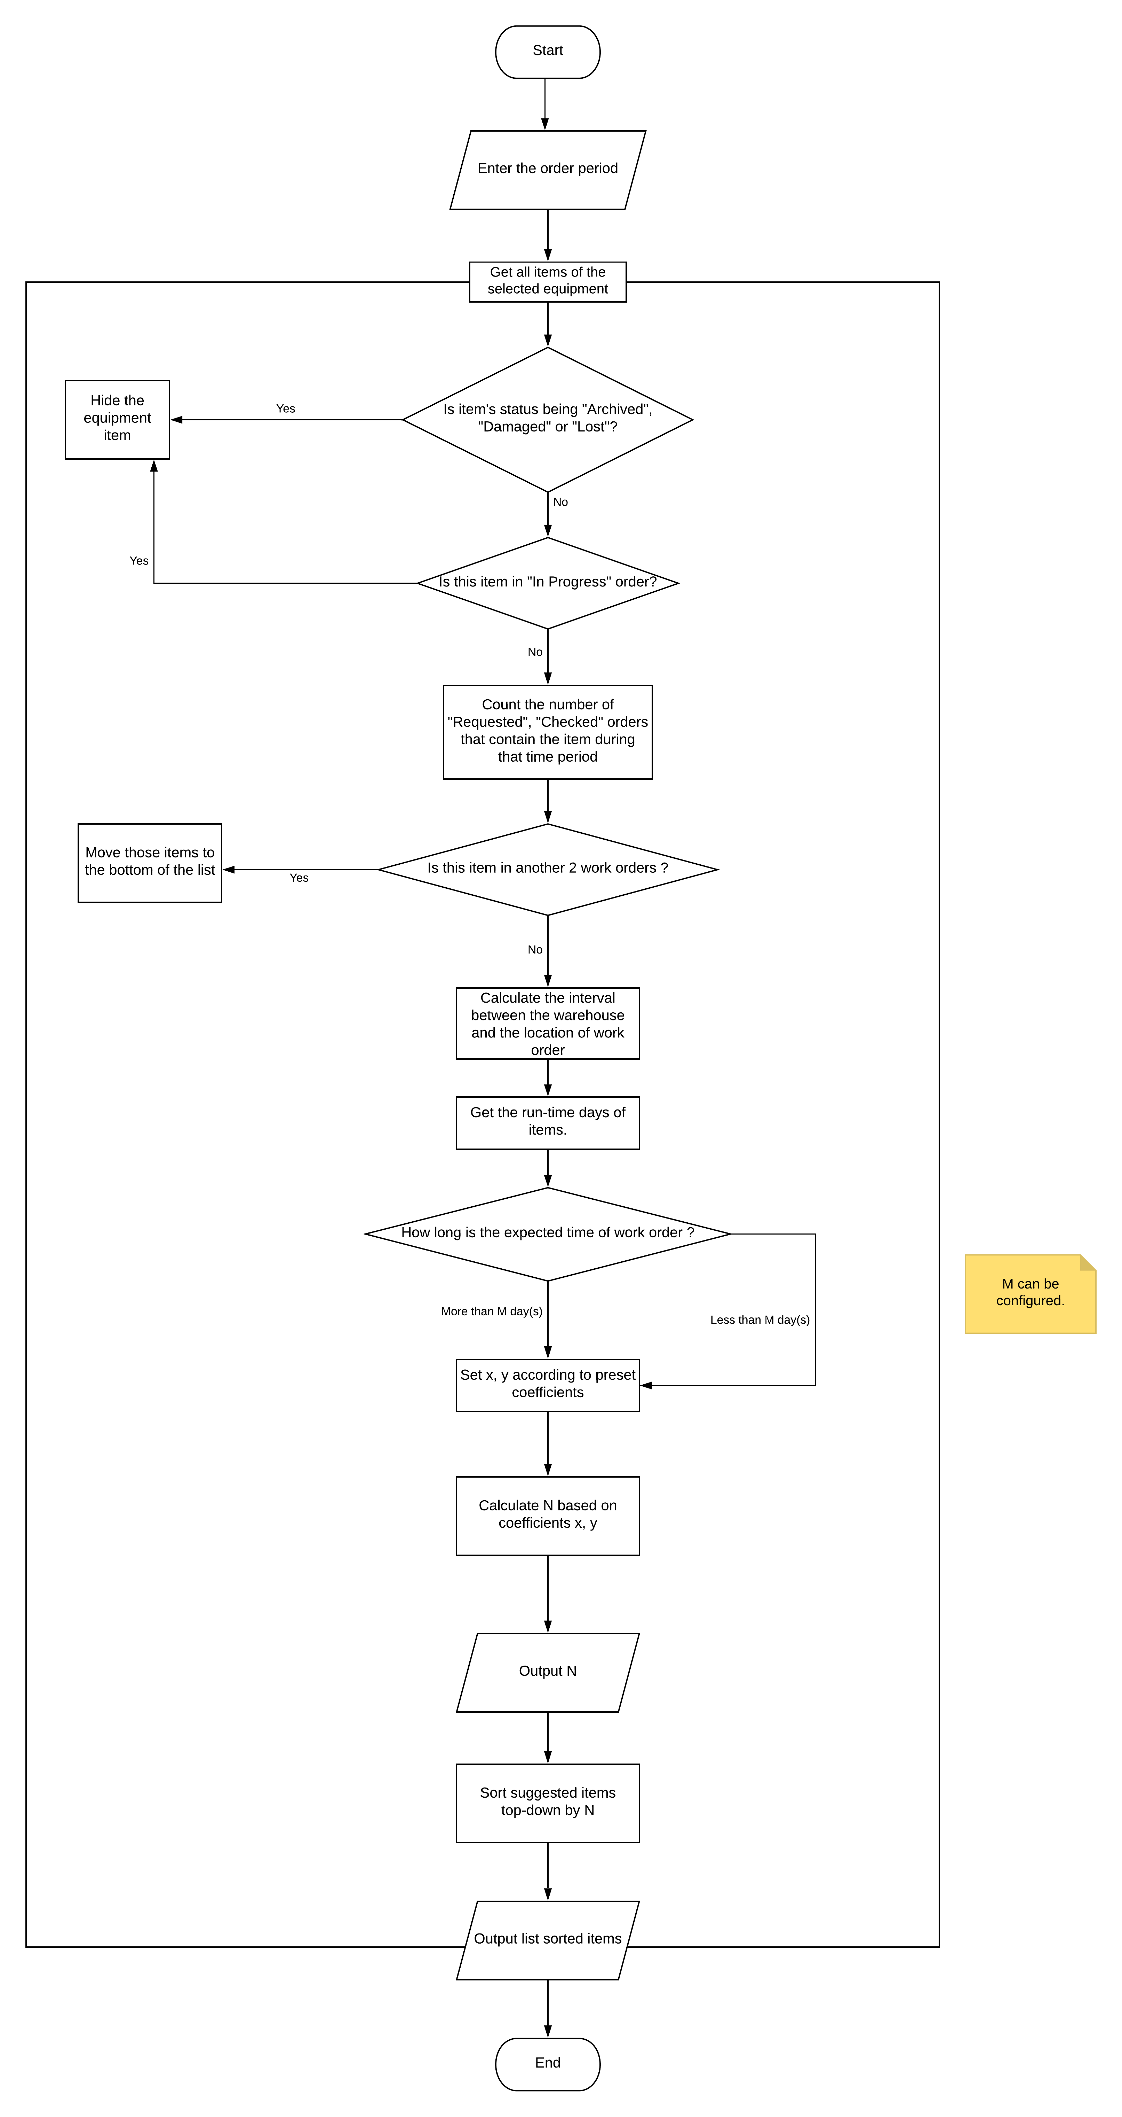

Figure 78 - Flowchart of Algorithm

# E. System Implementation & Test

## 1. Introduction

### 1.1 Overview

This section describes the approach and methodologies used by group to plan, organize and manage the testing of EMS system. It provides in detail all necessary information about the implementation and testing procedure of the system included test plans, test cases, test result, test environments, pass/fail criteria and risks estimations as well as a checklist to cover all possible cases.

### 1.2 Test approach

* Goal: Test all features in the whole EMS system based on the core flow.
* Method: black-box testing
* Technique: check list

The testing for this project will consists of Integration System test level. Testing the program which was integrated and as a complete system to ensure that the software requirements have been met.

* Integration testing would be performed by all member of team and approved by team leader.

System testing is focused on assessing the system’s reliability. This process is concerned with finding errors that result from unanticipated interactions between components and component interface problems.

## 2. Database Relationship Diagram

### 2.1 Physical diagram

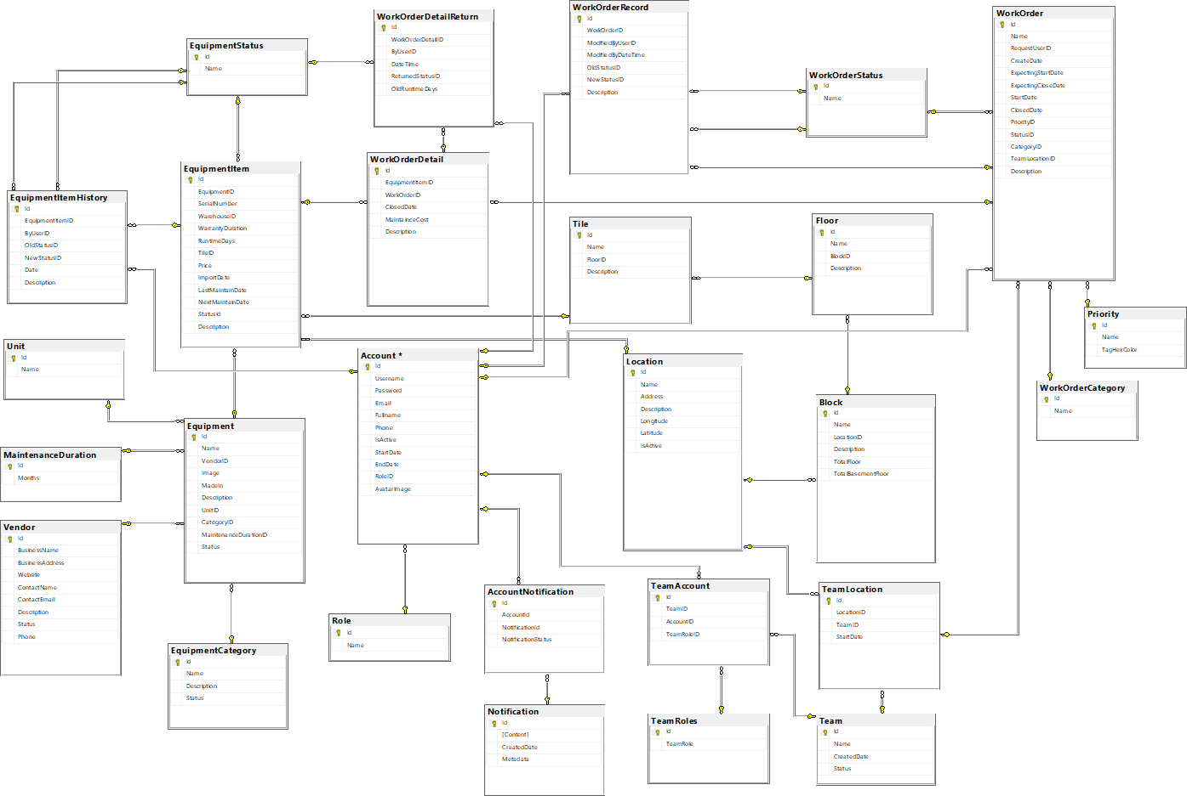

Figure 79 - Database Diagram

### 2.2 Data dictionary

|  |  |
| --- | --- |
| **DATA DICTIONARY: DESCRIBE CONTENT OF ALL TABLES** | |
| **Table name** | **Description** |
| Account | Contains the account information |
| Work Order | Contains the work order information |
| WorkOrderRecord | Contains the information of a user that modified in work order |
| WorkOrderStatus | Contains the work order’s status information |
| WorkOrderCategory | Contains the work order’s category information |
| Priority | Contains the work order’s priority information |
| Equipment | Contains the equipment information |
| Unit | Contains the unit information |
| Vendor | Contains the vendor information |
| EquipmentItem | Contains the information of item that belongs to equipment |
| EquipmentCategory | Contains the equipment’s category information |
| WorkOrderDetail | Contains the item information of a work order when user created a work order |
| EquipmentStatus | Contains the equipment’s status information |
| EquipmentItemHistory | Contains the equipment item’s history information |
| WorkOrderDetailReturn | Contains the work order information when user returned items |
| TeamAccount | Contains the information of user when that user join team |
| Team | Contains the team information |
| TeamRoles | Contains the user’s role information in a team |
| Location | Contains the location information |
| Block | Contains the block information |
| Floor | Contains the floor information |
| Tile | Contains the tile information |
| TeamLocation | Contains the information of team when team worked at location |
| Role | Contains the role’s information |
| Notification | Contains the notification’s information |
| AccountNotification | Contains the user’s information when received a notification |
| MaintenanceDuration | Contains information about the maintenance period of the equipment |

Table 89 - Data Dictionary All Tables

|  |  |  |  |  |
| --- | --- | --- | --- | --- |
| Table Name | Attributes | Description | Domain | Nulls |
| Account | ID | Unique identifier of an account | INT | NO |
| Username | Username of user | NVARCHAR(50) | NO |
| Password | Password of user | NVARCHAR(250) | NO |
| Email | Email of user | NVARCHAR(250) | YES |
| Fullname | Full name of user | NVARCHAR(250) | NO |
| AvatarImage | Avatar of user | NVARCHAR(250) | YES |
| Phone | Phone of user | NVARCHAR(13) | YES |
| IsActive | Status of user | BIT | YES |
|  | Roleid | Identifier of the role of user | INT(1) | NO |
| StartDate | Start Date of user | DATETIME | YES |
| EndDate | End Date of user | DATETIME | YES |
| WorkOrder | ID | Identifier of work order | INT | NO |
| Name | Name of work order | NVARCHAR(250) | NO |
| RequestedUserID | Identifier of the user created work order | INT | NO |
| Description | Description of work order | NVARCHAR(250) | YES |
| CreateDate | Create Date of work order | DATETIME | YES |
| DueDate | Due Date of work order | DATETIME | YES |
| ClosedDate | Closed Date of work order | DATETIME | YES |
| PriorityID | Identifier of priority of work order | INT | YES |
| StatusID | Identifier of status of work order | INT | YES |
| CategoryID | Identifier of Category of work order | INT | YES |
| TeamLocationID | Identifier of Location that has Team’s user created work order | INT | YES |
| WorkOrderRecord | ID | Identifier of work order record | INT | NO |
| WorkOderId | Identifier of work order | INT | NO |
| ModifiedByUserID | Identifier of modified User | INT | NO |
| ModifiedByDatetime | Modified Datetime by User | DATETIME | YES |
| OldStatusID | Old Status of Work Order | INT | YES |
| NewStatusID | New Status of Work Order | INT | YES |
| Description | Description of Work Order Record | NVARCHAR(500) | YES |
| WorkOrderStatus | ID | Identifier of Work Order Status | INT | NO |
| Name | Name of Work Order Status | NVARCHAR(50) | YES |
| WorkOrderCategory | ID | Identifier of Work Order Category | INT | NO |
| Name | Name of Work Order Category | NVARCHAR(50) | YES |
| Priority | ID | Identifier of Priority | INT | NO |
| Name | Name of Priority | NVARCHAR(50) | YES |
| Equipment | ID | Identifier of Equipment | INT | NO |
| Name | Name of Equipment | NVARCHAR(50) | YES |
| VendorID | Identifier of Vendor that has Equipment | INT | YES |
| Image | Image of Equipment | NVARCHAR(250) | YES |
| MadeIn | Origin of Equipment | NVARCHAR(50) | YES |
| Description | Description of Equipment | NVARCHAR(250) | YES |
| UnitID | Identifier of Unit | INT | YES |
| CategoryID | Identifier of Category | INT | YES |
| Status | Status of Equipment | BIT | YES |
| Equipment Item | ID | Identifier of item | INT | NO |
| EquipmentID | Identifier of Equipment | INT | YES |
| SerialNumber | Serial number of Item | NVARCHAR(50) | YES |
| WarrantyDuration | Warranty Duration of Item | INT | YES |
| RuntimeDays | Run-time Days of Item | INT | YES |
| Price | Price of Item | FLOAT | YES |
| ImportDate | Import Date of Item | DATETIME | YES |
| Last Maintain Date | Last Maintain Date of Item | DATETIME | YES |
| Next Maintain Date | Next Maintain Date of Item | DATETIME | YES |
| StatusID | Identifier of Status | INT | YES |
| Description | Description of Item | NVARCHAR(250) | YES |
| TileID | Identifier | INT | YES |
| Unit | ID | Identifier of Unit | INT | NO |
| Name | Name of Unit | NVARCHAR(50) | YES |
| Description | Description of skill | VARCHAR(200) | YES |
| EquipmentCategory | ID | Identifier of Equipment Category | INT | NO |
| Name | Name of Equipment Category | NVARCHAR(250) | YES |
| Description | Description of Category | NVARCHAR(250) | YES |
| Status | Status of Equipment Category | BIT | YES |
| WorkOrderDetailReturn | ID | Identifier of Work Order Detail Return | INT | NO |
| WorkOrderDetailID | Identifier of Work Order Detail | INT | YES |
| ByUserID | Identifier of Return User | INT | YES |
| Datetime | Datetime of Work Order Detail Return | DATETIME | YES |
| NewItemStatusID | Identifier of Status of Item | INT | YES |
| ReturnedStatusID | Identifier of Status of Returned Item | INT | YES |
| WorkOrderDetail | ID | Identifier of Work Order Detail | INT | NO |
| EquipmentItemID | Identifier of Item | INT | YES |
| WorkOrderID | Identifier of Work Order | INT | YES |
| ExpectingStartDate | Expecting Start Date of Work Order Detail | DATETIME | YES |
| ExpectingDueDate | Expecting Due Date of Work Order Detail | DATETIME | YES |
| StartDate | Start Date of Work Order Detail | DATETIME | YES |
| ClosedDate | Closed Date of Work Order Detail | DATETIME | YES |
| MaintainCost | Maintain Cost of Work Order Detail | FLOAT | YES |
| Description | Description of Work Order Detail | TEXT | YES |
| EquipmentStatus | ID | Identifier of Equipment Status | INT | NO |
| Name | Name of Equipment Status | NVARCHAR(250) | YES |
| EquipmentItemHistory | ID | Identifier of Equipment Item History | INT | NO |
| EquipmentItemID | Identifier of Item | INT | YES |
| ByUserID | Identifier of User | INT | YES |
| OldStatusID | Identifier of Old Status | INT | YES |
| NewStatusID | Identifier of New Status | INT | YES |
| Date | Date of Equipment Item History | DATETIME | YES |
| Description | Description of Equipment Item History | NVARCHAR(250) | YES |
| TeamAccount | ID | Identifier of a Account when join a Team | INT | NO |
| TeamID | Identifier of Team | INT | YES |
| AccountID | Identifer of Account | INT | YES |
| TeamRoleID | Identifier of Team’s Role | INT | YES |
| Team | ID | Identifier of Team | INT | NO |
| Name | Name of Team | NVARCHAR(50) | YES |
| Createddate | Created Date of Team | DATETIME | YES |
| Status | Status of Team | BIT | YES |
| TeamRoles | ID | Identifier of a User’s Role when join a Team | INT | NO |
| TeamRole | Name of Role | NVARCHAR(50) | YES |
| Location | ID | Identifier of Location | INT | NO |
| Name | Name of Location | NVARCHAR(250) | YES |
| Address | Address of Location | NVARCHAR(250) | YES |
| Description | Description of Location | NVARCHAR(250) | YES |
| Longitude | Longitude of Location | FLOAT | YES |
| Latitude | Latitude of Location | FLOAT | YES |
| IsActive | Status of Location | BIT | YES |
| Role | Id | Identifier of role | INT | NO |
| Name | Name of role | NVARCHAR(50) | NO |
| Block | Id | Identifier of Block | INT | NO |
| Name | Name of Block | NVARCHAR(50) | YES |
| LocationID | Identifier of Location that belongs to | INT | YES |
| Description | Description of Block | NVARCHAR(250) | YES |
| TotalFloor | Total Floor of Block | INT | YES |
| TotalBasementFloor | Total Basement Floor of Block | INT | YES |
| Floor | ID | Identifier of Floor | INT | NO |
| Name | Name of Floor | NVARCHAR(50) | YES |
| BlockID | Identifier of Block that belongs to | INT | YES |
| Description | Description of Floor | NVARCHAR(250) | YES |
| Tile | ID | Identifier of Tile | INT | NO |
| Name | Name of Tile | NVARCHAR(50) | YES |
| FloorID | Identifier of Floor that belongs to | INT | YES |
| Description | Description of Tile | NVARCHAR(250) | YES |
| TeamLocation | ID | Identifier of Team when working in a Location | INT | NO |
| LocationID | Identifier of Location | INT | YES |
| TeamID | Identifier of Team | INT | YES |
| StartDate | Start Date of Team when working in a Location | DATETIME | YES |
| Notification | ID | Identifier of Notification | INT | NO |
| Content | Content of Notification | STRING | YES |
| CreatedDate | Created Date of Notification | DATETIME | YES |
| AccountNotification | ID | Identifier of Notification when the user received | INT | NO |
| AccountID | Identifier of Account | INT | YES |
| NotificationID | Identifier of Notification | INT | YES |
| NotificationStatus | Notification’s Status | BOOLEAN | YES |
| Vendor | ID | Identifier of Vendor | INT | NO |
| BusinessName | Business Name of Vendor | NVARCHAR(250) | YES |
| BusinessAddress | Business Address of Vendor | NVARCHAR(250) | YES |
| Website | Website of Vendor | NVARCHAR(250) | YES |
| ContactName | Contact Name of Vendor | NVARCHAR(250) | YES |
| ContactEmail | Contact Email of Vendor | NVARCHAR(250) | YES |
| Description | Description of Vendor | NVARCHAR(250) | YES |
| Status | Status of Vendor | BIT | YES |
| Phone | Phone Number of Vendor | VARCHAR(20) | YES |
| MaintenanceDuration | ID | Identifier of Maintenance Duration | INT | NO |
| Months | Months of maintenance period | INT | YES |

Table 90 - Data Dictionary

## 3. Test plan

The overall purpose of testing is to ensure EMS meets its entire technical, functional and business requirement. The purpose of this document is to describe the overall test plan and strategy for testing the EMS. The approach described in this document provides the framework for all testing related to this application. Individual test cases will be written for each version of the application that is released. This document will also be updated as required for each release.

### 3.1 Features to be tested

* Admin: Add account
* Manager: Add location, edit location, add vendor, edit vendor, add equipment
* Equipment Staff: Add equipment, edit equipment

### 3.2 Features not to be tested

* Create Work Order
* Approve Work Order

## 4. System Testing Test Case

### 4.1 Test case

#### 4.1.1 <Manager> Add Location

|  |  |  |  |  |  |
| --- | --- | --- | --- | --- | --- |
| ID | Test Case Description | Test case procedure | Expected output | Result | Test Date |
| AL_1 | Test manager adds a location successfully | 1. User enters “Vincom Phạm Văn Đồng” into “Name” required field  2. User enters “62 Phạm Văn Đồng, Phường 3, Gò Vấp, Hồ Chí Minh, Việt Nam” into “Address” required field  3. User clicks “Create New Location” button | 1. System shows “Successfully” | Pass | 15/07/18 |
| AL_2 | Test manager creates a location with a blank text box | 1. User inputs a blank in field “Name”  2. User clicks “Create New Location” button | 1. System shows error message “Please Enter Name!” | Pass | 15/07/18 |
| AL_3 | Test manager creates a location with a blank text box | 1. User inputs a blank in field “Address”  2. User clicks “Create New Location” button | 1. System shows error message “Please Enter and Choose Address!” | Pass | 15/07/18 |
| AL_4 | Test manager creates a location with wrong input requirement | 1. User inputs “A” in field “Name”  2. User clicks “Create New Location” button | 1. Error message will be shown at the bottom of input with content: “Use 6 characters or more for location's name!” | Pass | 15/07/18 |

Table 91 - Test case <Add Location>

#### 4.1.2 <Manager> Edit Location

|  |  |  |  |  |  |
| --- | --- | --- | --- | --- | --- |
| ID | Test Case Description | Test case procedure | Expected output | Result | Test Date |
| EL_1 | Manager edits a location successfully | 1. User enters “Vincom Phạm Văn Đồng B” into “New Name” required field  2. User clicks “Save changes” button | 1. System shows “Successfully”  2. System navigates to “List View all Location” screen. | Pass | 15/07/18 |
| EL_2 | Manager edits a location with “Cancel” button | 1. User enters “Vincom Phạm Văn Đồng B” into “New Name” required field  2. User clicks “Cancel” button | 1. System navigates to “List View all Locations” screen.  2. Location information will not be updated. | Pass | 15/07/18 |

Table 92 - Test case <Edit Location>

#### 4.1.3 <Equipment Staff> Add Vendor

|  |  |  |  |  |  |
| --- | --- | --- | --- | --- | --- |
| ID | Test Case Description | Test case procedure | Expected output | Result | Test Date |
| AV_1 | Equipment Staff adds a vendor successfully | 1. User enters “Công ty TNHH Xuân Thu” into “Business Name” required field  2. User enters “63 Trần Xuân Soạn, Giảng Võ, Hà Nội” into “Business Address” required field  3. User enters “Trần Xuân Hội” into “Contact Name” required field  4. User enters “hoitx6739@gmail.com” into “Email” required field  5. User enters “0123456789” into “Phone” required field  6. User clicks “Create Vendor” button | 1. System shows “Successfully”  2. System navigates to “View all Vendor” screen. | Pass | 15/07/18 |
| AV_2 | Equipment Staff creates a vendor with a blank text box | 1. User inputs a blank in required field “Name”  2. User inputs a blank in required field “Business Address”  3. User inputs a blank in required field “Contact Name”  4. User inputs a blank in required field “Email”  5. User clicks “Create Vendor” button | 1. Error message will be shown at the bottom of input with content:  “You must provide business name for this vendor”  “You must provide business address for this vendor”  “You must provide contact name for this vendor”  “You must provide contact email for this vendor” | Pass | 15/07/18 |

Table 93 - Test case <Add Vendor>

#### 4.1.4 < Equipment Staff> Edit Vendor

|  |  |  |  |  |  |
| --- | --- | --- | --- | --- | --- |
| ID | Test Case Description | Test case procedure | Expected output | Result | Test Date |
| EV_1 | Equipment Staff edits a vendor successfully | 1. User enters “Số 14B Ngõ 200 Vinh Hung, Quận Hoàng Mai, Hà Nội” into “Business Address” required field  2. User clicks “Save changes” button | 1. System shows “Successfully”.  2. System navigates to “View all Vendor” screen. | Pass | 15/07/18 |
| EV_2 | Equipment Staff creates a vendor with “Cancel” button | 1. User enters “Số 14B Ngõ 200 Vinh Hung, Quận Hoàng Mai, Hà Nội” into “Business Address” required field  2. User clicks “Cancel” button | 1. System navigates to “View all Vendors” screen.  2. Vendor information will not be updated. | Pass | 15/07/18 |

Table 94 - Test case <Edit Vendor>

#### 4.1.5 <Equipment Staff > Add Equipment

|  |  |  |  |  |  |
| --- | --- | --- | --- | --- | --- |
| ID | Test Case Description | Test case procedure | Expected output | Result | Test Date |
| AE_1 | Equipment Staff adds an equipment successfully | 1. User chooses image “concrete-mixer.jpg”  2. User enters “Concrete-mixer350” into “Equipment Name” required field  3. User selects “Máy xây dựng” in “Category” required combo box  4. User selects “FINTEC” in “Vendor” required combo box  5. User selects “Máy” in “Unit” required combo box  6. User clicks “Add Equipment” button | 1. System shows “Successfully”.  2. System navigates to “View all Equipment” screen. | Pass | 15/07/18 |
| AE_2 | Equipment Staff creates some items in an equipment successfully | 1. User enters “5” into “Quantity” required field  2. User clicks “Create Serial Number” button  3. User enters “50000000” into “Price” required field  4. User enters “36” into “Warranty” required field  5. User selects “Cầu vượt Nguyễn Thái Sơn” in “Location” required combo box  6. User selects “Block A” in “Block” required combo box  7. User selects “G” in “Floor” required combo box  8. User selects “05” in “Tile” required combo box  9. User clicks “Create Items” button | 1. System shows “Successfully”.  2. System navigates to “Equipment Details” screen. | Pass | 15/07/18 |
| AL_3 | Equipment Staff creates some items in an equipment with wrong input requirement | 1. User enters “-5” into “Quantity” required field  2. User clicks “Create Serial Number” button | 1. System shows error message “Quantity must be bigger than 0!” | Pass | 15/07/18 |

Table 95 - Test case <Add Equipment>

#### 4.1.6 <Admin> Add Account

|  |  |  |  |  |  |
| --- | --- | --- | --- | --- | --- |
| ID | Test Case Description | Test case procedure | Expected output | Result | Test Date |
| AA_1 | Admin creates an account successfully | 1. User enters “tantq1” into “Username” required field  2. User enters “123456” into “Password” required field  3. User enters “Tran Quang Tan” into “Fullname” required field  4. User enters “+84620123651” into “Phone” required field  5. User enters “tantq1@gmail.com” into “Email” required field  6. User selects “Equipment Staff” in “Role” required combo box  7. User clicks “Add Account” button | 1. System shows “Successfully”.  2. System navigates to “View all Account” screen. | Pass | 15/07/18 |
| AA_2 | Admin creates a account with a blank text box | 1. User inputs a blank in field “Username”  2. User inputs a blank in field “Password”  3. User inputs a blank in field “Full name”  4. User inputs a blank in field “Phone”  5. User inputs a blank in field “Email”  6. User inputs a blank in field “Role”  7. User clicks “Create Account” button | 1. System shows error message “Use from 6 to 50 characters for your username!”  “Use from 6 to 50 characters for your password”  “Use from 6 to 50 characters for your full name”  “Use from 9 to 13 characters for your phone”  “Enter email”  “Select role” | Pass | 15/07/18 |
| AA_3 | Admin creates an account with “Cancel” button | 1. User enters “tantq2” into “Username” required field  2. User clicks “Cancel” button | 1. System navigates to “View all Account” screen.  2. Account information will not be added. | Pass | 15/07/18 |
| AA_4 | Admin edits an account with “Cancel” button | 1. User enters “tantq2” into “Username” required field  2. User clicks “Cancel” button | 1. System navigates to “View all Account” screen.  2. Account information will not be updated. | Pass | 15/07/18 |

Table 96 - Test case <Add Account>

#### 4.1.7 <Equipment Staff> Add Equipment Items

|  |  |  |  |  |  |
| --- | --- | --- | --- | --- | --- |
| ID | Test Case Description | Test case procedure | Expected output | Result | Test Date |
| AA_1 | Equipment Staff creates items successfully | 1. User enters “1” into “Quantity” required field  2. User clicks “Create Serial Number” button  3. User enters “900000” into “Price” required field  4. User enters “12” into “Warranty” required field  5. User enters “Nha anh Chau” into “Location” required field  6. User selects “Block A1” in “Block” dropdown list required field  7. User selects “Gin “Floor” dropdown list required field  8. User selects “101” in “Tile” dropdown list required field  9. User clicks “Create New Items” button | 1. System shows “Successfully”.  2. System navigates to “View Equipment Detail” screen. | Pass | 15/07/18 |
| AA_2 | Equipment Staff creates items with a blank textbox | 1. User inputs a blank in field “Quantity”  2. User inputs a blank in field “Price”  3. User clicks “Create New Items” button | 1. System shows error message  “You must enter Quantity”  “You must enter Price” | Pass | 15/07/18 |

Table 97 - Test case <Add Equipment Items>

### 4.2 テストケース

#### 4.2.1 ＜マネージャ＞場所を追加します

|  |  |  |  |  |  |
| --- | --- | --- | --- | --- | --- |
| ID | テストケースの説明 | テストケースの手順 | 予想出力 | 結果 | 実行日 |
| AL_1 | テストマネージャーが場所を正しく追加します。 | 1.　ユーザーが "名前"必須フィールドに 「Vincom　Phạm　Văn　Đồng」と入力します。  2.　ユーザーが「住所」フィールドに「62　Phạm　Văn　Đồng、Phường3、Gò　Vấp、Hồ　Chí　Minh、ViệtNam」と入力します。  3.　ユーザーが「新しい場所を作成」ボタンをクリックします。 | 1.　システムが「Successfully」と表示されます。 | 合格 | 07/15/2018 |
| AL_2 | テストマネージャーは、空白のテキストボックスを含む場所を作成します。 | 1．ユーザは、フィールド「名前」に空白を入力します。  2．ユーザーが「新しい場所を作成」ボタンをクリックします。 | 1. 「Please Enter Name！」というエラーメッセージが表示されます。 | 合格 | 07/15/2018 |
| AL_3 | テストマネージャーは、空白のテキストボックスを含む場所を作成します。 | 1．ユーザは、フィールド 「場所」に空白を入力します。  2.　ユーザーが「新しい場所を作成」ボタンをクリックします。 | 1. 「Please Enter and Choose Address! 」というエラーメッセージが表示されます。 | 合格 | 07/15/2018 |
| AL_4 | テストマネージャが間違った入力要件のある場所を作成します。 | 1.　ユーザがフィールド「名前」に「A」を入力します。  2.　ユーザーが [新しい場所を作成] ボタンをクリックします。 | 1.　「 Use 6 characters or more for location's name！」という容の入力の最後にエラーメッセージが表示されます。 | 合格 | 07/15/2018 |

Table 98 - テストケース<場所を追加します>

#### 4.2.2 ＜マネージャ＞場所を編集します

|  |  |  |  |  |  |
| --- | --- | --- | --- | --- | --- |
| ID | テストケースの説明 | テストケースの手順 | 予想出力 | 結果 | 実行日 |
| EL_1 | テストマネージャが場所を正常に編集します。 | 1. ユーザーが 「Vincom Pham Văn Đồng B」を 「新しい名前」必須フィールドに入力します。  2. ユーザーが「変更を保存」ボタンをクリックします。 | 1.　システムが「Successfully」と表示されます | 合格 | 07/15/2018 |
| EL_2 | テストマネージャーは「キャンセル」ボタンで場所を編集します。 | 1. ユーザーが「Vincom Phạm Văn Đồng B」を「New Name」必須フィールドに入力します。  2. ユーザーが「キャンセル」ボタンをクリックします。 | 1. システムが「Show All Locations」の画面にナビゲートします。  2. 位置情報は更新されません。 | 合格 | 07/15/2018 |

Table 99 - テストケース<場所を編集します>

#### 4.2.3 ＜設備スタッフ＞ベンダーを追加します

|  |  |  |  |  |  |
| --- | --- | --- | --- | --- | --- |
| ID | テストケースの説明 | テストケースの手順 | 予想出力 | 結果 | 実行日 |
| AV_1 | テストマネージャーがベンダーを正常に追加します。 | 1. ユーザーが「ビジネス名」必須フィールドに「Công ty TNHH Xuân Thu」を入力します。  2.　ユーザが 「事業所アドレス」必須フィールドに 「63 Trần Xuân Soạn, Giảng Võ, Hà Nội」を入力します。  3.　ユーザが「担当者名」必須フィールドに「TrầnXuânHội」と入力します。  4.　ユーザーが 「メール」必須フィールドに 「hoitx6739@gmail.com」と入力します。  5.　ユーザーが「ベンダーを追加します」ボタンをクリックします。 | 1.　システムが「Successfully」と表示されます。 | 合格 | 07/15/2018 |
| AV_2 | テストマネージャーは、空のテキストボックスを持つベンダーを作成します。 | 1.　ユーザが必須項目「名前」に空白を入力します。  2.　ユーザが必要な項目「ビジネスアドレス」に空白を入力します。  3.　ユーザが必須フィールド「連絡先名」に空白を入力します。  4.　ユーザーが必須フィールドに「電子メール」を入力します。  5.　ユーザーが「ベンダーを追加します」ボタンをクリックします。 | 1. 「You must provide business name for this vendor」  「You must provide business address for this vendor」  「You must provide contact name for this vendor」  「You must provide contact email for this vendor」という内容の入力の最後にエラーメッセージが表示されます。 | 合格 | 07/15/2018 |

Table 100 - テストケース<ベンダーを追加します>

#### 4.2.4 ＜設備スタッフ＞ベンダーを編集します

|  |  |  |  |  |  |
| --- | --- | --- | --- | --- | --- |
| ID | テストケースの説明 | テストケースの手順 | 予想出力 | 結果 | 実行日 |
| EV_1 | テストマネージャがベンダーを正常に編集します。 | 1.　ユーザが「ビジネスアドレス」の必須フィールドに「Số 14B Ngõ 200 Vinh Hung, Quận Hoàng Mai, Hà Nội」を入力します。  2.　ユーザーが「変更を保存」ボタンをクリックします。 | 1.　システムが「Successfully」と表示されます | 合格 | 07/15/2018 |
| EV_2 | テストマネージャーは、「キャンセル」ボタンを使用してベンダーを作成します。 | 1.　ユーザが「Số 14B Ngõ 200 Vinh Hung, Quận Hoàng Mai, Hà Nội」を「事業所」必須フィールドに入力します。  2.　ユーザーが「キャンセル」ボタンをクリックします。 | 1.　システムが「View all Vendors」画面にナビゲートします。  2.　ベンダー情報は更新されません。 | 合格 | 07/15/2018 |

Table 101 - テストケース<ベンダーを編集します>

#### 4.2.5 ＜設備スタッフ＞設備を追加します

|  |  |  |  |  |  |
| --- | --- | --- | --- | --- | --- |
| ID | テストケースの説明 | テストケースの手順 | 予想出力 | 結果 | 実行日 |
| AE_1 | テストマネージャー/設備スタッフが機器を正常に追加します。 | 1. 　ユーザーが画像「concrete-mixer.jpg」を選択します。  2. 　ユーザが「設備名前」の必須フィールドに「Concrete-mixer350」と入力します。  3. 「範疇」の必須コンボボックスで 「Máyxâydựng」を選択します。  4.　ユーザが必要なコンボボックスの「ベンダ」で「FINTEC」を選択します。  5.　ユーザーが必要とする「単位」のコンボボックスで「Máy」を選択します。  6.　ユーザーが「機器を追加」ボタンをクリックします。 | 1.　システムが「Successfully」と表示されます | 合格 | 07/15/2018 |
| AE_2 | テストマネージャー/設備スタッフが機器にいくつかのアイテムを作成します。 | 1.　ユーザが「数量」必須項目に「5」を入力します。  2.　ユーザーが「シリアル番号の作成」ボタンをクリックします。  3.　ユーザーが 「価格」必須フィールドに 「50000000」を入力します。  4.　ユーザーが「保証」必須フィールドに「36」を入力します。  ５．ユーザーが「ロケーション」のコンボボックスに「CầuvượtNguyễnTháiSơn」を選択します。  6.　ユーザーが必要なコンボボックスの「ブロック」で「ブロックA」を選択します。  7. ユーザが必要なコンボボックスの 「床」で 「G」を選択します。  8. 「タイル」に必要なコンボボックスで「05」を選択します。  9. ユーザが「アイテムの作成」ボタンをクリックします。 | 1.　システムが「Successfully」と表示されます | 合格 | 07/15/2018 |
| AL_3 | テストマネージャー/設備スタッフが入力要求が間違っている機器にいくつかの項目を作成します。 | 1.　ユーザが「数量」必須項目に「-5」を入力する  2.　ユーザーが「シリアル番号の作成」ボタンをクリックします。 | 1.　システムにエラーメッセージ 「Quantity must be bigger than 0!」が表示されます。 | 合格 | 07/15/2018 |

Table 102 - テストケース<設備を追加します>

# F1. Software User’s Manual

## 1. Installation Guide

### 1.1 Hardware Requirement

|  |  |
| --- | --- |
| Hardware | Description |
| Internet | Over 8 Mbps |
| Processor | Over Intel® Core(TM) i5 CPU , M 460 @ 2.53GHz |
| RAM | Over 4GB |
| Hard disk driver | Over 40GB |

Table 103 - Hardware Requirement

### 1.2 Software Requirement

|  |  |
| --- | --- |
| Software | Application name / version |
| Operating system | Window 10 Pro-64bit |
| Development Environment | VueJS 2.0 |
| DBMS | Microsoft SQL server 2014 v17.4 |
| Source control | Github |
| Web browser | Chrome 63 or above |

Table 104 - Software Requirement

## 2. User Guide

### 2.1 Login



Figure 80 - User Guide <Login>

|  |  |
| --- | --- |
| **Step** | **Description** |
| 1 | Enter the user name. |
| 2 | Enter the password. |
| 3 | Click on “Login” button |

Table 105 - User Guide <Login>

### 2.2 View Dashboard

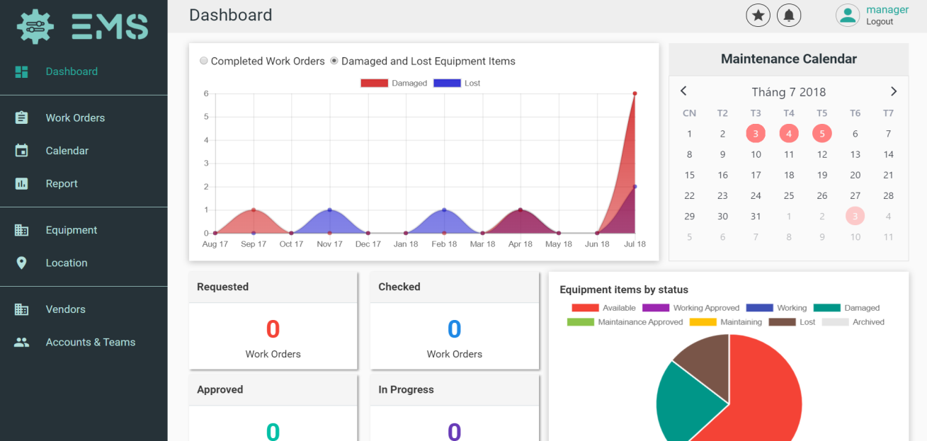

Figure 81 - User Guide <View Dashboard>

|  |  |
| --- | --- |
| **Step** | **Description** |
| 1 | Click on “Dashboard” hyperlink. |

Table 106 - User Guide <View Dashboard>

### 2.3 View Work Order



Figure 82 - User Guide <View Work Order>

|  |  |
| --- | --- |
| **Step** | **Description** |
| 1 | Click on “Work Orders” hyperlink. |

Table 107 - User Guide <View Work Order>

### 2.4 View Equipment

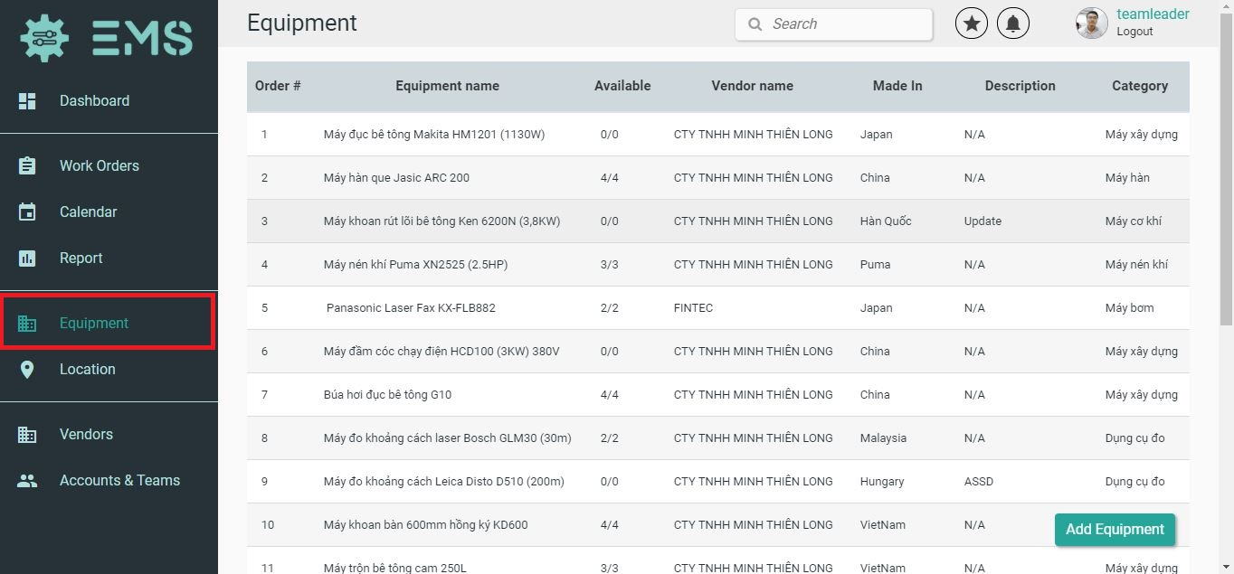

Figure 83 - User Guide <View Equipment>

|  |  |
| --- | --- |
| **Step** | **Description** |
| 1 | Click on “Equipment” hyperlink. |

Table 108 - User Guide <View Equipment>

### 2.5 Import an Equipment

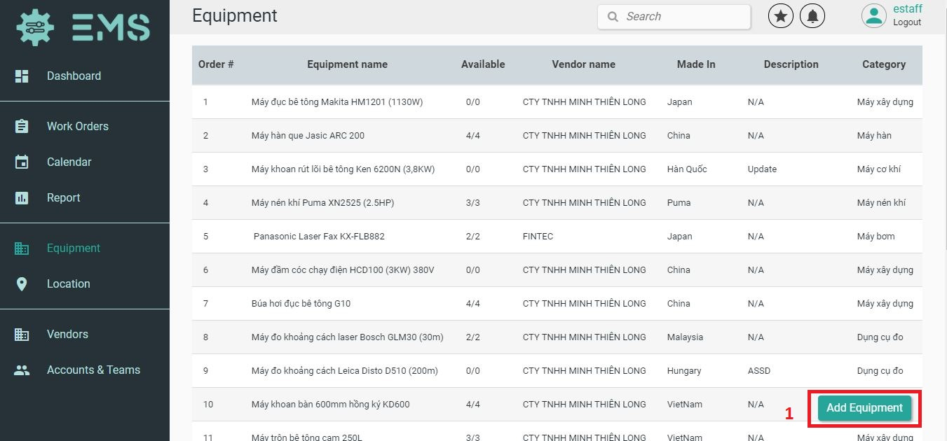

Figure 84 - User Guide <Import Equipment 1>

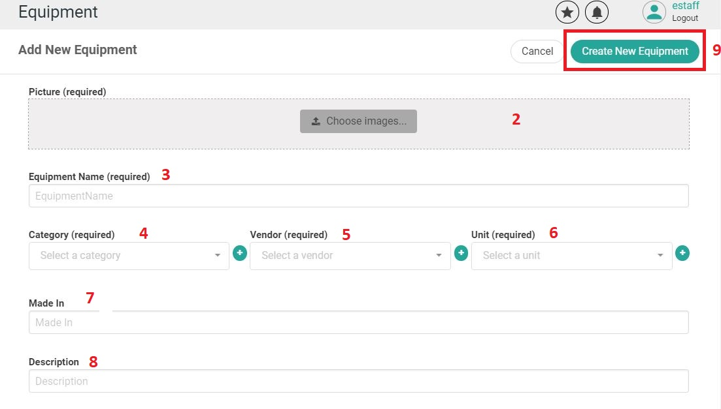

Figure 85 - User Guide <Import Equipment 2>

|  |  |
| --- | --- |
| **Step** | **Description** |
| 1 | Click on “Add Equipment” button. |
| 2 | Click on “Choose image” button. |
| 3 | Fill in field: “Equipment Name”. |
| 4 | Fill in field: “Category”. |
| 5 | Fill in field: “Vendor”. |
| 6 | Fill in field: “Unit”. |
| 7 | Fill in field: “Made in”. |
| 8 | Fill in field: “Description”. |
| 9 | Click on “Create New Equipment” button. |

Table 109 - User Guide <Import Equipment>

### 2.6 Edit an Equipment Information

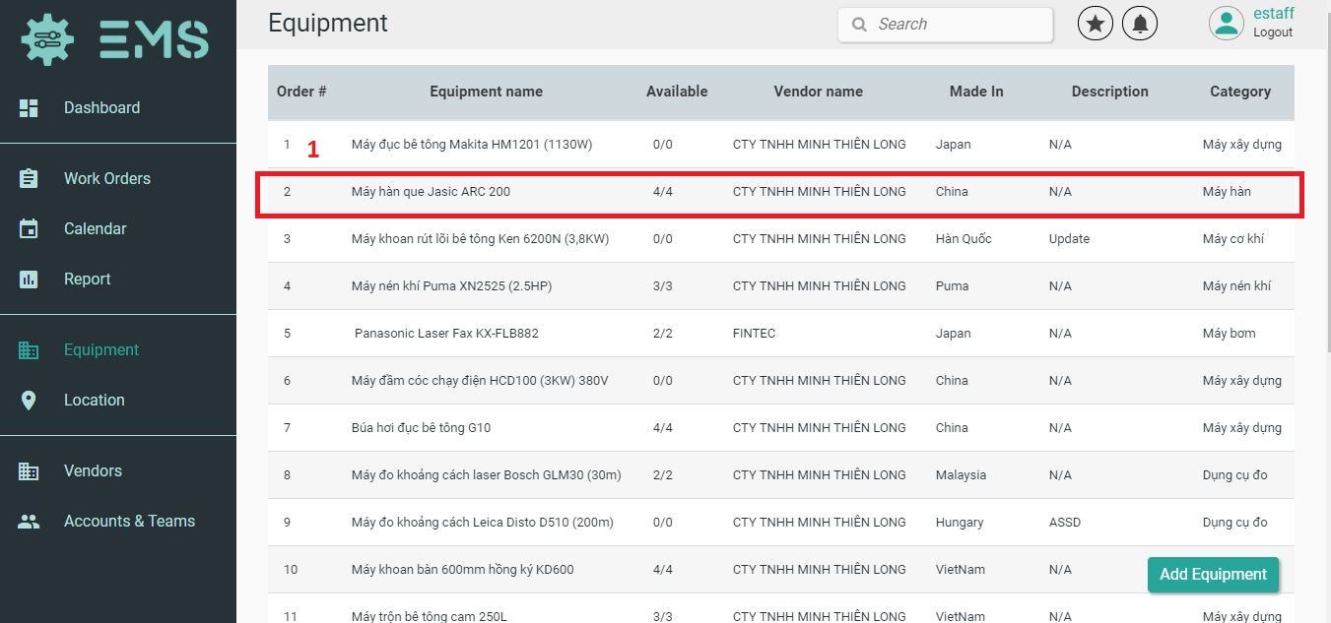

Figure 86 - User Guide <Edit Equipment Information 1>

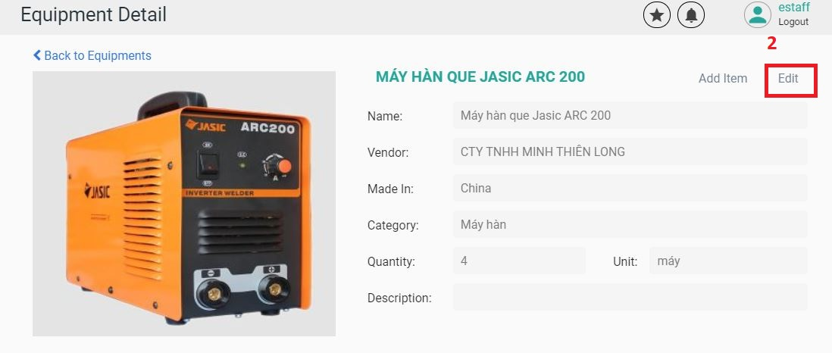

Figure 87 - User Guide <Edit Equipment Information 2>

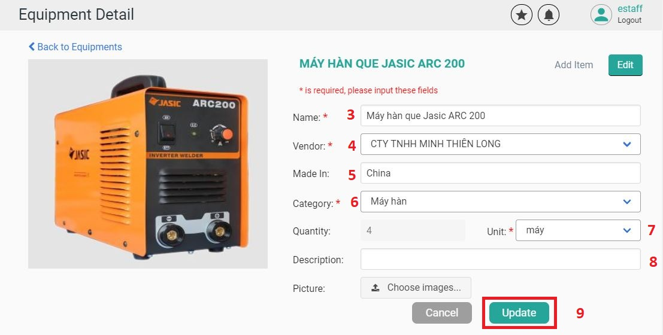

Figure 88 - User Guide <Edit Equipment Information 3>

|  |  |
| --- | --- |
| **Step** | **Description** |
| 1 | Click on the equipment that you want to edit. |
| 2 | Click on “Edit” button. |
| 3 | Fill in field: “Name”. |
| 4 | Fill in field: “Vendor”. |
| 5 | Fill in field: “Made in”. |
| 6 | Fill in field: “Category”. |
| 7 | Fill in field: “Unit”. |
| 8 | Fill in field: “Description”. |
| 9 | Click on “Choose Image” button. |
| １０ | Click on “Update” button. |

Table 110 - User Guide <Edit Equipment Information>

### 2.7 Create Equipment Items

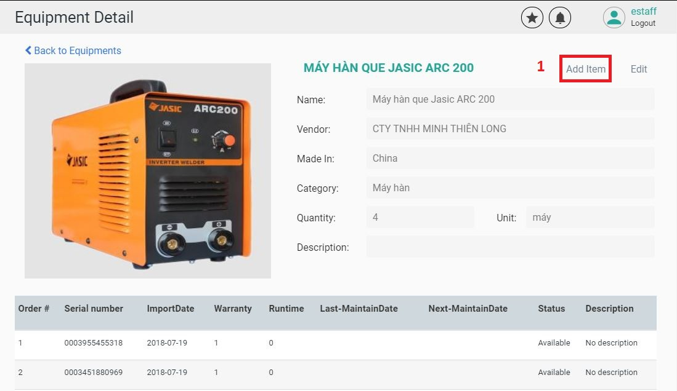

Figure 89 - User Guide <Create Equipment Items 1>

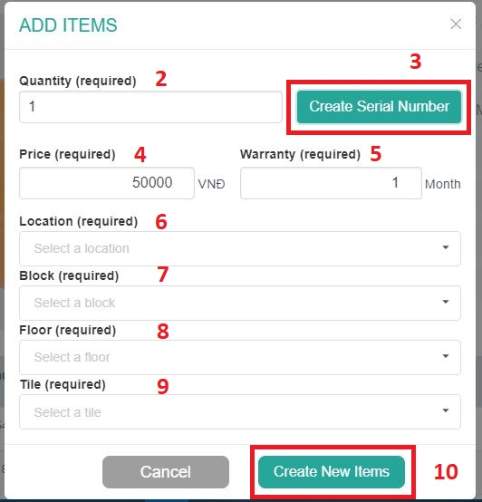

Figure 90 - User Guide <Create Equipment Items 2>

|  |  |
| --- | --- |
| **Step** | **Description** |
| 1 | Click on “Add Item” button. |
| 2 | Fill in field: “Quantity”. |
| 3 | Click on “Create Serial Number”. |
| 4 | Fill in field: “Price”. |
| 5 | Fill in field: “Warranty”. |
| 6 | Fill in field: “Location”. |
| 7 | Fill in field: “Block”. |
| 8 | Fill in field: “Floor”. |
| 9 | Fill in field: “Tile”. |
| １０ | Click on “Create New Items”. |

Table 111 - User Guide <Create Equipment Items>

### 2.8 View Location <List View>



Figure 91 - User Guide <View Location List View>

|  |  |
| --- | --- |
| **Step** | **Description** |
| 1 | Click on “Location” hyperlink. |
| 2 | Click on “List View” tab. |

Table 112 - User Guide <View Locations List View>

### 2.9 View Location <Map View>



Figure 92 - User Guide <View Location Map View>

|  |  |
| --- | --- |
| **Step** | **Description** |
| 1 | Click on “Location” hyperlink. |
| 2 | Click on “Map View” tab. |

Table 113 - User Guide <View Location Map View>

### 2.10 Create a Location

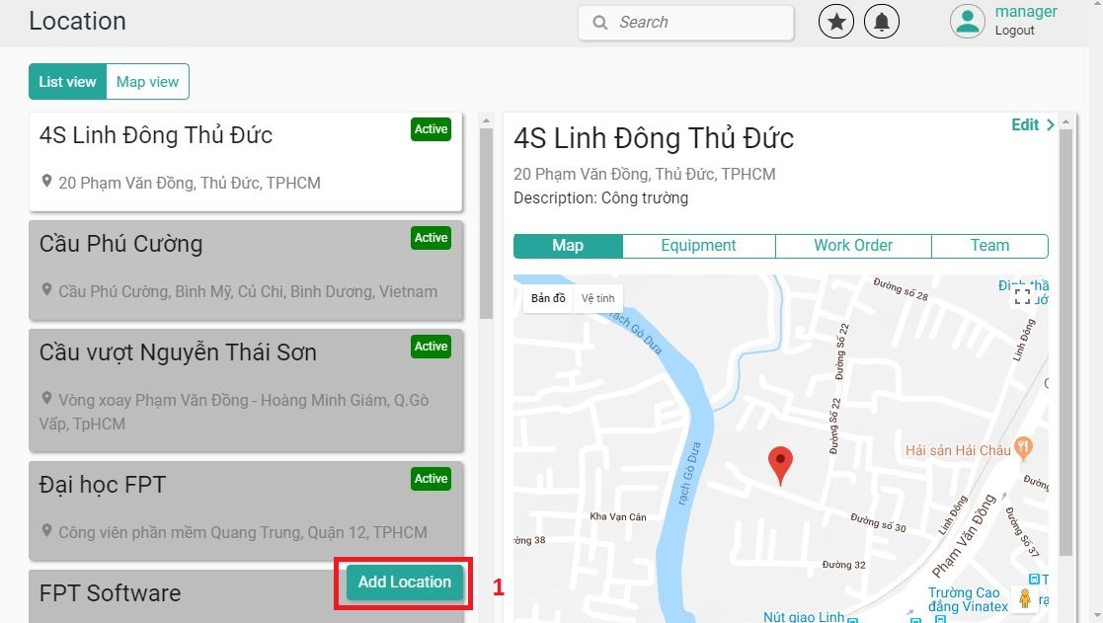

Figure 93 - User Guide <Create a Location 1>

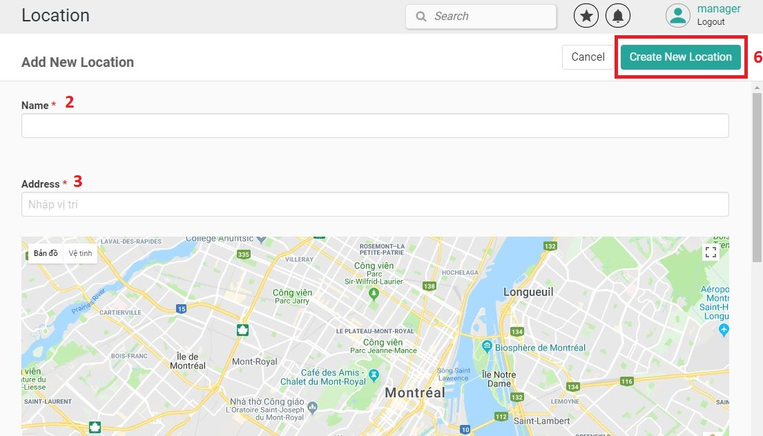

Figure 94 - User Guide <Create a Location 2>

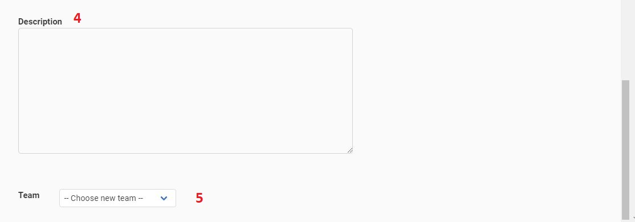

Figure 95 - User Guide <Create a Location 3>

|  |  |
| --- | --- |
| **Step** | **Description** |
| 1 | Click on “Add Location” button. |
| 2 | Fill in field: “Name”. |
| 3 | Fill in field: “Address”. |
| 4 | Fill in field: “Description”. |
| 5 | Fill in field: “Team”. |
| 6 | Click on “Create New Location” button. |

Table 114 - User Guide <Create a Location >

### 2.11 View Vendor

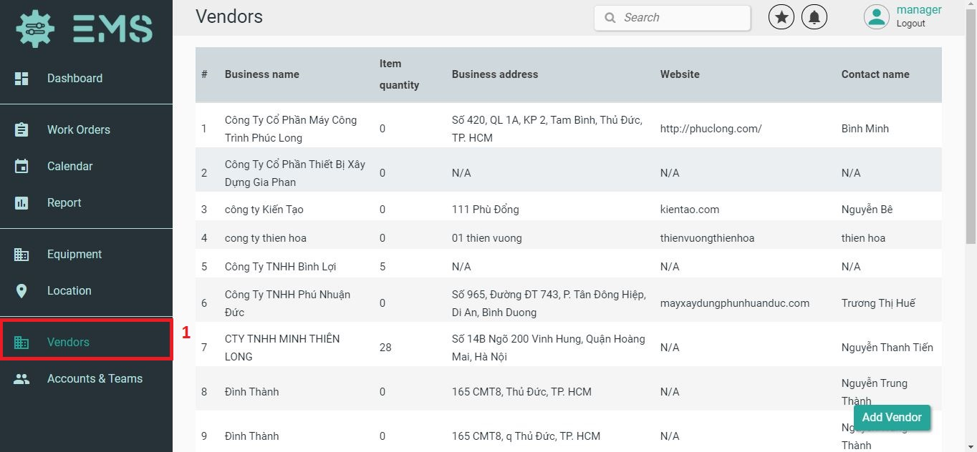

Figure 96 - User Guide <View Vendor>

|  |  |
| --- | --- |
| **Step** | **Description** |
| 1 | Click on “Vendor” hyperlink. |

Table 115 - User Guide <View Vendor>

### 2.12 Create a Vendor

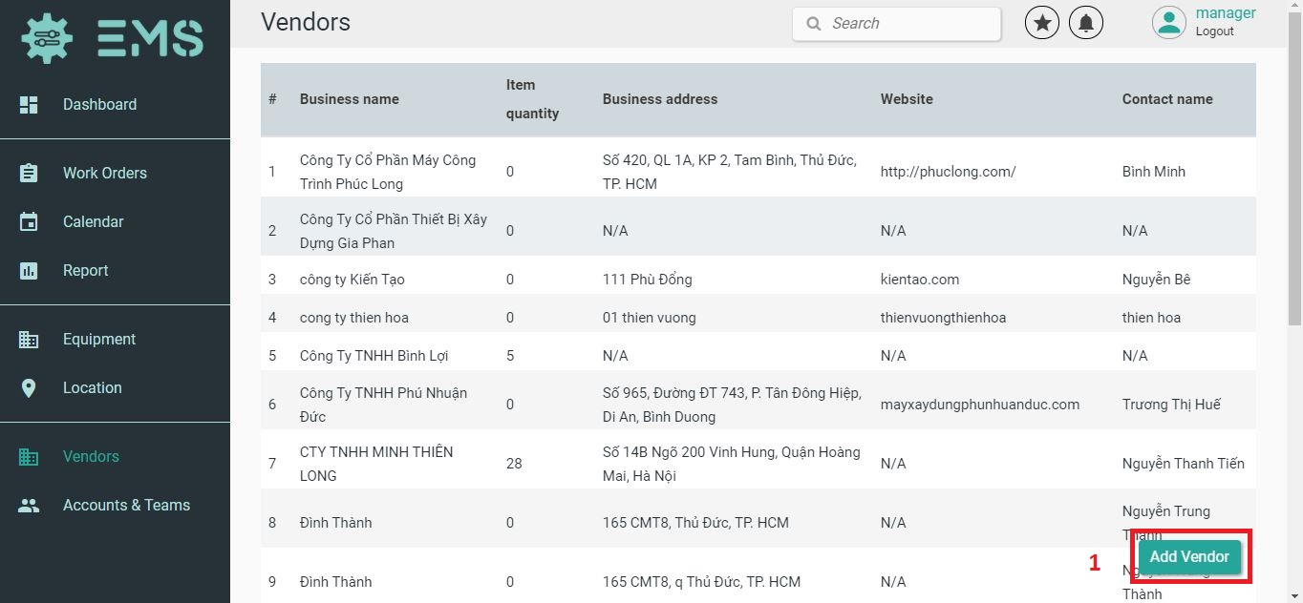

Figure 97 - User Guide <Create a Vendor 1>

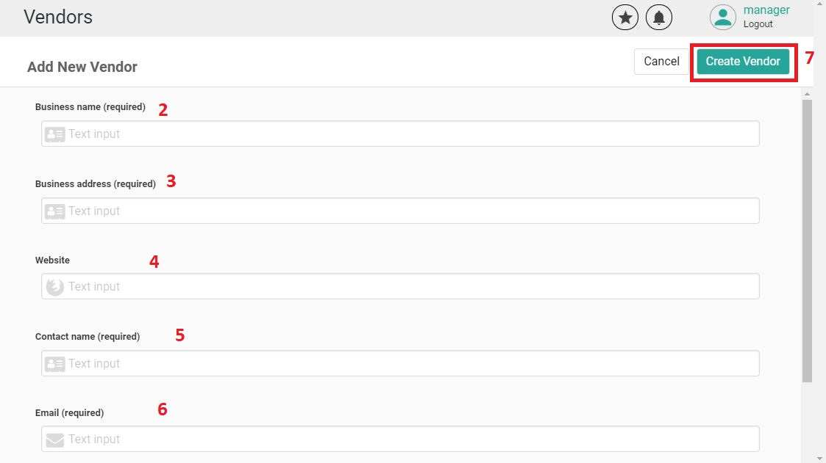

Figure 98 - User Guide <Create a Vendor 2>

|  |  |
| --- | --- |
| **Step** | **Description** |
| 1 | Click on “Add Vendor” button. |
| 2 | Fill in field: “Business Name”. |
| 3 | Fill in field: “Business Address”. |
| 4 | Fill in field: “Website”. |
| 5 | Fill in field: “Contact Name”. |
| 6 | Fill in field: “Email”. |
| 7 | Click on “Create Vendor” button. |

Table 116 - User Guide <Create Vendor>

### 2.13 Edit a Location Information

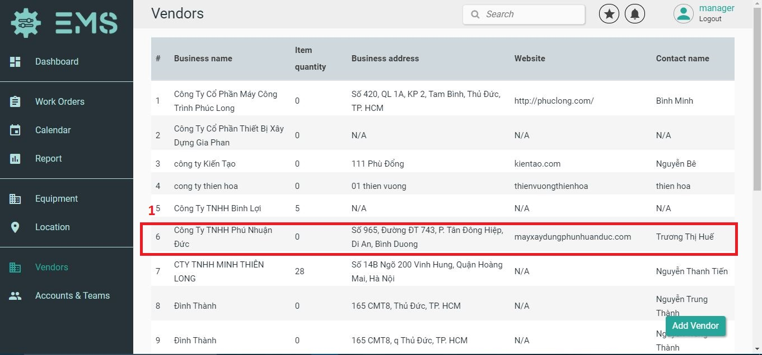

Figure 99 - User Guide <Edit Location Information 1>

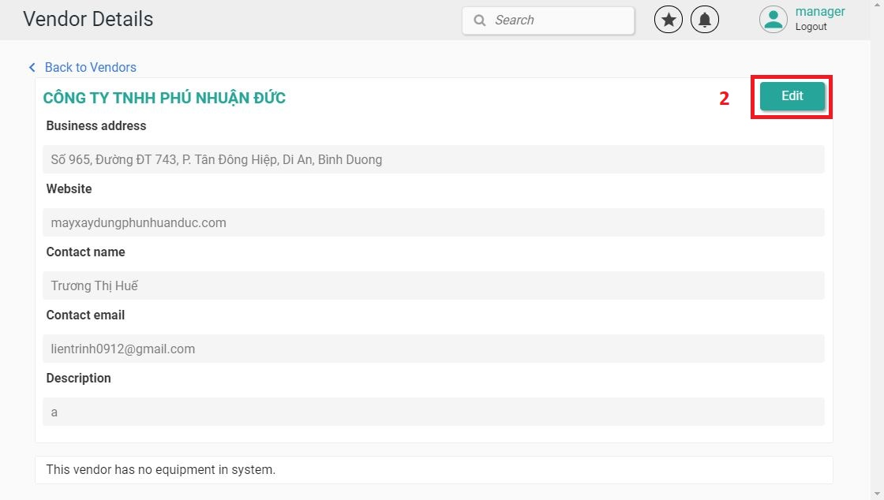

Figure 100 - User Guide <Edit Location Information 2>

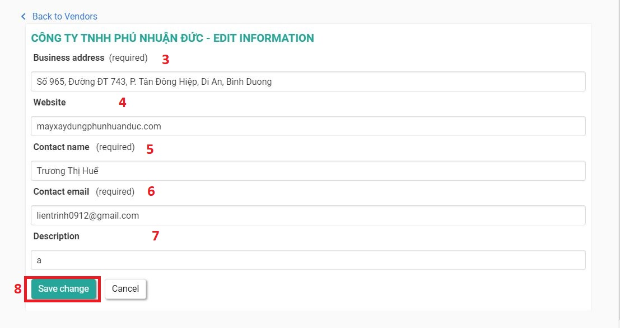

Figure 101 - User Guide <Edit Location Information 3>

|  |  |
| --- | --- |
| **Step** | **Description** |
| 1 | Click on the vendor that you want to edit. |
| 2 | Click on “Edit” button. |
| 3 | Fill in field: “Business Address”. |
| 4 | Fill in field: “Website”. |
| 5 | Fill in field: “Contact Name”. |
| 6 | Fill in field: “Email”. |
| 7 | Fill in field: “Description”. |
| 8 | Click on “Save changes” button. |

Table 117 - User Guide <Edit Location information>

### 2.14 View Account

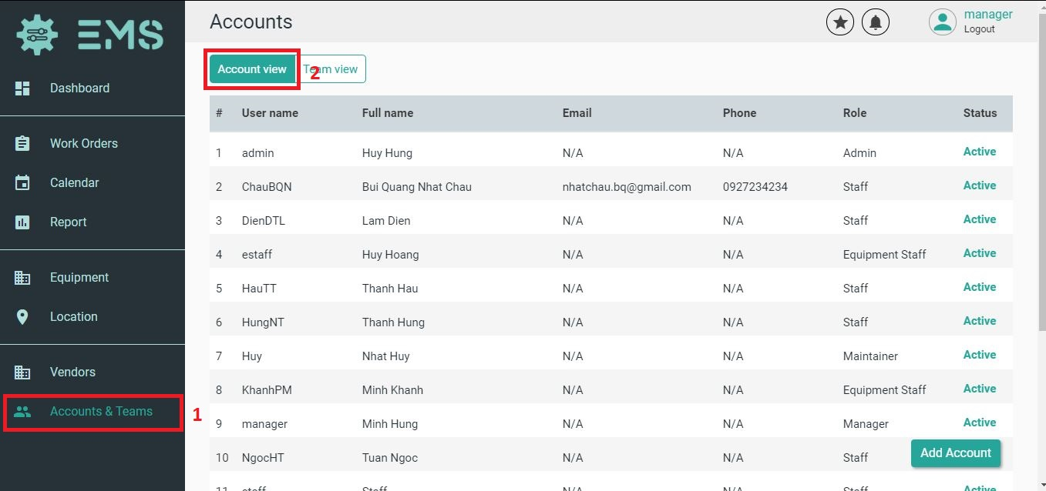

Figure 102 - User Guide <View Account>

|  |  |
| --- | --- |
| **Step** | **Description** |
| 1 | Click on “Accounts & Teams” hyperlink. |
| 2 | Click on “Account View” tab. |

Table 118 - User Guide <View Account>

### 2.15 Create an Account

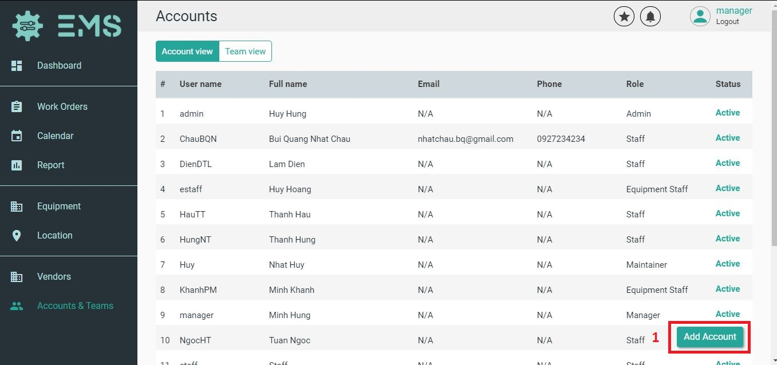

Figure 103 - User Guide <Create an Account 1>

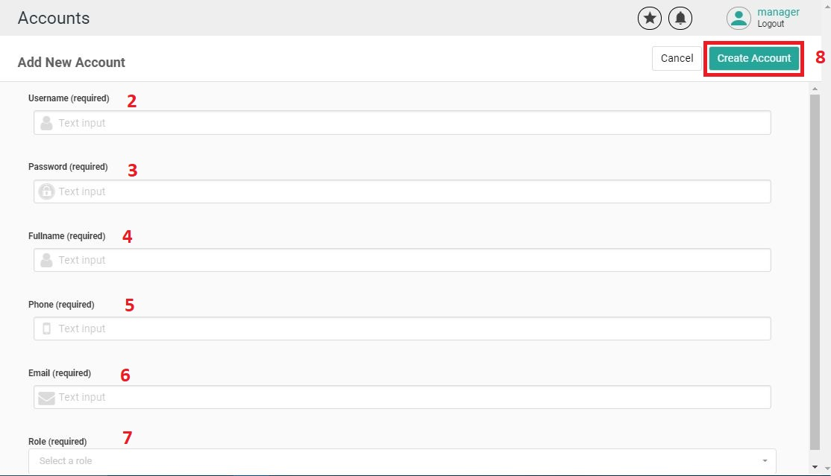

Figure 104 - User Guide <Create an Account 2>

|  |  |
| --- | --- |
| **Step** | **Description** |
| 1 | Click on “Add Account” button. |
| 2 | Fill in field: “Username”. |
| 3 | Fill in field: “Password”. |
| 4 | Fill in field: “Fullname”. |
| 5 | Fill in field: “Phone”. |
| 6 | Fill in field: “Email”. |
| 7 | Fill in field: “Role”. |
| 8 | Click on “Create Account” button. |

Table 119 - User Guide <Create an Account>

### 2.16 Edit an Account Information

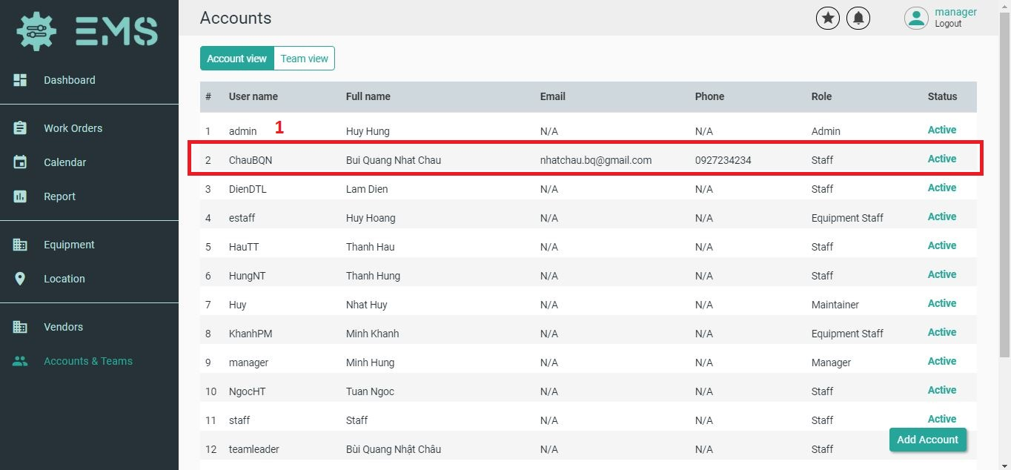

Figure 105 - User Guide <Edit Account Information 1>

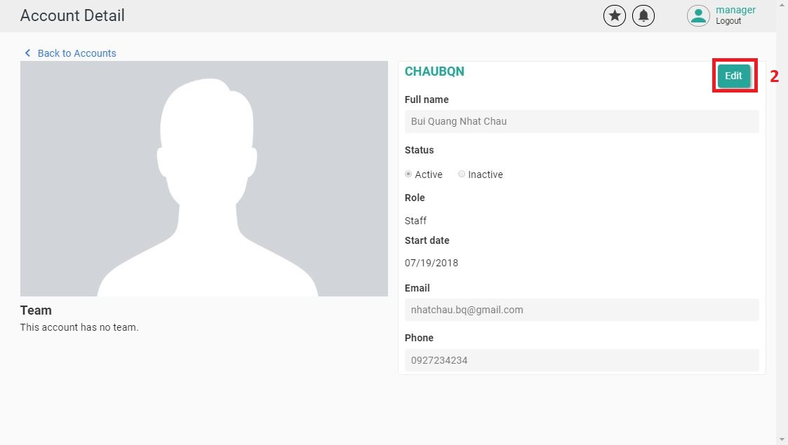

Figure 106 - User Guide <Edit Account Information 2>

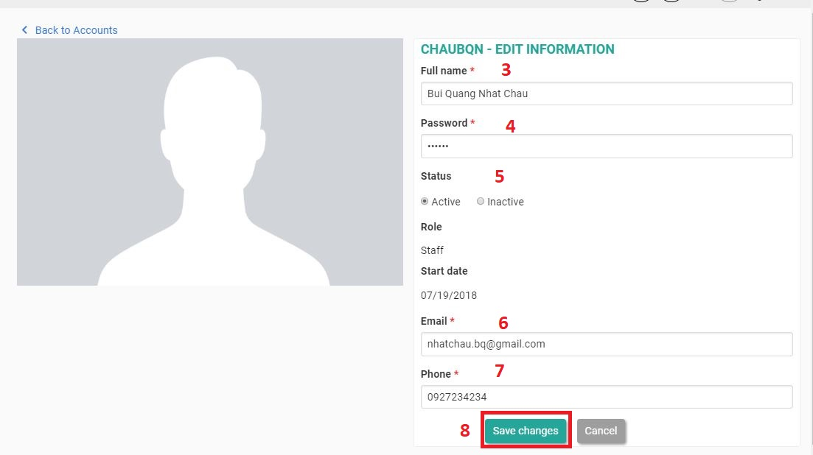

Figure 107 - User Guide <Edit Account Information 3>

|  |  |
| --- | --- |
| **Step** | **Description** |
| 1 | Click on the account that you want to edit. |
| 2 | Click on “Edit” button. |
| 3 | Fill in field: “Fullname”. |
| 4 | Fill in field: “Password”. |
| 5 | Choose “Active” or “Inactive” status. |
| 6 | Fill in field: “Email”. |
| 7 | Fill in field: “Phone”. |
| 8 | Click on “Save changes” button. |

Table 120 - User Guide <Edit Account Information>

### 2.17 View Team



Figure 108 - User Guide <View Team>

|  |  |
| --- | --- |
| **Step** | **Description** |
| 1 | Click on “Accounts & Teams” hyperlink. |
| 2 | Click on “Team View” tab. |

Table 121 - User Guide <View Team>

### 2.18 Create a Team

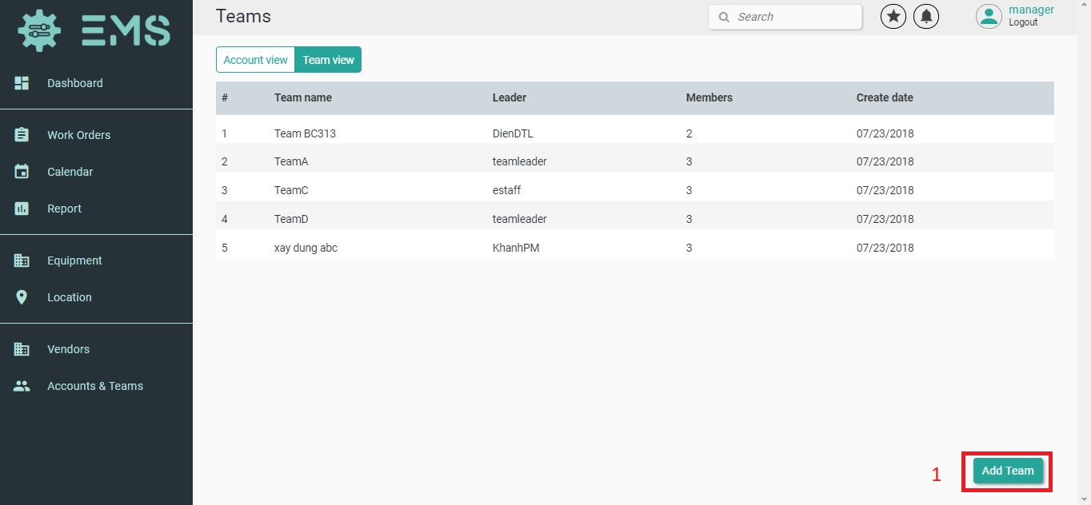

Figure 109 - User Guide <Create a Team 1>



Figure 110 - User Guide <Create a Team 2>

|  |  |
| --- | --- |
| **Step** | **Description** |
| 1 | Click on “Add Team” button. |
| 2 | Fill in field: “Team name”. |
| 3 | Fill in field: “Member”. |
| 4 | Click on “Create Team” button. |

Table 122 - User Guide <Create a Team>

### 2.19 Edit a Team Information

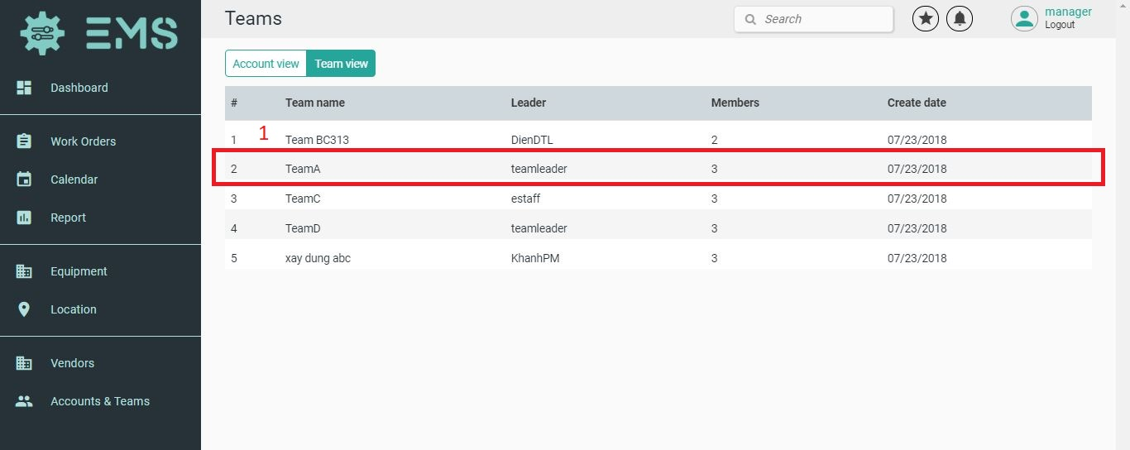

Figure 111 - User Guide <Edit Team Information 1>

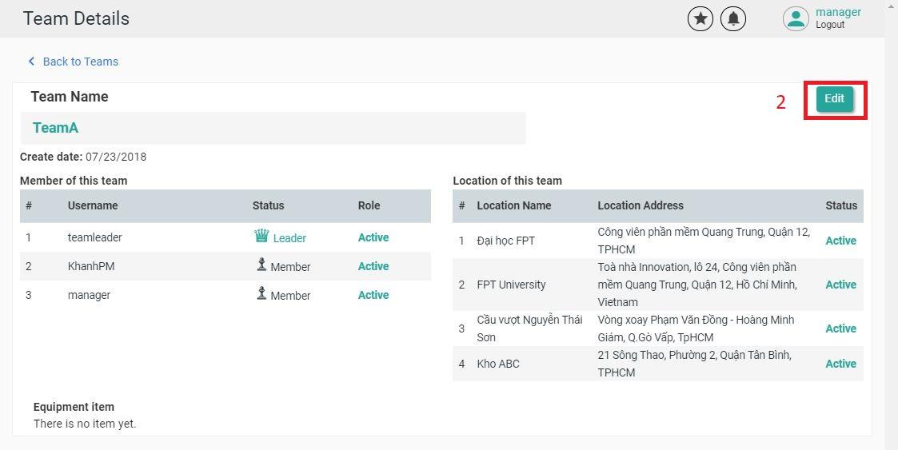

Figure 112 - User Guide <Edit Team Information 2>

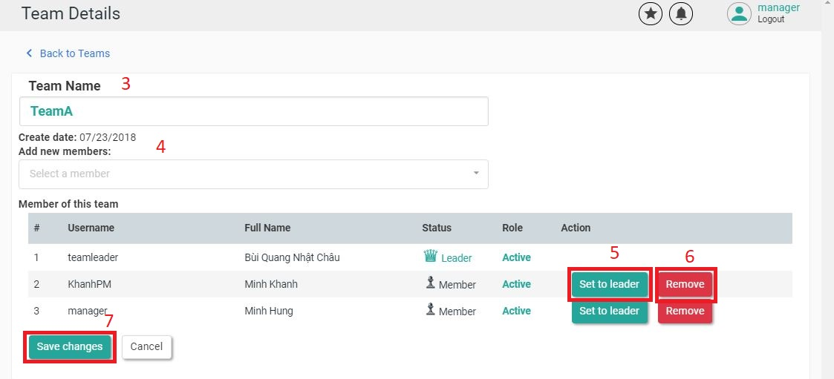

Figure 113 - User Guide <Edit Team Information 3>

|  |  |
| --- | --- |
| **Step** | **Description** |
| 1 | Click on the team that you want to edit. |
| 2 | Click on “Edit” button. |
| 3 | Fill in field: “Team Name”. |
| 4 | Fill in field: “Member”. |
| 5 | To set this account as a leader, click the "Set to leader" button. |
| 6 | To delete this account from the team, click the "Remove" button. |
| 7 | Click on “Save changes” button. |

Table 123 - User Guide <Edit Team Information >

# F2. ソフトウェアユーザーマニュアル

## 1. インストレーションガイド

### 1.1ハードウェア要件

|  |  |
| --- | --- |
| ハードウェア | 記述 |
| インターネット | 8 Mbps以上 |
| プロセッサー | Intel® Core(TM) i5 CPU , M 460 @ 2.53GHz以上 |
| RAM | 4GB以上 |
| ハードディスクドライブ | 40GB 以上 |

Table 124 - ハードウェア要件

### 1.2ソフトウェア要件

|  |  |
| --- | --- |
| ソフトウェア | アプリケーション名前／バージョン |
| オペレーティングシステム | Window 10 Pro-64bit |
| 環境 | VueJS 2.0 |
| DBMS | Microsoft SQL server 2014 v17.4 |
| ソース管理 | Github |
| ウェブブラウザ | Chrome 63 以上 |

Table 125 - ソフトウェア要件

## 2. ユーザーガイド

### 2.1ログイン



Figure 114 - ユーザーガイド <ログイン>

|  |  |
| --- | --- |
| **Step** | **Description** |
| 1 | ユーザー名の内容を入力します。 |
| 2 | パスワードの内容を入力します。 |
| 4 | 「Login 」のボタンをクリックします。 |

Table 126 - ユーザーガイド<ログイン>

### 2.2ダッシュボードを表示します

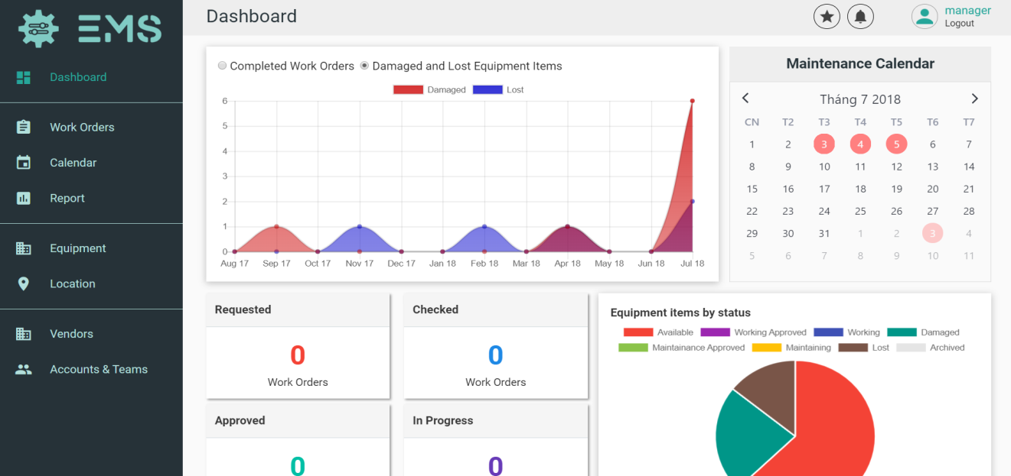

Figure 115 - ユーザーガイド <ダッシュボードを表示します>

|  |  |
| --- | --- |
| **Step** | **Description** |
| 1 | サイドバーの「　Dashboard　」をクリックします。 |

Table 127 - ユーザーガイド<ダッシュボードを表示します>

### 2.3作業の順序を管理します



Figure 116 - ユーザーガイド <作業の順序を管理します>

|  |  |
| --- | --- |
| **Step** | **Description** |
| 1 | サイドバーの「　Work Orders 」をクリックします。 |

Table 128 - ユーザーガイド <作業の順序を管理します>

### 2.4機器の表示します



Figure 117 - ユーザーガイド <機器の表示します>

|  |  |
| --- | --- |
| **Step** | **Description** |
| 1 | サイドバーの「　Equipment 」をクリックします。 |

Table 129 - ユーザーガイド <機器の表示します>

### 2.5設備を追加します



Figure 118 - ユーザーガイド <設備を追加します>



Figure 119 - ユーザーガイド <設備を追加します>

|  |  |
| --- | --- |
| **Step** | **Description** |
| 1 | 「Add Equipment」のボタンをクリックします。 |
| 2 | 「Choose images」のボタンをクリックして、イメージを選択します。 |
| 3 | 設備名の内容を入力します。 |
| 4 | 範疇名の内容を入力します。 |
| 5 | ベンダー名の内容を入力します。 |
| 6 | 単位の内容を入力します。 |
| 7 | 製の内容を入力します。 |
| 8 | 説明の内容を入力します。 |
| 9 | 「Create New Equipment」のボタンをクリックします。 |

Table 130 - ユーザーガイド <設備を追加します>

### 2.6設備を編集します



Figure 120 - ユーザーガイド <設備を編集します>



Figure 121 - ユーザーガイド <設備を編集します>



Figure 122 - ユーザーガイド <設備を編集します>

|  |  |
| --- | --- |
| **Step** | **Description** |
| 1 | 編集する設備をクリックします。 |
| 2 | 「Edit」のボタンをクリックします。 |
| 3 | 設備名の内容を入力します。 |
| 4 | ベンダー名の内容を入力します。 |
| 5 | 製の内容を入力します。 |
| 6 | 範疇名の内容を入力します。 |
| 7 | 単位の内容を入力します。 |
| 8 | 説明の内容を入力します。 |
| 9 | 「Choose images」のボタンをクリックして、イメージを選択します。 |
| １０ | 「Update」のボタンをクリックします。 |

Table 131 - ユーザーガイド <設備を編集します>

### 2.7設備の項目を作成します



Figure 123 - ユーザーガイド <設備の項目を作成します>



Figure 124 - ユーザーガイド <設備の項目を作成します>

|  |  |
| --- | --- |
| **Step** | **Description** |
| 1 | 「Add Item」のボタンをクリックします。 |
| 2 | 数量の内容を入力します。 |
| 3 | 「Create Serial Number」のボタンをクリックします。 |
| 4 | 価格の内容を入力します。 |
| 5 | 保証の内容を入力します。 |
| 6 | 場所名の内容を入力します。 |
| 7 | 区画の内容を入力します。 |
| 8 | 床の内容を入力します。 |
| 9 | タイルの内容を入力します。 |
| １０ | 「Create New Items」のボタンをクリックします。 |

Table 132 - ユーザーガイド <設備の項目を作成します>

### 2.8場所を表示します＜リストビュー＞



Figure 125 - ユーザーガイド <場所を表示します>

|  |  |
| --- | --- |
| **Step** | **Description** |
| 1 | サイドバーの「　Location 」をクリックします。 |
| 2 | 「List View」のボタンをクリックします。 |

Table 133 - ユーザーガイド <場所を表示します>

### 2.9場所を表示します＜マップビュー＞



Figure 126 - ユーザーガイド <場所を表示します>

|  |  |
| --- | --- |
| **Step** | **Description** |
| 1 | サイドバーの「　Location 」をクリックします。 |
| 2 | 「MapView」のボタンをクリックします。 |

Table 134 - ユーザーガイド <場所を表示します>

### 2.10場所を作成します



Figure 127 - ユーザーガイド <場所を作成します>



Figure 128 - ユーザーガイド <場所を作成します>



Figure 129 - ユーザーガイド <場所を作成します>

|  |  |
| --- | --- |
| **Step** | **Description** |
| 1 | 「Add Location」のボタンをクリックします。 |
| 2 | 場所名の内容を入力します。 |
| 3 | 住所の内容を入力します。 |
| 4 | 説明の内容を入力します。 |
| 5 | チームの内容を入力します。 |
| 6 | 「Create New Location」のボタンをクリックします。 |

Table 135 - ユーザーガイド <場所を作成します>

### 2.11ベンダーを表示します



Figure 130 - ユーザーガイド <ベンダーを表示します>

|  |  |
| --- | --- |
| **Step** | **Description** |
| 1 | サイドバーの「　Vendor 」をクリックします。 |

Table 136 - ユーザーガイド <ベンダーを表示します>

### 2.12ベンダーを作成します



Figure 131 - ユーザーガイド <ベンダーを作成します>



Figure 132 - ユーザーガイド <ベンダーを作成します>

|  |  |
| --- | --- |
| **Step** | **Description** |
| 1 | 「Add Vendor」のボタンをクリックします。 |
| 2 | 商号名の内容を入力します。 |
| 3 | 事業所の住所の内容を入力します。 |
| 4 | ウェブサイトの内容を入力します。 |
| 5 | 連絡先の内容を入力します。 |
| 6 | メールの内容を入力します。 |
| 7 | 「Create Vendor」のボタンをクリックします。 |

Table 137 - ユーザーガイド <ベンダーを作成します>

### 2.13ベンダーを編集します



Figure 133 - ユーザーガイド <ベンダーを編集します>



Figure 134 - ユーザーガイド <ベンダーを編集します>



Figure 135 - ユーザーガイド <ベンダーを編集します>

|  |  |
| --- | --- |
| **Step** | **Description** |
| 1 | 編集するベンダーをクリックします。 |
| 2 | 「Edit」のボタンをクリックします。 |
| 3 | 事業所の内容を入力します。 |
| 4 | ウェブサイトの内容を入力します。 |
| 5 | 連絡先の内容を入力します。 |
| 6 | メールの内容を入力します。 |
| 7 | 説明の内容を入力します。 |
| 8 | 「Save changes」のボタンをクリックします。 |

Table 138 - ユーザーガイド <ベンダーを編集します>

### 2.14口座を表示します



Figure 136 - ユーザーガイド <口座を表示します>

|  |  |
| --- | --- |
| **Step** | **Description** |
| 1 | サイドバーの「　Accounts & Teams」をクリックします。 |
| 2 | 「Account View」のボタンをクリックします。 |

Table 139 - ユーザーガイド <口座を表示します>

### 2.15口座を作成します



Figure 137 - ユーザーガイド <口座を作成します>



Figure 138 - ユーザーガイド <口座を作成します>

|  |  |
| --- | --- |
| **Step** | **Description** |
| 1 | 「Add Account」のボタンをクリックします。 |
| 2 | ユーザー名の内容を入力します。 |
| 3 | パスワードの内容を入力します。 |
| 4 | 名前の内容を入力します。 |
| 5 | 電話番号の内容を入力します。 |
| 6 | メールの内容を入力します。 |
| 7 | 役割の内容を入力します。 |
| 8 | 「Create Account」のボタンをクリックします。 |

Table 140 - ユーザーガイド <口座を作成します>

### 2.16口座を編集します



Figure 139 - ユーザーガイド <口座を編集します>



Figure 140 - ユーザーガイド <口座を編集します>



Figure 141 - ユーザーガイド <口座を編集します>

|  |  |
| --- | --- |
| **Step** | **Description** |
| 1 | 編集する口座をクリックします。 |
| 2 | 「Edit」のボタンをクリックします。 |
| 3 | 名前の内容を入力します。 |
| 4 | パスワードの内容を入力します。 |
| 5 | 状態を選択します。 |
| 6 | メールの内容を入力します。 |
| 7 | 電話番号の内容を入力します。 |
| 8 | 「Save changes」のボタンをクリックします。 |

Table 141 - ユーザーガイド <口座を編集します>

### 2.17チームを表示します



Figure 142 - ユーザーガイド <チームを表示します>

|  |  |
| --- | --- |
| **Step** | **Description** |
| 1 | サイドバーの「　Accounts & Teams」をクリックします。 |
| 2 | 「Team View」のボタンをクリックします。 |

Table 142 - ユーザーガイド <チームを表示します>

### 2.18チームを作成します



Figure 143 - ユーザーガイド <チームを作成します>



Figure 144 - ユーザーガイド <チームを作成します>

|  |  |
| --- | --- |
| **Step** | **Description** |
| 1 | 「Add Team」のボタンをクリックします。 |
| 2 | チーム名の内容を入力します。 |
| 3 | 成員の内容を拾います。 |
| 4 | 「Create Team」のボタンをクリックします。 |

Table 143 - ユーザーガイド <チームを作成します>

### 2.19チームを編集します



Figure 145 - ユーザーガイド <チームを編集します>



Figure 146 - ユーザーガイド <チームを編集します>



Figure 147 - ユーザーガイド <チームを編集します>

|  |  |
| --- | --- |
| **Step** | **Description** |
| 1 | 編集するチームをクリックします。 |
| 2 | 「Edit」のボタンをクリックします。 |
| 3 | チーム名の内容を入力します。 |
| 4 | 成員の内容を拾います。 |
| 5 | この口座をリーダーに設定する場合は、「Set to leader」のボタンをクリックします。 |
| 6 | この口座をチームから削除する場合は、「Remove」のボタンをクリックします。 |
| 7 | 「Save changes」のボタンをクリックします。 |

Table 144 - ユーザーガイド <チームを編集します>

# G. Appendix

### 1. SOFTWARE ENGINEERING 9TH EDITION, BY IAN SOMMERVILLE

### 2. STARUML DOCUMENTATION FOR ACTIVITY DIAGRAM:

http://www.uml-diagrams.org/activity-diagrams-controls.html

3. STARUML DOCUMENTATION OF IBM:

https://www.ibm.com/developerworks/rational/library/content/RationalEdge/sep03/f_umlbasics_db.pdf

### 4. UML FOR DRAWING DIAGRAM (2.0 STANDARD)

<http://www.omg.org/spec/UML/2.0>

### 5. VUEJS FEATURES

[1] [2] [3] https://en.wikipedia.org/wiki/Vue.js